Dorset Council Contaminated Land Part 2A Public Register.
Part 2A of the Environmental Protection Act 1990 and the Contaminated Land (England) Regulations 2006 require councils to maintain a public register of specified information relating to sites in their area which have been formally determined as ‘contaminated land’.
This public register contains only the information required by law; it is important to note that it is not a register of:
- sites legally determined as contaminated land
- sites which may be contaminated land
- sites which are potentially contaminated, or
- sites about which the council has records as part of the Contaminated Land Inspection Strategy.
The public register is updated whenever the council becomes aware of new information which is relevant for the purposes of Section 78R of the Environmental Protection Act 1990.

There are currently two entries on the Dorset Council Contaminated Land Part 2A Public Register.
Entry 1
Site Address: Cogdean Elms Industrial Estate, Higher Merley Lane, Corfe Mullen, Wimborne. BH21 3EQ
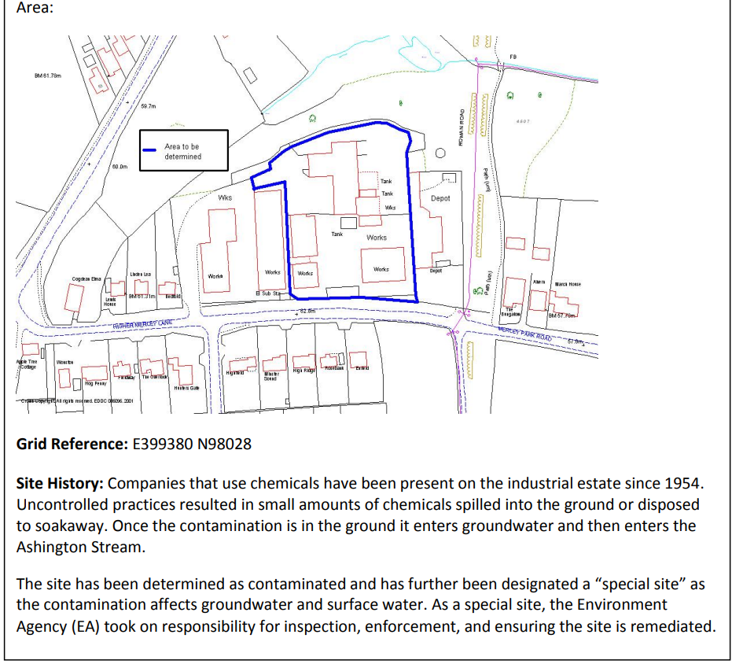

Entry 2
Site Address: FORMER SHERBORNE LANDFILL SITE, West Mill Lane, Sherborne, Dorset DT9 5NP
Area: 5.5 ha approximately
National Grid Reference: 363250 114938
Current Use: None
Site History: The site was a stream valley owned by Sherborne Castle Estates. It was leased by Sherborne Urban District Council, who culverted the stream and used the site to tip domestic refuse from 1970 onwards. The lease passed to Dorset County Council in 1974. Tipping ceased in 1993.
The site was formally designated by West Dorset District Council as contaminated land on 29th July 2003, and Dorset County Council obtained government funding to repair the collapsing culvert and remediate the site so that it no longer met the legal definition of ‘contaminated land’.

