2026 Air Quality Annual Status Report (ASR)
In fulfilment of Part IV of the Environment Act 1995 Local Air Quality Management, as amended by the Environment Act 2021
Date: June 2026

Information | Dorset Council Details
Local Authority Officer | Ben Frost-Jones
Department | Environmental Protection
Address | Dorset Council  County Hall  Dorchester  Dorset  DT1 1XJ
Telephone | 01305 221000
E-mail | envhealth@dorsetcouncil.gov.uk
Report Reference Number | DC_ASR_2026
Date | June 2026

Local Responsibilities and Commitment
This ASR was prepared by the Environmental Protection Department of Dorset Council with the support and agreement of the following officers and departments:
Darren Naraine, Team Leader, Environmental Protection
Janet Moore, Service Manager, Environmental Protection

This ASR has been approved by:
Graham Duggan, Head of Regulatory Services

This ASR has been signed off by Sam Crowe, Executive Director of Housing Communities and Prevention

If you have any comments on this ASR, please send them to the details provided above.

Executive Summary: Air Quality in Our Area

Air Quality in Dorset
Breathing in polluted air affects our health and costs the NHS and our society billions of pounds each year. Air pollution is recognised as a contributing factor in the onset of heart disease and cancer and can cause a range of health impacts, including effects on lung function, exacerbation of asthma, increases in hospital admissions and mortality.
Air pollution particularly affects the most vulnerable in society, children, the elderly, and those with existing heart and lung conditions. Low-income communities are also disproportionately impacted by poor air quality, exacerbating health and social inequalities.
Table ES 1 provides a brief explanation of the key pollutants relevant to Local Air Quality Management and the kind of activities they might arise from.
Table ES 1 - Description of Key Pollutants
Pollutant | Description
Nitrogen Dioxide (NO₂) | Nitrogen dioxide is a gas which is generally emitted from high-temperature combustion processes such as road transport or energy generation.
Sulphur Dioxide (SO₂) | Sulphur dioxide (SO₂) is a corrosive gas which is predominantly produced from the combustion of coal or crude oil.
Particulate Matter  (PM₁₀ and PM_{2.5}) | Particulate matter is everything in the air that is not a gas.  Particles can come from natural sources such as sea salt and pollen, as well as human made sources such as smoke from fires, emissions from industry and dust from tyres and brakes.  PM₁₀ refers to particles under 10 micrometres. Fine particulate matter or PM_{2.5} are particles under 2.5 micrometres.

Actions to Improve Air Quality
Whilst air quality has improved significantly in recent decades, there are some areas where local action is needed to protect people and the environment from the effects of air pollution.
The government’s Environmental Improvement Plan sets out actions that will drive continued improvements to air quality and to meet the new national interim and long-term targets for fine particulate matter (PM_{2.5}), the pollutant of most harmful to human health. The Air Quality Strategy provides more information on local authorities' responsibilities to work towards these new targets and reduce fine particulate matter in their areas. Dorset is already on course to meet these targets prior to their given deadlines.
The Road to Zero details the Government’s approach to reduce exhaust emissions from road transport through several mechanisms, in balance with the needs of the local community. This is extremely important given that cars are the most popular mode of personal travel, and the majority of Air Quality Management Areas (AQMAs) are designated due to elevated concentrations heavily influenced by transport emissions.
Primary actions taken to improve air quality in Dorset principally revolve around the Air Quality Action Plan for Chideock and the harmonisation and streamlining of air quality monitoring practices between teams. National Highways (formerly Highways England), who hold responsibility for actions regarding the A35 trunk road passing through Dorset – the principal source of NO₂ emissions in the AQMA in Chideock – have extended and permanently implemented a 30mph speed limit. Enforcement is being developed by way of average speed cameras along this stretch of the road, allowing for speed enforcement and ensuring better traffic flow and reduction of standing traffic and heavy acceleration through Chideock. Dorset Council continue to work with our colleagues at National Highways, as well as our own Highways Department, Public Health Dorset, elected members and Parish Councils.
Further working has been undertaken following a DEFRA-funded project to monitor and quantify emissions from solid-fuel burning appliances. This sought to quantify PM emissions in locales with higher numbers of solid-fuel burners and measure the impact of behaviour change initiatives and campaigns. This project was completed in summer/autumn 2024, and report prepared and published in early 2025. This has led to an annual publicity campaign to encourage better burning behaviours, including appropriate fuel seasoning and selection, stove and chimney maintenance, and HETAS registration. Partners in Public Health and Litter Free Dorset are partnering with Environmental Protection to further extend anti-idling schemes outside schools, and to extend the school-streets programme which closes roads around schools at drop-off and pick-up times.

Conclusions and Priorities
In general, concentrations of NO₂ at monitoring locations showed reductions on 2022 concentrations. Given 2022 was the first year since 2019 without COVID-19 travel restrictions, this is taken to be an accurate reflection of “normal” air pollution conditions. With 2022 indicating reduced concentrations from 2019, 2025 showed a continuation of this trend. In some cases, 2025 concentrations exceeded previous years, however these were isolated monitoring tubes in locations, and did not show a general flattening or reversing of the downwards trend.
Three exceedances of the AQO were detected. These occurred within the Chideock AQMA, at locations W39, H6 and H7. W39 and H6 are persistent exceeders of the objective, and H7 has been within 10% or exceeding since 2022. H7 no longer demonstrated an exceedance once corrected for distance, and W39 demonstrated concentrations of exactly 40.0µg/m³. The AQMA at Chideock will remain in place. All sites in Chideock show reductions compared to 2022, demonstrating a continuation of the downward trend occurring since 2019.
The former AQMA at Dorchester continues to detect low concentrations of NO₂, validating the decision to revoke it. Concentrations remain well below 10% of the AQO, with none exceeding 25 µg/m³. Monitoring will continue to ensure concentrations remain lowered. Most sites within the Bridport East Road area remain below 2022 levels, with no sites within 10% of the AQO. W29, however, shows a slight increase on 2022 levels. Whilst remaining below 10% of the AQO, monitoring will continue to ensure no increasing trend becomes apparent.
All sites in Weymouth, including the Boot Hill area, show improved air quality on 2022 concentrations demonstrating an overall downward trend. No sites show exceedances of the AQO, or concentrations within 10% of it. Monitoring will continue during 2026 with further provision for PM monitoring already installed in the Boot Hill area.
Air Quality in both former East Dorset and Purbeck districts remains very good, with no identified AQMAs, areas for concern, exceedances or sites within 10% of the AQO. All sites continue the downward trend from 2022 concentrations, with only two sites (E9, E13) demonstrating an increase on 2024. These sites, however, remain less than half of the annual mean. Monitoring continues to take place, with careful consideration given to sites near significant developments and those guided by public and member requests.
Due to reallocation of AQMesh Optical Particulate Counting devices, no measurement of PM₁₀ or PM_{2.5} took place in Dorset over 2025. This capacity is being reallocated for areas around Weymouth and Portland and has begun in 2026 for reporting in 2027.
We continue to work with other council services including Highways and Planning, the Environment Agency and local businesses by way of the permitting regime to ensure that air quality is continually reviewed.

How to get Involved
Our Local Plan states “Everyone has a role to play in tackling climate change and in adapting to its impacts. Community based initiatives such as local car share schemes, village hall investments, biofuel utilisation, community emergency support and renewable energy part ownership will be supported by the Council. Neighbourhood plans may address the adaptation and mitigation of climate change at the community level as recognition that all neighbourhoods can contribute towards tackling climate change in a way which is appropriate to their local area.”
The Dorset Council website https://www.dorsetcouncil.gov.uk/travel/travel.aspx includes measures the public can actively use to improve air quality within the area, these include matters such as interactive cycle maps, adult cycle training and walking routes and trails.

Table of Contents
Local Responsibilities and Commitment i
Executive Summary: Air Quality in Our Area ii
Air Quality in Dorset ii
Actions to Improve Air Quality iii
Conclusions and Priorities iii
How to get Involved iv
1 Local Air Quality Management 1
2 Actions to Improve Air Quality 2
2.1 Air Quality Management Areas 3
2.2 Progress and Impact of Measures to address Air Quality in Dorset 8
2.3 PM_{2.5} – Local Authority Approach to Reducing Emissions and/or Concentrations 13
3 Air Quality Monitoring Data and Comparison with Air Quality Objectives and National Compliance 15
3.1 Summary of Monitoring Undertaken 16
3.1.1 Automatic Monitoring Sites 16
3.1.2 Non-Automatic Monitoring Sites 16
3.2 Individual Pollutants 16
3.2.1 Nitrogen Dioxide (NO₂) 17
3.2.2 Particulate Matter (PM₁₀) 20
3.2.3 Particulate Matter (PM_{2.5}) 21
3.2.4 Sulphur Dioxide (SO₂) 22
Appendix A: Monitoring Results 24
Appendix B: Full Monthly Diffusion Tube Results for 2025 48
Appendix C: Supporting Technical Information / Air Quality Monitoring Data QA/QC 50
New or Changed Sources Identified Within Dorset Council During 2025 51
Additional Air Quality Works Undertaken by Dorset Council During 2025 51
QA/QC of Diffusion Tube Monitoring 52
Diffusion Tube Annualisation 53
Diffusion Tube Bias Adjustment Factors 54
NO₂ Fall-off with Distance from the Road 56
QA/QC of Automatic Monitoring 58
PM₁₀ and PM_{2.5} Monitoring Adjustment 58
Automatic Monitoring Annualisation 59
NO₂ Fall-off with Distance from the Road 61
Summary of Low Cost Air Quality Sensor Monitoring 63
Appendix D: Map(s) of Monitoring Locations and AQMAs 64
Appendix E: Summary of Air Quality Objectives in England 66
Glossary of Terms 67
References 68

Figures
Figure A.1 – Trends in Annual Mean NO₂ Concentrations 32
Figure D.1 – Map of Non-Automatic Monitoring Site 64
Tables
Table 2.1 – Declared Air Quality Management Areas 5
Table 2.2 – Progress on Measures to Improve Air Quality 10
Table A.1 – Details of Automatic Monitoring Sites 24
Table A.2 – Details of Non-Automatic Monitoring Sites 25
Table A.3 – Annual Mean NO₂ Monitoring Results: Automatic Monitoring (µg/m³) 26
Table A.4 – Annual Mean NO₂ Monitoring Results: Non-Automatic Monitoring (µg/m³) 29
Table A.5 – 1-Hour Mean NO₂ Monitoring Results, Number of 1-Hour Means > 200µg/m³ 34
Table A.6 – Annual Mean PM₁₀ Monitoring Results (µg/m³) 37
Table A.7 – 24-Hour Mean PM₁₀ Monitoring Results, Number of PM₁₀ 24-Hour Means > 50µg/m³ 40
Table A.8 – Annual Mean PM_{2.5} Monitoring Results (µg/m³) 43
Table A.9 – SO₂ 2025 Monitoring Results, Number of Relevant Instances 46
Table B.1 – NO₂ 2025 Diffusion Tube Results (µg/m³) 48
Table C.1 – Annualisation Summary (concentrations presented in µg/m³) 53
Table C.2 – Bias Adjustment Factor 54
Table C.3 – Local Bias Adjustment Calculation 55
Table C.4 – Non-Automatic NO₂ Fall off With Distance Calculations (concentrations presented in µg/m³) 57
Table C.5 – Automatic NO₂ Annualisation Summary (concentrations presented in µg/m³ 59
Table C.6 – Automatic PM₁₀ Annualisation Summary (concentrations presented in µg/m³ 60
Table C.7 – Automatic PM_{2.5} Annualisation Summary (concentrations presented in µg/m³ 60
Table C.8 – Automatic NO₂ Fall off With Distance Calculations (concentrations presented in µg/m³) 62
Table C.9– Details of Low Cost Sensor Sites 63
Table C.10 – Monthly Air Quality Sensor Monitoring Results 63
Table E.1 – Air Quality Objectives in England 66

Local Air Quality Management
This report provides an overview of air quality in Dorset Council during 2025. It fulfils the requirements of Local Air Quality Management (LAQM) as set out in Part IV of the Environment Act (1995), as amended by the Environment Act (2021), and the relevant Policy and Technical Guidance documents.
The LAQM process places an obligation on all local authorities to regularly review and assess air quality in their areas, and to determine whether the air quality objectives are likely to be achieved. Where an exceedance is considered likely the local authority must declare an Air Quality Management Area (AQMA) and prepare an Air Quality Action Plan (AQAP) setting out the measures it intends to put in place to achieve and maintain the objectives and the dates by which each measure will be carried out. This Annual Status Report (ASR) is an annual requirement showing the strategies employed by Dorset Council to improve air quality and any progress that has been made.
The statutory air quality objectives applicable to LAQM in England are presented in Table E.1.

Actions to Improve Air Quality
  - Air Quality Management Areas
Air Quality Management Areas (AQMAs) are declared when there is an exceedance or likely exceedance of an air quality objective. After declaration, the authority should prepare an Air Quality Action Plan (AQAP) within 18 months. The AQAP should specify how air quality targets will be achieved and maintained and provide dates by which measures will be carried out.
A summary of AQMAs declared by Dorset Council can be found in Table 2.1. The table presents a description of the one AQMA that is currently designated within Dorset Council.
Appendix D: Map(s) of Monitoring Locations and AQMAs provides maps of AQMA and the air quality monitoring locations in relation to the AQMA. The air quality objectives pertinent to the current AQMA designation are as follows:
- NO₂ annual mean
Dorchester AQMA was successfully revoked in March 2025. Monitoring continues within the former AQMA boundaries.

Table 2.1 – Declared Air Quality Management Areas

AQMA Name | Date of Declaration | Pollutants and Air Quality Objectives | One Line Description | Is air quality in the AQMA influenced by roads controlled by Highways England? | Highest Concentration: Declaration | Highest Concentration: Current Year | Number of Years Compliant with Air Quality Objective | Name and date of AQAP Publication | Web Link to AQAP
AQMA Chideock | May 2007, Amended March 2012 | NO₂ Annual Mean | A35 in Chideock | YES | 45.5 | 55.6 | 0 | Chideock Air Quality Action Plan, 2022 | Link
☒ Dorset Council confirm the information on UK-Air regarding their AQMA(s) is up to date.
☒ Dorset Council confirm that all current AQAPs have been submitted to Defra.

  - Progress and Impact of Measures to address Air Quality in Dorset
Defra’s appraisal of last year’s ASR concluded:
- DC provide good quality figures, showing the locations of all monitoring sites within the district. This is welcomed and is encouraged in future reports.
This continues for the 2026 ASR, with updated locations.

- There is no text outlining the justification of using a national bias adjustment factor in the QA/QC procedures. This should be corrected in future reports.
This has been added for 2026.

- DC are commended for including comments from the previous ASR appraisal. They are encouraged to continue with this in future reports.
This continues for 2026.

- DC include some discussion regarding measures to reduce PM_{2.5} emissions. However, they are encouraged to use and refer to Defra backgrounds in future reports, to provide background PM_{2.5} concentrations within Dorset. It may also be beneficial to discuss the Public Health Outcomes Framework indicator D01 (fraction of mortality attributable to particulate matter).
Only DEFRA background PM_{2.5} is available for the 2026 ASR, due to the cessation of background monitoring within Dorset. The AQMesh Optical Particle Counters will be repurposed and discussed in this report.

- DC include several well-presented charts in the report, which highlight the annual mean concentrations in different areas since 2019 and include a line highlighting the annual mean AQO, where appropriate. This is helpful in highlight any trends and potential concentration hot spots.
This continues for 2026.

- DC state that PM_{2.5} and PM₁₀ were monitored using AQMesh Optical Particle Counters. They are advised these monitors are indicative only and cannot be used as a direct comparison against the relevant AQOs. Any results from this monitoring should be included as a separate Appendix, rather than in the main body of the report.
Future AQMesh monitoring (for 2027 ASR onwards) will be reported in the appropriate section of the ASR.

Dorset Council has taken forward several direct measures during the current reporting year of 2025 in pursuit of improving local air quality. Details of all measures completed, in progress or planned are set out in Table 2.2. 11 measures are included within Table 2.2, with the type of measure and the progress Dorset Council have made during the reporting year of 2025 presented. Where there have been, or continue to be, barriers restricting the implementation of the measure, these are also presented within Table 2.2. This table has been significantly refined since the 2025 Annual Status Report to better reflect current and ongoing actions by Dorset Council.
More detail on these measures can be found in their respective Action Plans. Key completed measures are:
- Implementation and enforcement of the 30mph speed limit on Chideock Hill in partnership with National Highways and Dorset Police.
- Construction and opening of a new footpath and cycleway linking Chideock with Bridport.
- Conclusion and publishing of the DEFRA-funded solid-fuel burning project, in both report form, and as dissertation by lead author. This is supported by annual promotion campaigns in line with its findings.
- Increasing our provision of PM monitoring to include urban locations likely to be sensitive to PM pollution by repurposing AQMesh monitors used for solid fuel burning project
- Renewal of Dorset Council pool-car fleet to include new plug-in electric vehicles
- Installation of 10 charging points for use by council staff, and wider roll-out of charging points in Council-owned car parks
- Exploration of anti-idling, school street and traffic management schemes to improve roadside air quality.
- Expansion of 20mph speed limits in towns and villages including Beaminster, Bridport, Lyme Regis, Gillingham and Upton.
Dorset Council expects the following measures to be completed over the course of the next reporting year:
- Full installation and enforcement of 30mph speed limits on the A35
- Further exploration and drafting of an Air Quality Strategy
- Renewal of Chideock AQAP with relevant local consultation and stakeholder engagement
- Review of staff travel plan, policy and renumeration strategy.

Dorset Council worked to implement these measures in partnership with the following stakeholders during 2025:
- Neighbouring local authorities;
- National Highways
- Public Health Dorset
- Local and national transport authorities
- Dorset and Wiltshire Fire and Rescue
- Dorset Police
- South West Ambulance Trust
- NHS

Whilst the measures stated above and in Table 2.2 will help to contribute towards compliance, Dorset Council anticipates that further additional measures not yet prescribed will be required in subsequent years to achieve compliance and enable the revocation of Chideock AQMA. Actions available to Dorset Council to achieve compliance in Chideock become increasingly rare, due to limited control over the strategic road network and actions already completed on site.
Low Carbon Dorset Programme
The programme is run by Dorset Council and aims to help improve energy efficiency, increase the use of renewable energy, and aid the development of new low carbon products. Dorset based businesses, public sector and community organisations can access free support and a fund pot of over £2.15m to help improve energy efficiency and develop renewable energy projects. https://www.lowcarbondorset.org.uk/
Climate Strategy and Ecological Action Plan
Dorset Council declared a Climate and Ecological Emergency in 2019 and established an Executive Advisory Panel to strategically guide the Councils response. A Climate and Ecological Emergency Strategy was produced in July 2020 which presented 8 key areas for action to ensure that Dorset Council becomes Carbon Neutral by 2040 and the Dorset Council Area by 2050
https://www.dorsetcouncil.gov.uk/protecting-our-environment
https://www.dorsetcouncil.gov.uk/climate-emergency-progress
Measures within the Action Plan will positively affect air quality throughout the Dorset Council area, and include:
- Ensure access to sustainable transport is considered in planning applications
- Investigate potential for small scale park & ride hubs with electric vehicle charging point availability
- Encourage decarbonisation of road transport through development of public EV charging network & promotion of ultra-low emissions vehicles
- Expand cycle training and independent travel training programmes, and
- Explore introduction of a bike share scheme in larger settlements
Planning Applications
The Environmental Protection Team review all referred and validated planning applications for their air quality impact. Relevant guidance is followed when reviewing these applications, i.e. Land-Use Planning and Development Control: Planning for Air Quality, January 2017 (EPUK and IAQM). Where there is a potential adverse impact, or the development introduces new sensitive receptors within an AQMA, an air quality impact assessment is required. Where this identifies a significant adverse impact on air quality or human health then mitigation measures are required.
The Power fuel Portland Energy Recovery Facility – a waste incinerator – has drawn local and national attention and remains a source concern for local air quality both in terms of traffic and plan emissions. Monitoring has been commissioned for this source, examining both sources.
Travel choice
This is a County-wide initiative to raise awareness about the impacts of travel behaviour and to encourage people to make informed decisions about journeys they make. For example, information is provided on interactive cycle maps, adult cycle training and walking routes and trails. This initiative also promotes Car Share Dorset, an online tool to encourage and facilitate car sharing by matching journeys, run jointly by Dorset Council and Bournemouth, Christchurch and Poole (BCP) Council. More information can be found https://www.dorsetcouncil.gov.uk/travel/travel.aspx and https://liftshare.com/uk/community/dorset
Industrial Installations
Certain industrial processes and activities which have the potential to cause pollution are required to have an Environmental Permit to operate. The Environmental Permitting (England and Wales) Regulations 2016 were made under the Pollution Prevention and Control Act 1999 and prescribe those processes and activities which require a permit. These processes are split into three categories: Part A (1), Part A(2) and Part B and are regulated by the Environment Agency and local authorities.
A list of Permitted Processes in the Dorset Council area is available from https://www.dorsetcouncil.gov.uk/business-consumers-licences/licences-and-permits/environmental-permits/public-register-of-environmental-permits-in-west-dorset
Table 2.2 – Progress on Measures to Improve Air Quality
Measure No. | Measure Title | Category | Classification | Year Measure Introduced in AQAP | Estimated / Actual Completion Date | Organisations Involved | Funding Source | Funding Status | Estimated Cost of Measure | Measure Status | Reduction in Pollutant / Emission from Measure | Key Performance Indicator | Progress to Date | Comments / Barriers to Implementation
Priority Air Quality Actions
1 | Re-siting of PM₁₀/PM_{2.5} monitors to review roadside PM | Monitoring | Other | 2025 | 2026 | DC, Town/Parish Councils, Private Companies | Capital | Funded |  | Implementation | PM₁₀ and PM_{2.5} | Implementation and ongoing monitoring | Two monitors installed with third prepared | Procurement, operation of monitors
2 | Continue collaborative work with NH to direct measures to improve Chideock AQ inc. permanence and enforcement of 30mph speed limit | Traffic Management | Reduction of speed limits | 2018 | 2026 | DC/NH | Capital | Funded |  | Implementation | NO_{x}, PM₁₀ and PM_{2.5} | Average speed enforcement of A35 Bridport-Lyme Regis | Installation of cameras ongoing
3 | Control domestic emissions and promoting of cleaner solid fuel consumption | Promoting Low Emission Plant | Other Policy | 2022 | 2040 | DC | Capital | Funded |  | Implementation | PM₁₀ and PM_{2.5} |  | Main project undertaken, ongoing reminder posts and promotions
4 | Low Carbon Travel Strategy | Promoting Low Emission Transport | Other | 2011 | 2040 | DC/BCP | Capital | Funded |  | Ongoing | NO_{x}, PM₁₀ and PM_{2.5} |  | DC campaigns to encourage staff and residents to uptake EV vehicles
5 | Expand EV Charging Points & other ultra-low emission fuel alternatives | Promoting Low Emission Transport | Procuring alternative Refuelling infrastructure to promote Low Emission Vehicles, EV recharging, Gas fuel recharging | ongoing | 2040 | DC | Capital | Funded |  | Ongoing, but significant progress | NO_{x}, PM₁₀ and PM_{2.5} |  | 10 points installed at County Hall, Dorchester. Widespread roll out in DC car parks
6 | Improve cycle infrastructure | Promoting Travel Alternatives | Promotion of cycling | 2020 | 2040 | DC / BCP | Transforming Cities Fund | Funded |  | Implementation | NO_{x}, PM₁₀ and PM_{2.5} |  | Multiple new cycle routes and lanes in key commuting corridors
7 | To green the Council fleet | Vehicle Fleet Efficiency | Fleet efficiency and recognition schemes | 2019 | 2040 | DC | Capital | Funded |  | Implementation | NO_{x}, PM₁₀ and PM_{2.5} |  | 55% of small fleet BEV, and 75% of remaining fleet fuelled by HVO
8 | Reduce the need for staff to travel to and for work through remote working and the use of digital | Promoting Travel Alternatives | Workplace Travel Planning | 2019 | 2030 | DC | Capital | Funded |  | Completed | NO_{x}, PM₁₀ and PM_{2.5} |  | Review of Dorset Staff Travel Plan ongoing, staff parking reviews, mileage rate review
9 | Promote behaviour change away from single occupancy private vehicle use | Promoting Travel Alternatives | Intensive active travel campaign & infrastructure | 2019 |  | DC | Capital | Not Funded |  | Implementation | NO_{x}, PM₁₀ and PM_{2.5} |  | Travel campaigns, social media and paid advertising | Successful bid to the transforming cities fund, currently in implementation phase
10 | DC procurement of alternative refuelling infrastructure to promote LEVs, EV recharging, tax emission incentives and taxi licensing conditions | Vehicle Fleet Efficiency | Other | 2019 | 2026 | DC | Capital | Funded |  | Ongoing with significant progress | NO_{x}, PM₁₀ and PM_{2.5} |  | EV’s not subject to license number restriction in localities
11 | Dorset Council Air Quality Strategy | Other | Other | 2025 | 2027 | DC | Capital | Funded |  | Planning | NO₂, PM₁₀ and PM_{2.5}, NH₃ | Report publication | Report in draft status | Political will, need for strategy with AQAP

  - PM_{2.5} – Local Authority Approach to Reducing Emissions and/or Concentrations
As detailed in Policy Guidance LAQM.PG22 (Chapter 8) and the Air Quality Strategy, local authorities are expected to work towards reducing emissions and/or concentrations of fine particulate matter (PM_{2.5})). There is clear evidence that PM_{2.5} (particulate matter smaller 2.5 micrometres) has a significant impact on human health, including premature mortality, allergic reactions, and cardiovascular diseases.
Dorset Council is taking the following measures to address PM_{2.5}:
Prior monitoring by Dorset Council have revealed consistently low levels of PM_{2.5} pollution. Monitoring showed annual average concentrations broadly below 10µg/m³ (2040 AQO) since 2020. Background DEFRA monitoring confirms average for Dorset Council area to be 5.7949 µg/m³.
Despite this, actions to further reduce specifically PM_{2.5} concentrations include:
- Development stages of a potential Dorset Air Quality Strategy to include local and regional sources of PM_{2.5}, seeking influence through council assets and infrastructure
- DEFRA-funded solid fuel burning project examining PM_{2.5} emissions and behaviour influence methods to reduce improper burning and thus emissions to atmosphere (and indoor environments), leading to exploration of potential Smoke Control Areas within Dorset.
- Network Rail Dorset Connectivity seeking to increase train availability and service to reduce reliance on private car use for cross-district travel.
- Increased monitoring of PM_{2.5} in areas of likely change, specifically with regards to pre-monitoring for Portland Waste Incinerator.

Air Quality Monitoring Data and Comparison with Air Quality Objectives and National Compliance
This section sets out the monitoring undertaken within 2025 by Dorset Council and how it compares with the relevant air quality objectives. In addition, monitoring results are presented for a five-year period between 2021 and 2025 to allow monitoring trends to be identified and discussed.
  - Summary of Monitoring Undertaken

Automatic Monitoring Sites
Dorset Council did not undertake automatic (continuous) monitoring during 2025.

Non-Automatic Monitoring Sites
Dorset Council undertook non- automatic (i.e. passive) monitoring of NO₂ at 49 sites during 2025. Table A.2 in Appendix A presents the details of the non-automatic sites.
Maps showing the location of the monitoring sites are provided in Appendix D. Further details on Quality Assurance/Quality Control (QA/QC) for the diffusion tubes, including bias adjustments and any other adjustments applied (e.g. annualisation and/or distance correction), are included in Appendix C.
  - Individual Pollutants
The air quality monitoring results presented in this section are, where relevant, adjusted for bias, annualisation (where the annual mean data capture is below 75% and greater than 25%), and distance correction. Further details on adjustments are provided in Appendix C.

Nitrogen Dioxide (NO₂)
Table A.3 and Table A.4 in Appendix A compare the ratified and adjusted monitored NO₂ annual mean concentrations for the past five years with the air quality objective of 40µg/m³. The concentration data presented represents the concentration at the location of the monitoring site and has been bias adjusted and annualised as required. The values are not adjusted for distance from receptor – these values are discussed in the commentary.
For diffusion tubes, the full 2025 dataset of monthly mean values is provided in Appendix B. Note that the concentration data presented in Table B.1 includes distance corrected values, only where relevant.
NO₂ data demonstrates a general and sustained trend in reductions of pollution compared to 2022 concentrations. Given the travel restrictions in place due to the COVID-19 pandemic in both 2020 and 2021, this provides the most realistic indicator of improvement. The 2023 ASR reported an improvement in 2022 against 2019 data, demonstrating 2020 and 2021 to be anomalous years.

Data from the Purbeck and East Dorset areas show a unanimous decrease on 2022 data but decreases on 2024 data are not consistent. All locations demonstrated concentrations of less than half of the annual air quality objective.
Location | ID | 2021 | 2022 | 2023 | 2024 | 2025
Upton, Blandford Road North | P5 | 17.4 | 22.1 | 18.2 | 16.1 | 16.3
Sandford, Sandford Road | P9 | 14.0 | 15.7 | 13.2 | 12.2 | 14.3
Rempstone Car Park, Wareham | P12 |  |  |  | 9.3 | 8.9
North Street, Bere Regis | P13 |  |  |  | 11.3 | 11.3
45 Davids Lane, Ashley Heath | E4 | 11.3 | 12.9 | 11.3 | 11.2 | 10.0
2 Julians Road, Wimborne | E5 | 18.9 | 24.7 | 20.4 | 18.7 | 19.1
392 Ringwood Road, Ferndown | E6 | 18.4 | 22.3 | 21.0 | 18.6 | 18.5
7/9 Wimborne Road, Wimborne | E8 | 11.4 | 13.1 | 12.3 | 12.8 | 11.7
A31 24 Ringwood Road, Ashley Heath | E9 | 21.0 | 25.7 | 22.7 | 18.4 | 23.0
235 Christchurch Road, West Parley | E10 | 20.0 | 23.4 | 19.7 | 19.4 | 17.2
opp. 233 Christchurch Road, West Parley | E11 | 17.2 | 20.6 | 16.7 | 16.6 | 15.9
28a West Street, Wimborne | E12 | 11.6 | 15.4 | 13.6 | 12.8 | 11.3
7 West Borough, Wimborne | E13 | 13.3 | 16.1 | 15.4 | 13.4 | 13.8
Station Road, West Moors | E14 |  |  |  | 12.4 | 13.4
Monitoring at newer sites continue, despite showing very low concentrations of NO_{x}. North Street, Bere Regis, was established due to proposals for significant housing development in the area. Monitoring for sites continues into 2026.

Monitoring locations in the Weymouth and Portland area demonstrate decreased concentrations in comparison to 2022, some small increases on 2024. Increases were reported in the 2025 ASR too, although those increasing between 2023-2024 generally show reductions from 2024-2025 and vice-versa. Monitoring will continue to establish wider trends.
Location | ID | 2021 | 2022 | 2023 | 2024 | 2025
St Georges Est, Portland | W1 | 6.6 | 8.2 | 5.9 | 7.8 | 6.5
King St, Weymouth | W2 | 17.9 | 27.7 | 24.0 | 24.4 | 22.7
Rodwell Rd, Weymouth | W3 | 24.6 | 37.7 | 31.1 | 32.3 | 30.2
Co-location i | W5 | 22.8 | 30.9 | 31.8 | 25.5 | 28.6
Portmore Gardens, Weymouth | W6 | 21.0 | 31.1 | 26.7 | 26.4 | 26.3
Portland Port | W46 | 10.4 | 13.0 | 11.1 | 12.0 | 10.6
Castletown | W47 | 9.5 | 13.5 | 11.1 | 13.3 | 11.9
Rodwell Inn, Weymouth | W9 | 23.2 | 34.8 | 29.2 | 30.2 | 32.1
16 Rodwell Road, Weymouth | W10 | 19.0 | 37.3 | 31.9 | 31.9 | 28.2
Upwey St, Weymouth | W12 | 20.1 | 28.6 | 36.1 | 27.2 | 27.7
Dominoes, Weymouth | W13 | 20.8 | 30.5 | 30.6 | 25.4 | 26.7
Fortuneswell, Portland | W14 | 21.2 | 31.2 | 25.6 | 26.2 | 25.7
Upwey Street, W12, remains decreased from previously being within 10% of the annual objective, with nearby W13 also maintaining its decrease from 2024. Tubes in the Boot Hill/Rodwell Road area for concerns show concentrations broadly in line with 2024. The monitoring in Weymouth and Portland is to be supported by redistribution of the AQ Mesh pods to a site on Boot Hill, and near Portland Port. This is to monitor increased HGV traffic due to the now approved inert waste incinerator planned for Portland Port. Monitoring of all sites will continue into 2026.

Monitoring results from the Dorchester and Bridport areas demonstrate mixed results. All concentrations measured (except W29) remain below those from 2022, and most show decreases in 2024:
Location | ID | 2021 | 2022 | 2023 | 2024 | 2025
Stratton House, Dorchester | W15 | 22.2 | 30.7 | 25.9 | 27.2 | 25.1
High East St (Majestic Wines) | W17 | 17.3 | 24.0 | 23.8 | 20.2 | 19.4
High East St (Church House) | W18 | 21.3 | 32.1 | 28.2 | 25.0 | 23.5
Borough Gardens, Dorchester | W24 | 7.8 | 9.5 | 7.5 | 9.4 | 7.6
High West St (Homechester Hse) | W25 | 18.5 | 27.7 | 20.9 | 21.9 | 23.5
49 East Rd (Lampost 12) Bridport | W27 | 24.9 | 36.6 | 35.2 | 31.0 | 34.5
45 East Rd (Lampost 10) Bridport | W28 | 26.5 | 35.1 | 27.2 | 28.8 | 22.8
East Rd (Rdbt sign) Bridport | W29 | 18.1 | 21.8 | 18.5 | 18.2 | 22.9
Tubes within the former Dorchester AQMA (W17 and W18) show continued decline in concentrations, further vindicating Dorset Council’s decision to revoke the AQMA. W29, showing increase on 2022, is not anticipated to be a sign of a wider trend given the significance of the decreases shown by W27 and W28 for the same timeframe. Monitoring in all locations continues into 2026.

Tube locations within the Chideock AQMA continued a downards trend since 2022, but all changes relative to 2024 were minor, if generally showing decreases:
Location | ID | 2021 | 2022 | 2023 | 2024 | 2025
Duck St, Chideock | W34 | 22.1 | 29.8 | 25.0 | 25.6 | 24.0
Village Hall, Chideock | W36 | 23.2 | 32.7 | 28.6 | 27.4 | 26.5
Whitecroft, Chideock | W37 | 32.2 | 42.1 | 35.7 | 34.2 | 33.3
Warren House, Chideock | W38 | 15.2 | 19.5 | 15.7 | 19.8 | 15.0
Chideock Hill Cottage, Chideock | W39 | 47.6 | 64.5 | 54.4 | 59.0 | 55.6
Bay Tree House | H2 | 21.9 | 28.1 | 23.1 | 23.0 | 23.1
Willens Cottage | H3 | 22.3 | 28.1 | 23.3 | 23.9 | 23.5
Village Hall | H4 | 27.3 | 34.0 | 28.0 | 28.7 | 26.5
Southside Cottage | H5 | 29.2 | 39.3 | 31.0 | 33.8 | 32.0
Langdon | H6 | 39.9 | 57.2 | 57.9 | 49.3 | 45.4
Yew Tree House | H7 | 35.9 | 47.2 | 39.3 | 37.9 | 40.0
The Clock | H8 | 27.2 | 36.0 | 32.0 | 27.6 | 29.2
North Street | W48 |  |  |  |  | 4.3
A new site – W48 – was added to Chideock to provide an accurate background reading for distance correction. Three exceedances of the AQO in the AQMA were detected: W39, H6 and H7. Both W39 and H7 required distance correction, but W39 remained above the objective (40.0µg/m³) and H7 within 10% of the objective (37.5µg/m³). Monitoring will continue into 2026.
North Dorset area tubes showed continued low concentrations of NO₂.
Location | ID | 2021 | 2022 | 2023 | 2024 | 2025
Lawrence Cotts, Gillingham | W40 | 23.0 | 25.7 | 27.1 | 22.0 | 22.9
The Barbers, Sturminster Newton | W42 | 20.1 | 28.1 | 23.6 | 25.4 | 23.4
North Dorset area tubes show a consistent concentration of NOx, which remain below 2022 concentrations, and around half the AQO. Monitoring will continue into 2026.

Appendix A: Monitoring Results
Table A.2 – Details of Non-Automatic Monitoring Sites

Diffusion Tube ID | Site Name | Site Type | X OS Grid Ref (Easting) | Y OS Grid Ref (Northing) | Pollutants Monitored | In AQMA? Which AQMA? | Distance to Relevant Exposure (m) ⁽¹⁾ | Distance to kerb of nearest road (m) ⁽²⁾ | Tube Co-located with a Continuous Analyser? | Tube Height (m)
P5 | Upton, Blandford Road North | Roadside | 397910 | 93425 | NO2 |  | 19.0 | 2.0 | No | 2.2
P9 | Sandford, Sandford Road | Roadside | 393223 | 89947 | NO2 |  | 20.0 | 1.0 | No | 2.3
P12 | Rempstone Car Park, Wareham | Roadside | 392470 | 87339 | NO2 |  | 11.0 | 1.0 | No | 5.0
P13 | North Street, Bere Regis | Roadside | 385127 | 95184 | NO2 |  | 0.0 | 4.5 | No | 1.5
E4 | 45 Davids Lane, Ashley Heath | Urban Background | 413425 | 104429 | NO2 |  | 7.0 | 0.5 | No | 3.0
E5 | 2 Julians Road, Wimborne | Roadside | 400677 | 99998 | NO2 |  | 0.0 | 1.0 | No | 3.0
E6 | 392 Ringwood Road, Ferndown | Roadside | 407785 | 100135 | NO2 |  | 4.0 | 1.3 | No | 3.0
E8 | 7/9 Wimborne Road, Wimborne | Roadside | 401003 | 100736 | NO2 |  | 0.0 | 1.5 | No | 3.0
E9 | A31 24 Ringwood Road, Ashley Heath | Roadside | 412782 | 104118 | NO2 |  | 26.0 | 1.3 | No | 3.0
E10 | 235 Christchurch Road, West Parley | Roadside | 408384 | 97986 | NO2 |  | 8.0 | 1.0 | No | 3.0
E11 | opp. 233 Christchurch Road, West Parley | Roadside | 408468 | 98002 | NO2 |  | 4.0 | 1.0 | No | 3.0
E12 | 28a West Street, Wimborne | Roadside | 400833 | 100042 | NO2 |  | 0.0 | 1.2 | No | 3.0
E13 | 7 West Borough, Wimborne | Roadside | 400901 | 100149 | NO2 |  | 0.0 | 3.6 | No | 3.0
E14 | Station Road, West Moors | Roadside | 407915 | 102848 | NO2 |  | 6.0 | 1.0 | No | 3.0
W1 | St Georges Est, Portland | Urban Background | 368779 | 71706 | NO2 |  | 0.0 | 2.0 | No | 2.5
W2 | King St, Weymouth | Roadside | 368003 | 79527 | NO2 |  | 0.0 | 2.0 | No | 2.5
W3 | Rodwell Rd, Weymouth | Roadside | 367542 | 78548 | NO2 |  | 2.5 | 2.5 | No | 2.5
W5 | Co-location i | Roadside | 367540 | 78471 | NO2 |  | 0.0 | 3.5 | No | 3.0
W6 | Portmore Gardens, Weymouth | Roadside | 367528 | 78554 | NO2 |  | 0.0 | 2.0 | No | 3.0
W46 | Portland Port | Roadside | 368888 | 74356 | NO2 |  | 0.0 | 0.5 | No | 3.0
W47 | Castletown | Roadside | 368847 | 74356 | NO2 |  | 0.0 | 0.5 | No | 3.0
W9 | Rodwell Inn, Weymouth | Roadside | 367550 | 78485 | NO2 |  | 0.0 | 2.0 | No | 3.0
W10 | 16 Rodwell Road, Weymouth | Roadside | 367533 | 78531 | NO2 |  | 0.0 | 2.0 | No | 3.0
W12 | Upwey St, Weymouth | Roadside | 367879 | 78567 | NO2 |  | 0.0 | 1.5 | No | 3.0
W13 | Dominoes, Weymouth | Roadside | 367995 | 79528 | NO2 |  | 0.0 | 2.5 | No | 3.0
W14 | Fortuneswell, Portland | Roadside | 368540 | 73593 | NO2 |  | 0.9 | 1.5 | No | 2.5
W15 | Stratton House, Dorchester | Roadside | 369121 | 90739 | NO2 |  | 0.0 | 2.0 | No | 2.5
W17 | High East St (Majestic Wines) | Roadside | 369484 | 90759 | NO2 |  | 0.0 | 2.0 | No | 2.5
W18 | High East St (Church House) | Roadside | 369387 | 90742 | NO2 |  | 0.0 | 2.0 | No | 2.5
W24 | Borough Gardens, Dorchester | Urban Background | 368982 | 90453 | NO2 |  | 5.0 | 2.0 | No | 2.5
W25 | High West St ( Homechester Hse) | Roadside | 368982 | 90706 | NO2 |  | 0.0 | 3.0 | No | 2.5
W27 | 49 East Rd (Lampost 12) Bridport | Roadside | 347557 | 93023 | NO2 |  | 0.0 | 2.0 | No | 2.5
W28 | 45 East Rd (Lampost 10) Bridport | Roadside | 347612 | 93050 | NO2 |  | 0.0 | 2.0 | No | 2.0
W29 | East Rd (Rdbt sign) Bridport | Roadside | 347277 | 92867 | NO2 |  | 0.0 | 4.0 | No | 2.5
W34 | Duck St, Chideock | Roadside | 342190 | 92840 | NO2 | Chideock AQMA | 0.0 | 1.0 | No | 2.0
W36 | Village Hall, Chideock | Roadside | 342015 | 92887 | NO2 | Chideock AQMA | 0.0 | 2.0 | No | 2.5
W37 | Whitecroft, Chideock | Roadside | 341946 | 92908 | NO2 | Chideock AQMA | 0.0 | 1.0 | No | 2.0
W38 | Warren House, Chideock | Roadside | 342025 | 92894 | NO2 | Chideock AQMA | 0.0 | 1.5 | No | 2.0
W39 | Chideock Hill Cottage, Chideock | Roadside | 341629 | 93139 | NO2 | Chideock AQMA | 3.5 | 1.0 | No | 2.5
W40 | Lawrence Cotts, Gillingham | Roadside | 381302 | 126181 | NO2 | Chideock AQMA | 4.1 | 1.5 | No | 2.5
W42 | The Barbers, Sturminster Newton | Kerbside | 378606 | 114009 | NO2 | Chideock AQMA | 0.0 | 1.3 | No | 2.5
H2 | Bay Tree House | Roadside | 342143 | 92845 | NO2 | Chideock AQMA | 0.0 | 1.5 | No | 2.0
H3 | Willens Cottage | Roadside | 342084 | 92856 | NO2 | Chideock AQMA | 0.0 | 1.5 | No | 2.5
H4 | Village Hall | Roadside | 342004 | 92890 | NO2 | Chideock AQMA | 0.0 | 1.5 | No | 2.5
H5 | Southside Cottage | Roadside | 341933 | 92913 | NO2 | Chideock AQMA | 0.0 | 3.0 | No | 2.5
H6 | Langdon | Roadside | 341881 | 92934 | NO2 | Chideock AQMA | 0.0 | 1.5 | No | 2.0
H7 | Yew Tree House | Roadside | 341819 | 92953 | NO2 | Chideock AQMA | 1.5 | 6.0 | No | 1.5
H8 | The Clock | Roadside | 342129 | 92847 | NO2 | Chideock AQMA | 0.0 | 1.5 | No | 2.0
W48 | North Road, Chideock | Rural | 342113 | 93119 | NO2 |  | 0.0 | 1.0 | No | 2.0
Notes:
(1) 0m if the monitoring site is at a location of exposure (e.g. installed on the façade of a residential property).
(2) N/A if not applicable.

Table A.4 – Annual Mean NO₂ Monitoring Results: Non-Automatic Monitoring (µg/m³)
Diffusion Tube ID | X OS Grid Ref (Easting) | Y OS Grid Ref (Northing) | Site Type | Valid Data Capture for Monitoring Period (%) ⁽¹⁾ | Valid Data Capture 2025 (%) ⁽²⁾ | 2021 | 2022 | 2023 | 2024 | 2025
P5 | 397910 | 93425 | Roadside | 92.3 | 92.3 | 17.4 | 22.1 | 18.2 | 16.1 | 16.3
P9 | 393223 | 89947 | Roadside | 100.0 | 100.0 | 14.0 | 15.7 | 13.2 | 12.2 | 14.3
P12 | 392470 | 87339 | Roadside | 90.4 | 90.4 |  |  |  | 9.3 | 8.9
P13 | 385127 | 95184 | Roadside | 100.0 | 100.0 |  |  |  | 11.3 | 11.3
E4 | 413425 | 104429 | Urban Background | 100.0 | 100.0 | 11.3 | 12.9 | 11.3 | 11.2 | 10.0
E5 | 400677 | 99998 | Roadside | 100.0 | 100.0 | 18.9 | 24.7 | 20.4 | 18.7 | 19.1
E6 | 407785 | 100135 | Roadside | 100.0 | 100.0 | 18.4 | 22.3 | 21.0 | 18.6 | 18.5
E8 | 401003 | 100736 | Roadside | 100.0 | 100.0 | 11.4 | 13.1 | 12.3 | 12.8 | 11.7
E9 | 412782 | 104118 | Roadside | 100.0 | 100.0 | 21.0 | 25.7 | 22.7 | 18.4 | 23.0
E10 | 408384 | 97986 | Roadside | 100.0 | 100.0 | 20.0 | 23.4 | 19.7 | 19.4 | 17.2
E11 | 408468 | 98002 | Roadside | 100.0 | 100.0 | 17.2 | 20.6 | 16.7 | 16.6 | 15.9
E12 | 400833 | 100042 | Roadside | 75.0 | 75.0 | 11.6 | 15.4 | 13.6 | 12.8 | 11.3
E13 | 400901 | 100149 | Roadside | 90.4 | 90.4 | 13.3 | 16.1 | 15.4 | 13.4 | 13.8
E14 | 407915 | 102848 | Roadside | 100.0 | 100.0 |  |  |  | 12.4 | 13.4
W1 | 368779 | 71706 | Urban Background | 92.3 | 92.3 | 6.6 | 8.2 | 5.9 | 7.8 | 6.5
W2 | 368003 | 79527 | Roadside | 100.0 | 100.0 | 17.9 | 27.7 | 24.0 | 24.4 | 22.7
W3 | 367542 | 78548 | Roadside | 100.0 | 100.0 | 24.6 | 37.7 | 31.1 | 32.3 | 30.2
W5 | 367540 | 78471 | Roadside | 92.3 | 92.3 | 22.8 | 30.9 | 31.8 | 25.5 | 28.6
W6 | 367528 | 78554 | Roadside | 92.3 | 92.3 | 21.0 | 31.1 | 26.7 | 26.4 | 26.3
W46 | 368888 | 74356 | Roadside | 100.0 | 100.0 | 10.4 | 13.0 | 11.1 | 12.0 | 10.6
W47 | 368847 | 74356 | Roadside | 100.0 | 100.0 | 9.5 | 13.5 | 11.1 | 13.3 | 11.9
W9 | 367550 | 78485 | Roadside | 100.0 | 100.0 | 23.2 | 34.8 | 29.2 | 30.2 | 32.1
W10 | 367533 | 78531 | Roadside | 100.0 | 100.0 | 19.0 | 37.3 | 31.9 | 31.9 | 28.2
W12 | 367879 | 78567 | Roadside | 100.0 | 100.0 | 20.1 | 28.6 | 36.1 | 27.2 | 27.7
W13 | 367995 | 79528 | Roadside | 100.0 | 100.0 | 20.8 | 30.5 | 30.6 | 25.4 | 26.7
W14 | 368540 | 73593 | Roadside | 92.3 | 92.3 | 21.2 | 31.2 | 25.6 | 26.2 | 25.7
W15 | 369121 | 90739 | Roadside | 100.0 | 100.0 | 22.2 | 30.7 | 25.9 | 27.2 | 25.1
W17 | 369484 | 90759 | Roadside | 92.3 | 92.3 | 17.3 | 24.0 | 23.8 | 20.2 | 19.4
W18 | 369387 | 90742 | Roadside | 92.3 | 92.3 | 21.3 | 32.1 | 28.2 | 25.0 | 23.5
W24 | 368982 | 90453 | Urban Background | 100.0 | 100.0 | 7.8 | 9.5 | 7.5 | 9.4 | 7.6
W25 | 368982 | 90706 | Roadside | 100.0 | 100.0 | 18.5 | 27.7 | 20.9 | 21.9 | 23.5
W27 | 347557 | 93023 | Roadside | 100.0 | 100.0 | 24.9 | 36.6 | 35.2 | 31.0 | 34.5
W28 | 347612 | 93050 | Roadside | 100.0 | 100.0 | 26.5 | 35.1 | 27.2 | 28.8 | 22.8
W29 | 347277 | 92867 | Roadside | 100.0 | 100.0 | 18.1 | 21.8 | 18.5 | 18.2 | 22.9
W34 | 342190 | 92840 | Roadside | 92.3 | 92.3 | 22.1 | 29.8 | 25.0 | 25.6 | 24.0
W36 | 342015 | 92887 | Roadside | 100.0 | 100.0 | 23.2 | 32.7 | 28.6 | 27.4 | 26.4
W37 | 341946 | 92908 | Roadside | 100.0 | 100.0 | 32.2 | 42.1 | 35.7 | 34.2 | 33.3
W38 | 342025 | 92894 | Roadside | 100.0 | 100.0 | 15.2 | 19.5 | 15.7 | 19.8 | 15.0
W39 | 341629 | 93139 | Roadside | 100.0 | 100.0 | 47.6 | 64.5 | 54.4 | 59.0 | 55.6
W40 | 381302 | 126181 | Roadside | 90.4 | 90.4 | 23.0 | 25.7 | 27.1 | 22.0 | 22.9
W42 | 378606 | 114009 | Kerbside | 100.0 | 100.0 | 20.1 | 28.1 | 23.6 | 25.4 | 23.4
H2 | 342143 | 92845 | Roadside | 100.0 | 100.0 | 21.9 | 28.1 | 23.1 | 23.0 | 23.1
H3 | 342084 | 92856 | Roadside | 100.0 | 100.0 | 22.3 | 28.1 | 23.3 | 23.9 | 23.5
H4 | 342004 | 92890 | Roadside | 100.0 | 100.0 | 27.3 | 34.0 | 28.0 | 28.7 | 26.5
H5 | 341933 | 92913 | Roadside | 100.0 | 100.0 | 29.2 | 39.3 | 31.0 | 33.8 | 32.0
H6 | 341881 | 92934 | Roadside | 100.0 | 100.0 | 39.9 | 57.2 | 57.9 | 49.3 | 45.4
H7 | 341819 | 92953 | Roadside | 100.0 | 100.0 | 35.9 | 47.2 | 39.3 | 37.9 | 40.0
H8 | 342129 | 92847 | Roadside | 100.0 | 100.0 | 27.2 | 36.0 | 32.0 | 27.6 | 29.2
W48 | 342113 | 93119 | Rural | 92.3 | 92.3 |  |  |  |  | 4.3
☒ Annualisation has been conducted where data capture is <75% and >25% in line with LAQM.TG22.
☒ Diffusion tube data has been bias adjusted.
☒ Reported concentrations are those at the location of the monitoring site (bias adjusted and annualised, as required), i.e. prior to any fall-off with distance correction.
Notes:
The annual mean concentrations are presented as µg/m³.
Exceedances of the NO₂ annual mean objective of 40µg/m³ are shown in bold.
NO₂ annual means exceeding 60µg/m³, indicating a potential exceedance of the NO₂ 1-hour mean objective are shown in bold and underlined.
Means for diffusion tubes have been corrected for bias. All means have been “annualised” as per LAQM.TG22 if valid data capture for the full calendar year is less than 75%. See Appendix C for details.
Concentrations are those at the location of monitoring and not those following any fall-off with distance adjustment.
(1) Data capture for the monitoring period, in cases where monitoring was only carried out for part of the year.
(2) Data capture for the full calendar year (e.g. if monitoring was carried out for 6 months, the maximum data capture for the full calendar year is 50%).

Figure A.1 – Trends in Annual Mean NO₂ Concentrations

Appendix B: Full Monthly Diffusion Tube Results for 2025
Table B.1 – NO₂ 2025 Diffusion Tube Results (µg/m³)

DT ID | X OS Grid Ref (Easting) | Y OS Grid Ref (Northing) | Jan | Feb | Mar | Apr | May | Jun | Jul | Aug | Sep | Oct | Nov | Dec | Annual Mean: Raw Data | Annual Mean: Annualised and Bias Adjusted  (0.81) | Annual Mean: Distance Corrected to Nearest Exposure | Comment
P5 | 397910 | 93425 | 29.4 | 19.8 | 19.6 | 18.5 | 17.2 | 20.2 | 17.7 | 17.8 | 17.7 | 21.7 |  | 21.8 | 20.1 | 16.3
P9 | 393223 | 89947 | 24.2 | 19.9 | 24.1 | 23.6 | 17.3 | 15.7 | 9.4 | 16.5 | 13.0 | 14.5 | 15.8 | 18.4 | 17.7 | 14.3
P12 | 392470 | 87339 | 16.2 | 12.3 | 12.0 | 11.0 | 8.1 | 9.0 | 11.5 | 10.3 | 7.7 |  | 10.8 | 12.0 | 11.0 | 8.9
P13 | 385127 | 95184 | 19.5 | 18.1 | 19.6 | 16.1 | 10.9 | 6.9 | 8.1 | 11.9 | 11.4 | 10.4 | 17.3 | 17.4 | 14.0 | 11.3
E4 | 413425 | 104429 | 18.1 | 15.2 | 12.3 | 9.5 | 11.2 | 9.1 | 10.3 | 12.1 | 12.4 | 13.3 | 14.9 | 10.3 | 12.4 | 10.0
E5 | 400677 | 99998 | 31.0 | 27.2 | 23.6 | 20.3 | 22.4 | 18.5 | 18.8 | 23.8 | 21.1 | 24.2 | 25.1 | 26.4 | 23.5 | 19.1
E6 | 407785 | 100135 | 33.5 | 25.7 | 27.6 | 23.0 | 20.8 | 18.3 | 13.0 | 22.8 | 18.6 | 20.3 | 25.6 | 24.6 | 22.8 | 18.5
E8 | 401003 | 100736 | 20.6 | 15.9 | 15.7 | 14.1 | 11.7 | 7.3 | 5.7 | 13.4 | 13.1 | 15.9 | 13.6 | 26.8 | 14.5 | 11.7
E9 | 412782 | 104118 | 40.8 | 33.7 | 29.3 | 34.4 | 23.7 | 24.6 | 15.8 | 32.8 | 25.2 | 27.3 | 31.1 | 21.8 | 28.4 | 23.0
E10 | 408384 | 97986 | 27.9 | 23.7 | 23.4 | 22.9 | 19.1 | 19.3 | 15.1 | 20.3 | 17.3 | 19.9 | 23.7 | 21.7 | 21.2 | 17.2
E11 | 408468 | 98002 | 27.9 | 26.1 | 25.3 | 22.2 | 16.7 | 15.0 | 14.2 | 16.0 | 15.7 | 19.6 | 20.9 | 16.7 | 19.7 | 15.9
E12 | 400833 | 100042 |  | 17.8 | 16.4 | 15.7 | 11.8 | 11.5 | 10.3 |  | 12.2 | 14.1 | 15.6 |  | 13.9 | 11.3
E13 | 400901 | 100149 | 22.4 | 20.1 | 16.5 | 18.8 | 14.1 | 15.5 | 13.4 | 14.9 | 15.5 | 16.3 | 19.5 |  | 17.0 | 13.8
E14 | 407915 | 102848 | 23.7 | 19.7 | 17.9 | 15.6 | 13.4 | 13.3 | 11.6 | 12.4 | 14.8 | 16.9 | 20.0 | 19.9 | 16.6 | 13.4
W1 | 368779 | 71706 |  | 10.6 | 12.2 | 9.5 | 7.4 | 8.2 | 6.2 | 7.0 | 6.1 | 5.3 | 7.5 | 8.1 | 8.0 | 6.5
W2 | 368003 | 79527 | 33.4 | 25.2 | 29.7 | 35.7 | 27.3 | 26.7 | 21.6 | 32.8 | 24.2 | 25.8 | 28.0 | 26.6 | 28.1 | 22.7
W3 | 367542 | 78548 | 52.0 | 34.9 | 50.2 | 57.0 | 40.4 | 40.0 | 28.0 | 39.4 | 36.2 | 34.4 | 0.0 | 35.4 | 37.3 | 30.2
W5 | 367540 | 78471 | 42.8 | 28.9 | 37.4 | 35.5 | 36.5 | 37.3 | 34.2 |  | 33.8 | 32.2 | 37.4 | 33.0 | 35.4 | 28.6
W6 | 367528 | 78554 | 40.8 | 24.4 | 28.8 | 33.9 | 34.0 | 34.9 | 28.9 | 36.0 | 32.1 | 31.8 |  | 31.5 | 32.5 | 26.3
W46 | 368888 | 74356 | 13.7 | 12.9 | 17.7 | 19.9 | 14.6 | 10.7 | 9.5 | 10.6 | 10.9 | 13.8 | 10.6 | 12.8 | 13.1 | 10.6
W47 | 368847 | 74356 | 15.9 | 27.4 | 20.8 | 21.1 | 15.2 | 11.2 | 8.9 | 10.0 | 10.4 | 13.1 | 9.9 | 12.2 | 14.7 | 11.9
W9 | 367550 | 78485 | 43.0 | 60.9 | 44.4 | 48.1 | 42.0 | 37.1 | 30.8 | 37.6 | 33.5 | 31.8 | 32.7 | 33.9 | 39.6 | 32.1
W10 | 367533 | 78531 | 44.4 | 35.9 | 31.6 | 36.9 | 36.5 | 38.1 | 39.8 | 39.9 | 35.9 | 37.2 | 0.0 | 41.6 | 34.8 | 28.2
W12 | 367879 | 78567 | 38.3 | 30.6 | 28.5 | 40.3 | 37.0 | 37.3 | 33.8 | 36.6 | 31.6 | 29.3 | 34.5 | 32.8 | 34.2 | 27.7
W13 | 367995 | 79528 | 37.4 | 31.2 | 32.6 | 37.0 | 33.0 | 36.0 | 32.6 | 35.0 | 29.0 | 27.3 | 33.4 | 31.5 | 33.0 | 26.7
W14 | 368540 | 73593 | 41.0 | 31.3 |  | 35.4 | 31.2 | 28.0 | 31.7 | 32.3 | 26.9 | 31.0 | 30.9 | 29.4 | 31.7 | 25.7
W15 | 369121 | 90739 | 37.7 | 33.7 | 37.9 | 32.6 | 28.9 | 29.0 | 27.7 | 26.2 | 28.2 | 35.2 | 24.8 | 29.5 | 31.0 | 25.1
W17 | 369484 | 90759 | 30.6 |  | 22.4 | 25.7 | 20.5 | 26.6 | 19.7 | 20.7 | 19.3 | 21.4 | 31.4 | 25.7 | 24.0 | 19.4
W18 | 369387 | 90742 |  | 31.1 | 30.8 | 33.2 | 28.2 | 28.2 | 23.6 | 31.0 | 30.1 | 31.9 | 25.8 | 25.3 | 29.0 | 23.5
W24 | 368982 | 90453 | 14.6 | 11.5 | 9.4 | 9.7 | 7.0 | 6.6 | 6.3 | 7.8 | 7.5 | 9.0 | 10.1 | 13.0 | 9.4 | 7.6
W25 | 368982 | 90706 | 31.3 | 29.0 | 32.8 | 33.0 | 25.5 | 21.3 | 21.4 | 24.2 | 23.6 | 31.9 | 39.0 | 34.5 | 29.0 | 23.5
W27 | 347557 | 93023 | 44.1 | 40.7 | 42.5 | 52.5 | 43.8 | 45.5 | 39.7 | 50.1 | 41.9 | 38.1 | 37.4 | 35.3 | 42.6 | 34.5
W28 | 347612 | 93050 | 36.6 | 32.9 | 33.1 | 37.8 | 33.3 | 39.8 | 21.8 | 24.5 | 20.4 | 18.5 | 19.3 | 20.4 | 28.2 | 22.8
W29 | 347277 | 92867 | 23.4 | 22.4 | 18.6 | 22.7 | 20.2 | 17.9 | 38.7 | 41.6 | 35.3 | 34.6 | 32.5 | 31.1 | 28.3 | 22.9
W34 | 342190 | 92840 |  | 28.2 | 27.5 | 36.9 | 29.9 | 37.4 | 33.1 | 38.1 | 27.3 | 26.0 | 26.0 | 16.2 | 29.7 | 24.0
W36 | 342015 | 92887 | 30.1 | 30.4 | 30.4 | 40.0 | 33.6 | 36.4 | 36.1 | 43.5 | 29.8 | 29.6 | 26.1 | 24.9 | 32.6 | 26.4
W37 | 341946 | 92908 | 41.3 | 40.3 | 39.5 | 47.7 | 46.1 | 45.2 | 40.4 | 45.7 | 40.0 | 38.4 | 33.9 | 35.0 | 41.1 | 33.3
W38 | 342025 | 92894 | 20.4 | 19.8 | 21.2 | 22.6 | 17.3 | 17.0 | 18.3 | 19.4 | 15.4 | 17.1 | 17.1 | 16.7 | 18.5 | 15.0
W39 | 341629 | 93139 | 75.5 | 67.4 | 70.2 | 79.6 | 75.1 | 70.8 | 76.6 | 71.8 | 65.5 | 59.1 | 58.2 | 53.2 | 68.6 | 55.6 | 40.0
W40 | 381302 | 126181 | 36.7 | 29.8 | 28.4 | 26.2 |  | 32.0 | 26.5 | 23.2 | 24.2 | 25.3 | 29.6 | 29.6 | 28.3 | 22.9
W42 | 378606 | 114009 | 40.1 | 31.3 | 27.1 | 26.7 | 28.1 | 29.2 | 24.2 | 25.4 | 29.0 | 31.4 | 28.9 | 25.7 | 28.9 | 23.4
H2 | 342143 | 92845 | 26.6 | 31.3 | 28.2 | 32.4 | 29.3 | 32.2 | 29.0 | 34.8 | 26.3 | 25.2 | 23.5 | 23.0 | 28.5 | 23.1
H3 | 342084 | 92856 | 32.4 | 32.2 | 24.3 | 32.5 | 30.3 | 32.2 | 32.9 | 36.5 | 24.7 | 23.0 | 24.9 | 21.6 | 29.0 | 23.5
H4 | 342004 | 92890 | 34.0 | 34.3 | 31.1 | 35.2 | 34.5 | 36.9 | 38.8 | 36.1 | 29.4 | 30.2 | 28.8 | 23.8 | 32.8 | 26.5
H5 | 341933 | 92913 | 38.3 | 39.4 | 36.2 | 41.7 | 42.7 | 44.4 | 43.7 | 50.8 | 36.3 | 35.9 | 33.3 | 31.2 | 39.5 | 32.0
H6 | 341881 | 92934 | 51.4 | 54.2 | 42.6 | 57.8 | 64.8 | 62.2 | 70.8 | 71.1 | 56.4 | 55.3 | 49.4 | 37.3 | 56.1 | 45.4
H7 | 341819 | 92953 | 44.6 | 49.8 | 49.8 | 55.6 | 56.6 | 55.6 | 55.3 | 59.5 | 47.8 | 44.7 | 38.8 | 34.9 | 49.4 | 40.0 | 37.5
H8 | 342129 | 92847 | 36.1 | 35.2 | 34.5 | 38.7 | 40.6 | 44.4 | 36.4 | 44.3 | 32.1 | 32.3 | 29.5 | 28.5 | 36.0 | 29.2
W48 | 342113 | 93119 | 6.2 | 6.9 |  | 4.9 | 4.9 | 4.8 | 3.8 | 6.5 | 5.0 | 4.9 | 5.2 | 5.8 | 5.3 | 4.3
☒ All erroneous data has been removed from the NO₂ diffusion tube dataset presented in Table B.1.
☒ Annualisation has been conducted where data capture is <75% and >25% in line with LAQM.TG22.
☐ Local bias adjustment factor used.
☒ National bias adjustment factor used.
☒ Where applicable, data has been distance corrected for relevant exposure in the final column.
☒ Dorset Council confirm that all 2025 diffusion tube data has been uploaded to the Diffusion Tube Data Entry System.
Notes:
Exceedances of the NO₂ annual mean objective of 40µg/m³ are shown in bold.
NO₂ annual means exceeding 60µg/m³, indicating a potential exceedance of the NO₂ 1-hour mean objective are shown in bold and underlined.
See Appendix C for details on bias adjustment and annualisation.

Appendix C: Supporting Technical Information / Air Quality Monitoring Data QA/QC

New or Changed Sources Identified Within Dorset Council During 2025

Dorset Council has not identified any new sources relating to air quality within the reporting year of 2025.

Additional Air Quality Works Undertaken by Dorset Council During 2025

Dorset Council has not completed any additional works within the reporting year of 2025.

QA/QC of Diffusion Tube Monitoring

Diffusion Tube Annualisation
All diffusion tube monitoring locations within Dorset Council recorded data capture of 75% therefore it was not required to annualise any monitoring data. In addition, any sites with a data capture below 25% do not require annualisation.

Diffusion Tube Bias Adjustment Factors
The diffusion tube data presented within the 2025 ASR have been corrected for bias using an adjustment factor. Bias represents the overall tendency of the diffusion tubes to under or over-read relative to the reference chemiluminescence analyser. LAQM.TG22 provides guidance about the application of a bias adjustment factor to correct diffusion tube monitoring. Triplicate co-location studies can be used to determine a local bias factor based on the comparison of diffusion tube results with data taken from NO_{x}/NO₂ continuous analysers. Alternatively, the national database of diffusion tube co-location surveys provides bias factors for the relevant laboratory and preparation method.
Dorset Council have applied a national bias adjustment factor of 0.81 to the 2025 monitoring data. Dorset Council have not carried out any automatic monitoring, so were therefore unable to generate a local factor. A summary of bias adjustment factors used by Dorset Council over the past five years is presented in Table C.2.
Table C.2 – Bias Adjustment Factor
Monitoring Year | Local or National | If National, Version of National Spreadsheet | Adjustment Factor
2025 | National | 03/26 | SCC: 0.81
2024 | National | 03/25 | SCC: 0.81
2023 | National | 03/24 | SCC: 0.79
2022 | National | 03/23 | SCC: 0.82
2021 | National | 03/22 | SYAQS: 0.77

NO₂ Fall-off with Distance from the Road
Wherever possible, monitoring locations are representative of exposure. However, where this is not possible, the NO₂ concentration at the nearest location relevant for exposure has been estimated using the Diffusion Tube Data Processing Tool/NO₂ fall-off with distance calculator available on the LAQM Support website. Where appropriate, non-automatic annual mean NO₂ concentrations corrected for distance are presented in Table B.1.
Table C.4 – Non-Automatic NO₂ Fall off With Distance Calculations (concentrations presented in µg/m³)
Site ID | Distance (m): Monitoring Site to Kerb | Distance (m): Receptor to Kerb | Monitored Concentration (Annualised and Bias Adjusted | Background Concentration | Concentration Predicted at Receptor | Comments
W39 | 1.0 | 4.5 | 55.6 | 4.3 | 40.0 | Predicted concentration at Receptor above AQS objective.
H7 | 6.0 | 7.5 | 40.0 | 4.3 | 37.5 | Predicted concentration at Receptor within 10% the AQS objective.

Appendix D: Map(s) of Monitoring Locations and AQMAs
Figure D.1 – Map of Non-Automatic Monitoring Site
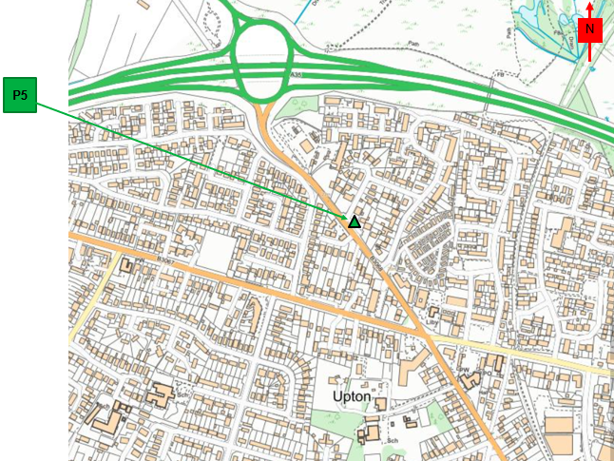
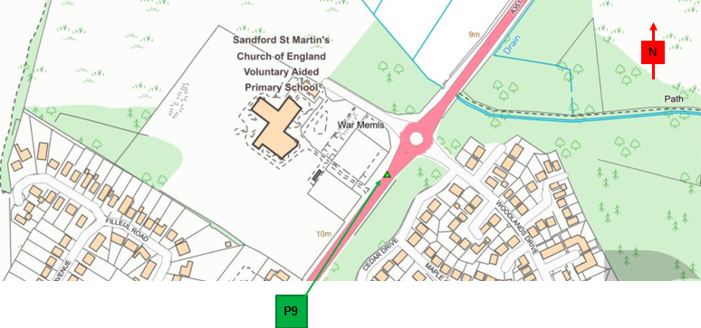
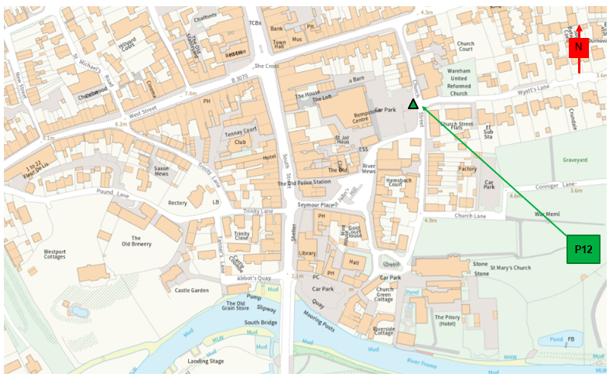
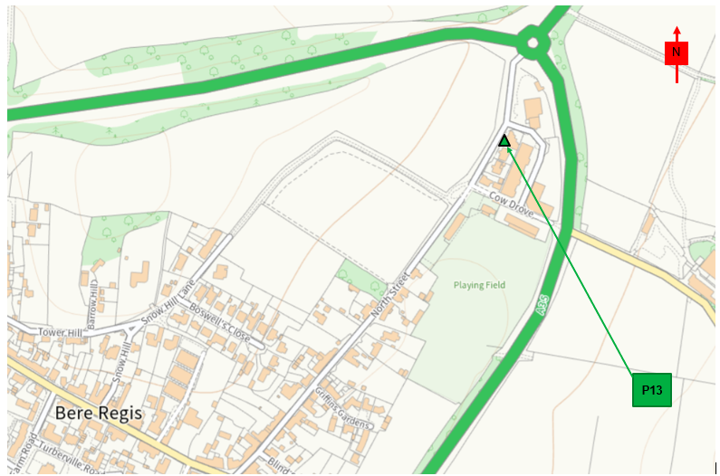
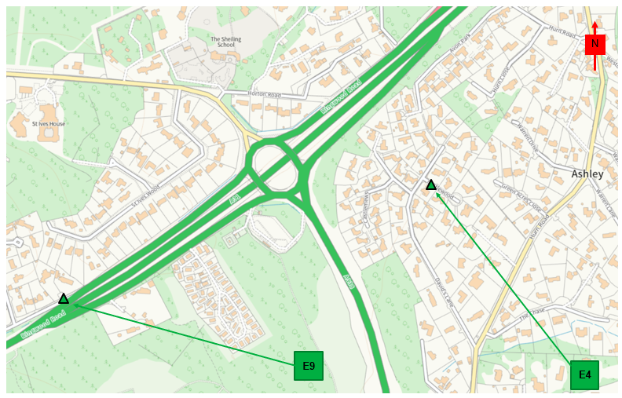
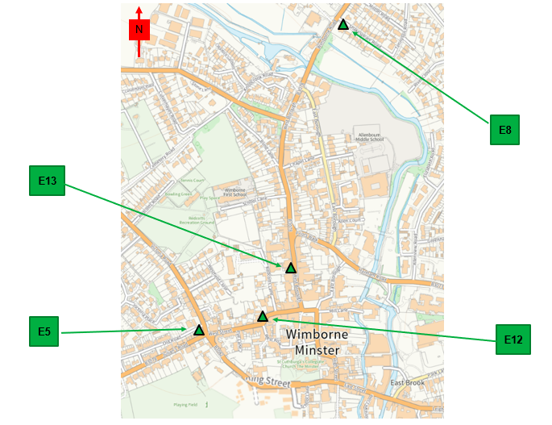
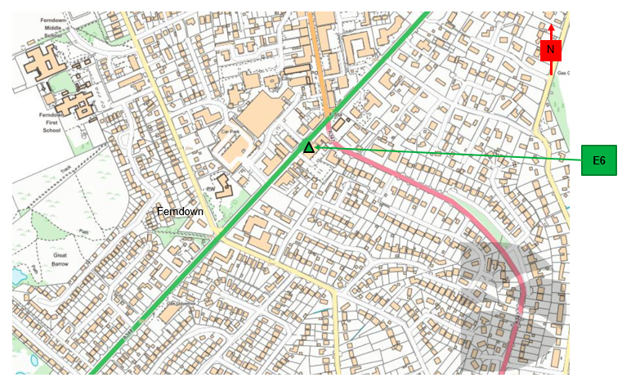
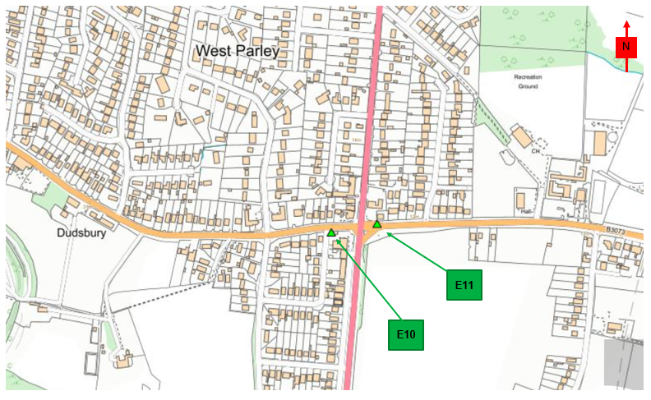
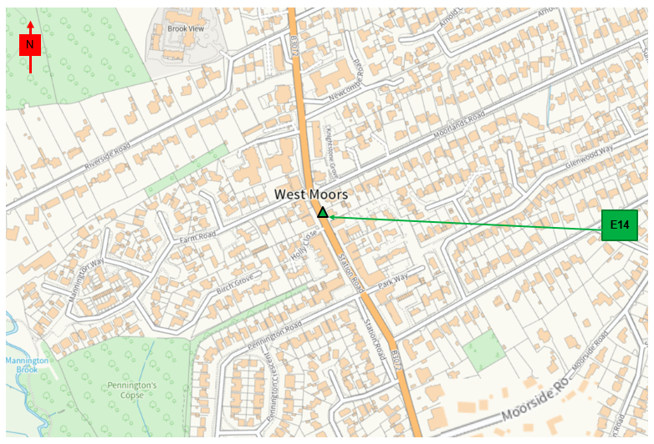
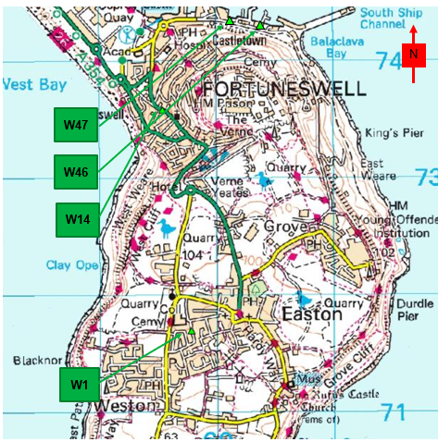
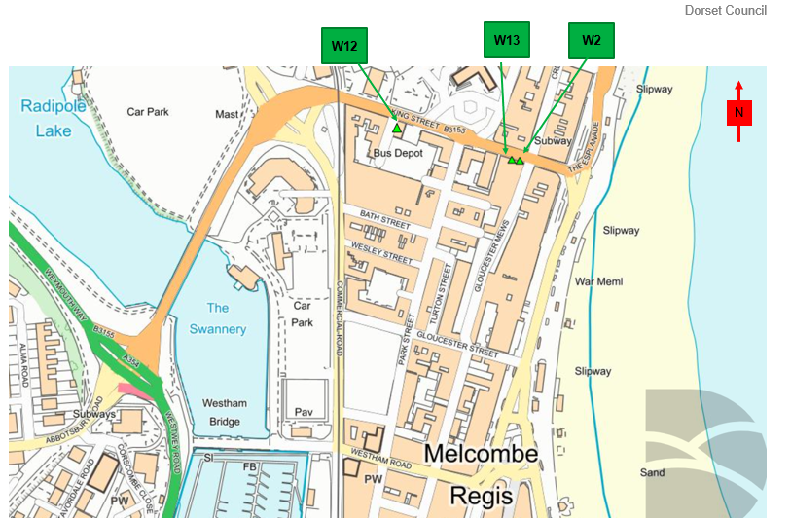
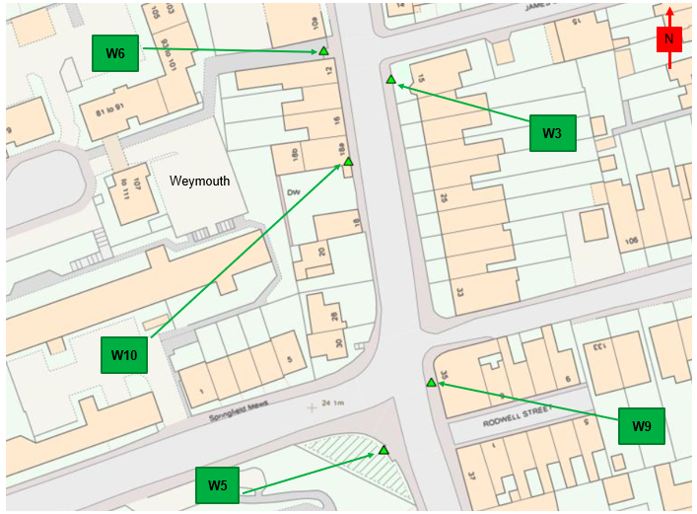
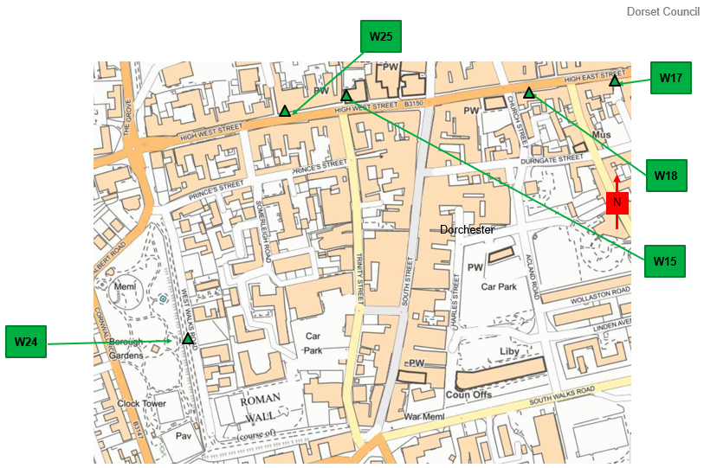
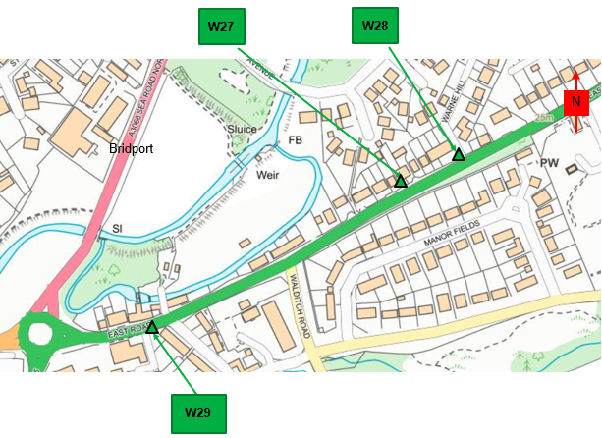
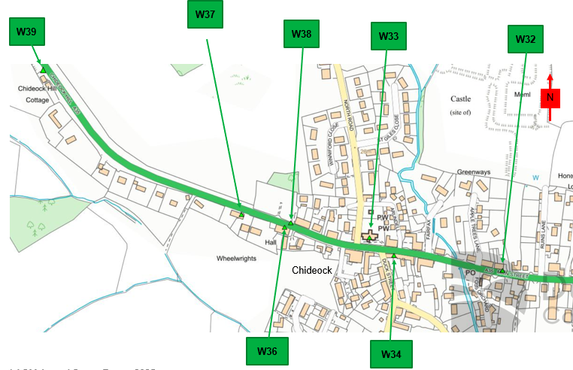
W48
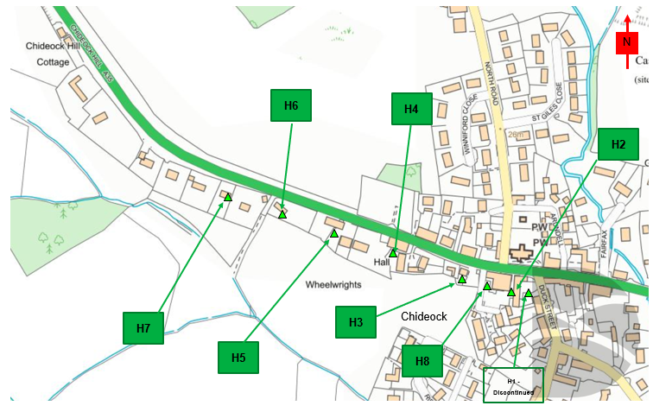
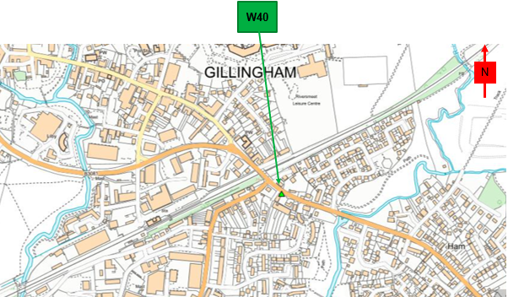
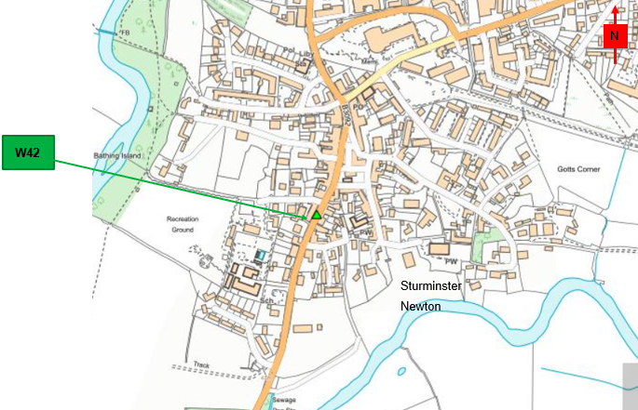

Figure D.2 – Map of AQMAs
AQMA Chideock 2007 Boundary
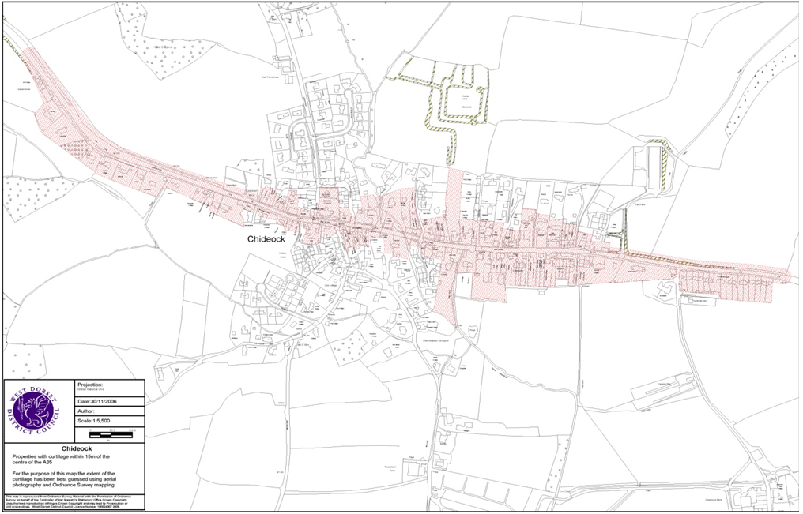
N

AQMA Chideock 2012 Amended Boundary
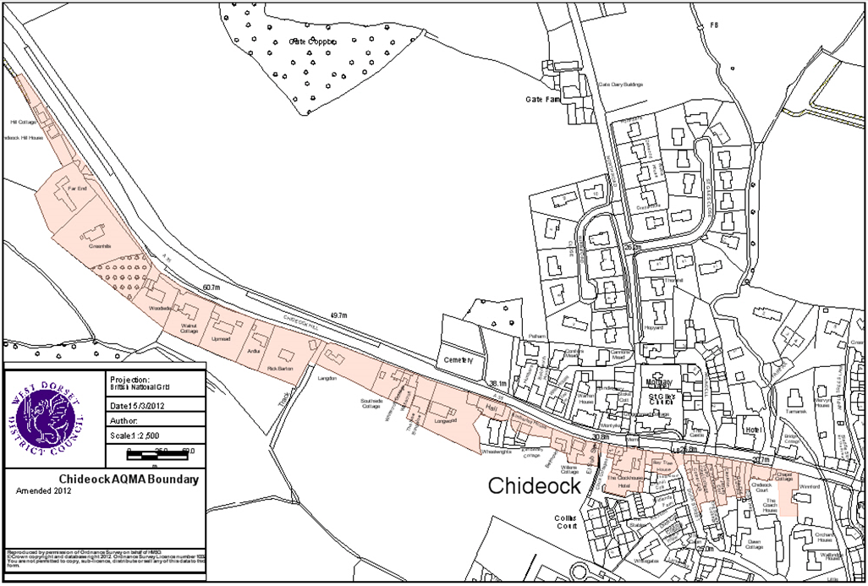
N

Appendix E: Summary of Air Quality Objectives in England
Table E.1 – Air Quality Objectives in England
Pollutant | Air Quality Objective: Concentration | Air Quality Objective: Measured as
Nitrogen Dioxide (NO₂) | 200µg/m³ not to be exceeded more than 18 times a year | 1-hour mean
Nitrogen Dioxide (NO₂) | 40µg/m³ | Annual mean
Particulate Matter (PM₁₀) | 50µg/m³, not to be exceeded more than 35 times a year | 24-hour mean
Particulate Matter (PM₁₀) | 40µg/m³ | Annual mean
Sulphur Dioxide (SO₂) | 350µg/m³, not to be exceeded more than 24 times a year | 1-hour mean
Sulphur Dioxide (SO₂) | 125µg/m³, not to be exceeded more than 3 times a year | 24-hour mean
Sulphur Dioxide (SO₂) | 266µg/m³, not to be exceeded more than 35 times a year | 15-minute mean

Glossary of Terms
Abbreviation | Description
AQAP | Air Quality Action Plan - A detailed description of measures, outcomes, achievement dates and implementation methods, showing how the local authority intends to achieve air quality limit values’
AQMA | Air Quality Management Area – An area where air pollutant concentrations exceed / are likely to exceed the relevant air quality objectives. AQMAs are declared for specific pollutants and objectives
ASR | Annual Status Report
Defra | Department for Environment, Food and Rural Affairs
DMRB | Design Manual for Roads and Bridges – Air quality screening tool produced by National Highways
LAQM | Local Air Quality Management
NO₂ | Nitrogen Dioxide
NO_{x} | Nitrogen Oxides
PM₁₀ | Airborne particulate matter with an aerodynamic diameter of 10µm or less
PM_{2.5} | Airborne particulate matter with an aerodynamic diameter of 2.5µm or less
QA/QC | Quality Assurance and Quality Control
SO₂ | Sulphur Dioxide

References
- Local Air Quality Management Technical Guidance LAQM.TG22. August 2022. Published by Defra in partnership with the Scottish Government, Welsh Assembly Government and Department of the Environment Northern Ireland.
- Local Air Quality Management Policy Guidance LAQM.PG22. August 2022. Published by Defra in partnership with the Scottish Government, Welsh Assembly Government and Department of the Environment Northern Ireland.
- Chemical hazards and poisons report: Issue 28. June 2022. Published by UK Health Security Agency
- Air Quality Strategy – Framework for Local Authority Delivery. August 2023. Published by Defra.

Defra. Air Quality Strategy – Framework for Local Authority Delivery, August 2023
The units are in microgrammes of pollutant per cubic metre of air (µg/m³).

