**Dorset Council**

**Employment Check**

**System User Guide – ID Verifier**

**(Updated April 2019)**

**Your role and other types of users**

There are a number of roles available in the Employment Check system which allow Dorset Council as an employer to complete the DBS check process.

**Business Unit Admin (BUA)**

* creates and amends applications for DBS checks
* completes applications on behalf of an individual (if required)
* run reports
* view current status of the application

**Applicant**

* will be sent access details after the BUA has created the application in the system (unless BUA is completing on their behalf)

**ID Verifier (IDV)**

* validates the ID documents provided by the applicant
* completes online checks for assigned applications
* can only view applications assigned to them

**Countersignatory - HR only role**

* authorises eBulk submission of the form to the DBS

**Super Admin - HR only role**

* full access to the system, including set up

Before you are granted access to the system you are required to access the DBS modules via [**www.dorsetcouncil.gov.uk/dbs-training**](http://www.dorsetcouncil.gov.uk/dbs-training)

You are required to complete the relevant modules and assessments for your role in the DBS process:

|  |  |  |  |
| --- | --- | --- | --- |
|  | Your role: | Business Unit Administrator | ID Verifier |
| Modules required | DBS policy and procedures | 🗸*  certificate required | 🗸*  certificate required |
| Business Unit Administrator | 🗸  certificate required |  |
| ID verification |  | 🗸  certificate required |

🗸* pre-requisite for completing the other required modules – you need to complete these modules first

You are required to submit copies of your certificates of completion and the DBS Employment Check system user acceptance statement to the relevant HR and Payroll Support team via the email address below:

For schools and external customers staff: [hrdbsteam@dorsetcouncil.gov.uk](mailto:hrdbsteam@dorsetcouncil.gov.uk)

For Dorset Council and Tricuro staff: [hrandpayrollsupport@dorsetcc.gov.uk](mailto:hrandpayrollsupport@dorsetcc.gov.uk)

Your HR and Payroll Support team will provide details of your user name and password via email address to enable you to log into the system.

**Accessing the system**

Once you have your log in information you can access the home page of Dorset Council’s criminal record checking facility using the web address:

<https://dorsetcc.employmentcheck.org.uk/>

The system performs best in Google Chrome.

**Logging onto the system**

3.1 To log on to the employment check system, click “Login” on the Home Page menu, and enter the username and password provided.

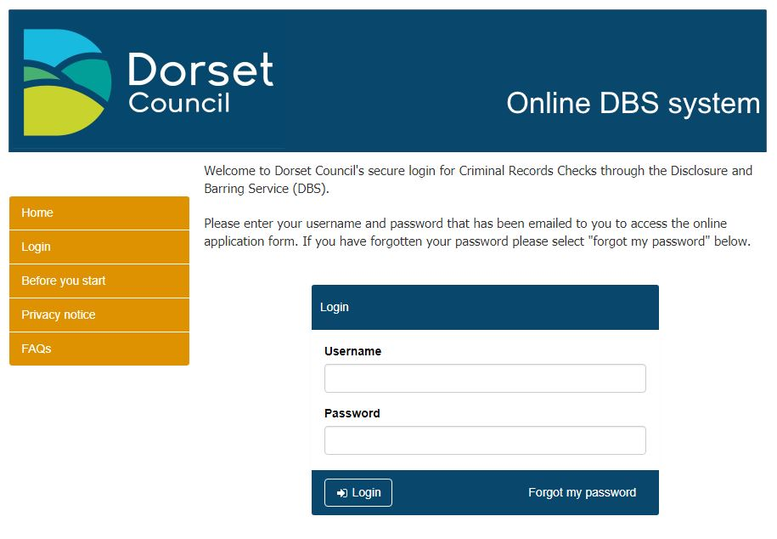

* + 1. Dorset Council has specified terms and conditions of use by BU Admins and ID Verifiers, you will be required to agree to these in order to access your account.

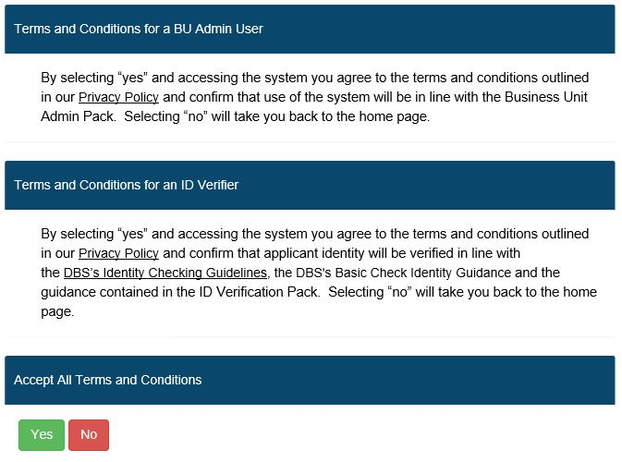

* 1. **Forgotten passwords**
     1. If you have forgotten your password, you should click the “Forgot my password” link on the Login screen. You will then be prompted to enter your username, and click on “Request a reset”. You will then receive an email with a secure link enabling you to access the system in order to change your password.
     2. If a password is entered incorrectly three times, your access will be revoked, and you will need to use the “Forgot my password” option to generate an email to your account with a secure link to access the system to change your password.

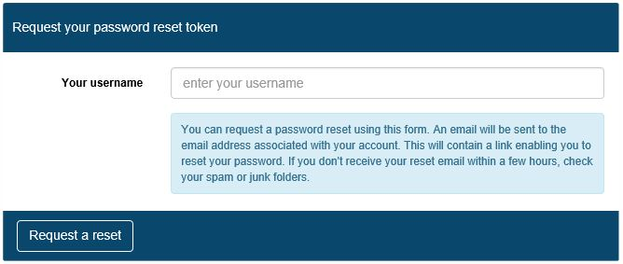

* + 1. BU Admins and HR and Payroll Support users can also reset applicant passwords manually, by selecting the “Manage Applications” option, searching the individuals name and clicking on the pencil icon.

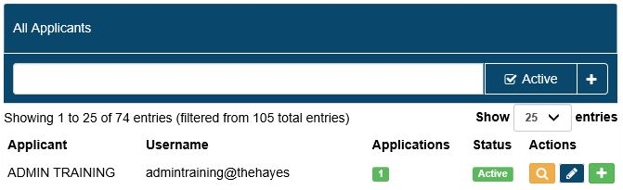

* + 1. They should then amend the details as required and click on “Save”. Please

note that if an applicant has locked themselves out of their account, the

administrator would also need to uncheck the “Access revoked” box at this stage.

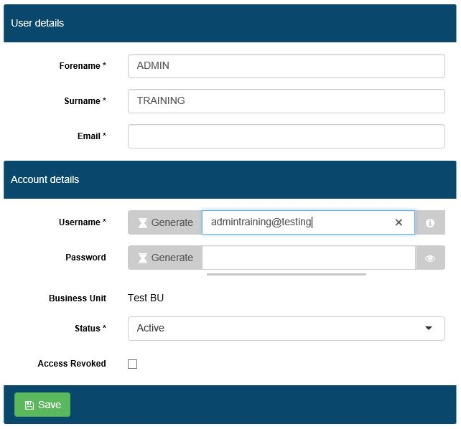

* 1. **Account activation/deactivation**
     1. User accounts are automatically deactivated after six months of inactivity. Once an ID Verifier account becomes inactive it can only be reactivated by a BU Admin or HR and Payroll Support user. BU Admin level accounts can be reactivated by an HR and Payroll Support user. For applicants who have been deactivated, the system will automatically reactivate them when a new check is created.
     2. User accounts may also be manually activated/deactivated by system administrators, as summarised below:

|  |  |  |
| --- | --- | --- |
| **User type** | **User types who can activate / deactivate these accounts** | **How to activate / deactivate accounts** |
| Applicant | BU Admin (for ID Verifiers for the Business Unit to which the BU Admin is attached) | Search for the applicant under the “Manage Applications” section and click the  icon. If you scroll to the bottom, you can then archive the application using the “Application status” dropdown on the edit screen. |
| ID Verifier | BU Admin (for ID Verifiers for the Business Unit to which the BU Admin is attached) | Search for the ID verifier under the “Manager ID Verifiers” section and click on the  icon to edit the account. You can tick/untick the “Access Revoked” box in order to activate/deactivate the account and then click “Save ID Verifier”. |

* 1. **Editing your account details**
     1. All users can edit their own password and contact email address using the “My Account” menu option.

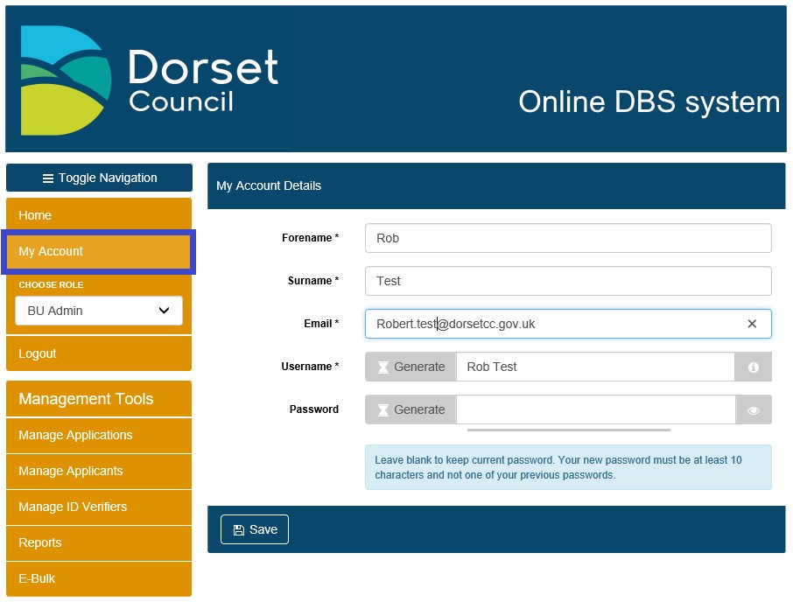

* + 1. Passwords must be at least ten characters long and contain characters from three of the following four categories:

1. English uppercase characters (A through Z)

2. English lowercase characters (a through z)

3. Numeric 10 digits (0 through 9)

Selecting “Show Password” will display the password entered

* 1. **Logging out of the system**
     1. To log out of the system, simply click on “Logout” on the left hand menu.
  2. **Guidance on symbols used**
     1. The following symbols are used throughout the system to denote the various statuses that applications go through:

|  |  |  |
| --- | --- | --- |
| **Symbol** | **Status** | **Description of Status** |
| [https://ekhuft.employmentcheck.org.uk/images/status/waiting.png](https://ekhuft.employmentcheck.org.uk/admin/secure/?status=2) | Waiting for Applicant to Fill in Details | Once an applicant account has been created the application status changes to “Waiting for Applicant to Fill in Details”. It remains in this status until the applicant submits their form or the application is manually moved by a BU Admin, Admin+ or Admincs user. |
| [https://ekhuft.employmentcheck.org.uk/images/status/awaiting_id_verification.png](https://ekhuft.employmentcheck.org.uk/admin/secure/?status=12) | Awaiting ID Verification | When the applicant finishes their section of the form an email gets sent to the assigned ID Verifier asking them to check the ID for that applicant. Until this is completed (or the record is manually moved by a BU Admin, Admin+ or Admincs user) the application sits in Awaiting ID Verification status. |
| [https://ekhuft.employmentcheck.org.uk/images/status/completed.png](https://ekhuft.employmentcheck.org.uk/admin/secure/?status=3) | Ready for eBulk Processing | This status is used for holding applications ready for countersigning, until the counter signatory sends them via secure eBulk to the DBS. |
| [https://www.employmentcheck.org.uk/images/status/submitted.png](https://www.employmentcheck.org.uk/admin/secure/?status=4) | Application Submitted via eBulk | Submitted applications move into this status until a receipt confirming that the DBS have the application has been obtained at which point the status changes to Received by DBS. |
| [https://ekhuft.employmentcheck.org.uk/images/status/received_by_crb.png](https://ekhuft.employmentcheck.org.uk/admin/secure/?status=5) | Received by DBS | This status confirms that the DBS have successfully received an application. The DBS check sits in this status until the results are returned from DBS. Within this status you can track the progress of checks against the various stages of the DBS process. |
| [https://ekhuft.employmentcheck.org.uk/images/status/result_received.png](https://ekhuft.employmentcheck.org.uk/admin/secure/?status=11) | Result Received from DBS | Disclosure results are received electronically and display in this status. A paper copy of the disclosure certificate is also sent to the individual applicant. If the disclosure is clear an email is automatically generated to the manager to notify them that the disclosure has been returned.  Any disclosure with additional information will be flagged with a “**P**” and a note to say “Please wait to view applicant certificate”. |
| [https://ekhuft.employmentcheck.org.uk/images/status/archive.png](https://ekhuft.employmentcheck.org.uk/admin/secure/?status=13) | Application Archived | Once a recruitment decision has been made or a check cancelled, the application can be archived. Once done, the system will automatically purge any confidential information after 6 months in line with DBS requirements. |
| [https://ekhuft.employmentcheck.org.uk/images/status/holding.png](https://ekhuft.employmentcheck.org.uk/admin/secure/?status=19) | Holding | This status is used to pause applications for example in cases where an applicant is on long term leave and the check should be requested upon their return. Applications in this status will no longer receive any automated reminder emails. Applications can be moved here via the edit screen and eBulk menus by BU Admin, Admin+ and Admincs users. |
| [https://ekhuft.employmentcheck.org.uk/images/status/in_progress.png](https://ekhuft.employmentcheck.org.uk/admin/secure/?status=8) | In Process with DBS | This status is for hardcopy application forms where applicants cannot get access to a PC. Applications may be placed here until the hardcopy results are returned, to ensure these records are included in reporting. |
| [https://ekhuft.employmentcheck.org.uk/images/status/error.png](https://ekhuft.employmentcheck.org.uk/admin/secure/?status=20) | Error | This status displays applications that have been rejected by the DBS. The error code describes the reason for rejection. Applications in this status generally require action from an Admincs user before the check can be resubmitted to the DBS. |

* + 1. Additionally, the following symbols are used throughout the system to indicate common functions:

|  |  |
| --- | --- |
| **Symbol** | **Description** |
|  | Add/Expand |
|  | Edit |
|  | History log |
|  | Tool tip |
|  | Preview |
|  | Clone |
|  | History |
|  | Assign |
|  | Logs |
|  | View |

1. **ID Verification**

4.1 After the applicant submits their application the assigned ID Verifier will receive an email asking them to log on to the system and enter the ID details for the applicant which they will either have checked and copied at interview stage or have available by completing this process with the applicant present. A hard copy record of the ID documents should be used if the applicant is not present with you when you complete the online validation – see appendix A.

4.2 The link on the email will take them to the login screen where they will need to enter their username and password to access the system.

4.3 ID Verifiers are asked to complete the ID verification within a specified period.

In the event that this is not completed within the stated timescales, automated reminder e-mails will be sent by the system to the ID Verifier after 5 days.

* 1. Logging onto the system will bring up the administration panel, as shown below. Please note that the menu options visible will reflect the permissions associated with the type of administrative user account as detailed in section 1 above.
  2. You can change between your assigned roles using the drop down to ‘choose role’, where you have more than one role. Choosing the ID Verifier role shows you all pending applications assigned to you. You can also reach this from the “Pending Applications” menu option.

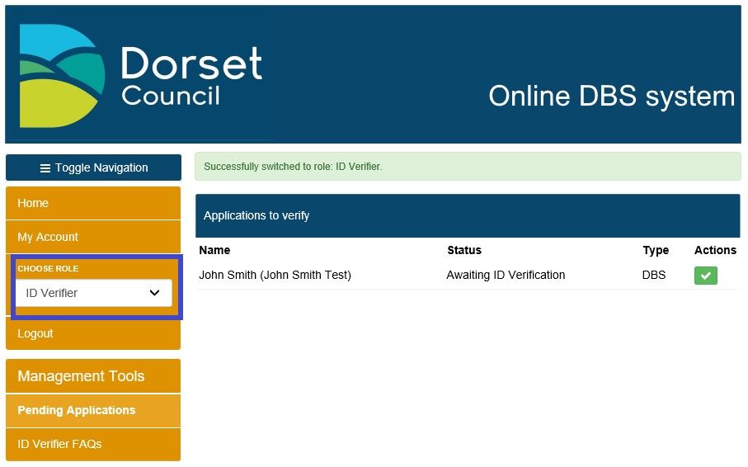

4.6 This will display a list of those applicants for whom ID verification is outstanding. They will then need to click on “approve” (denoted by a green tick), which will then take them to the next screen to complete the ID verification.

4.7 The next screen provides a preview of the details the applicant has already entered to allow the ID Verifier to verify the ID against this information.

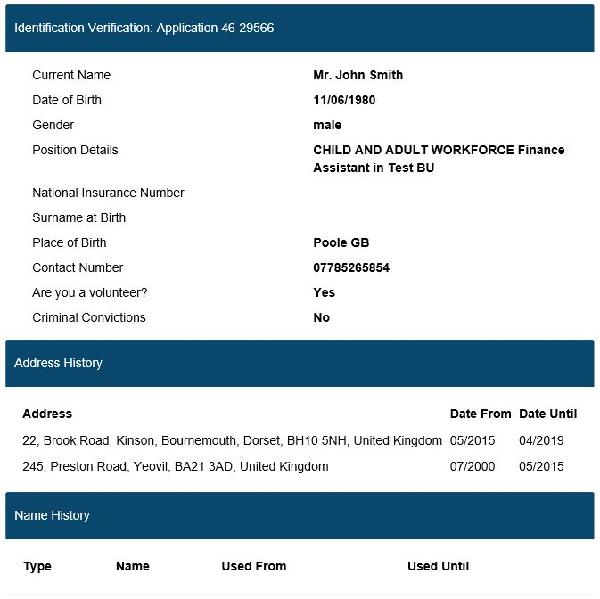

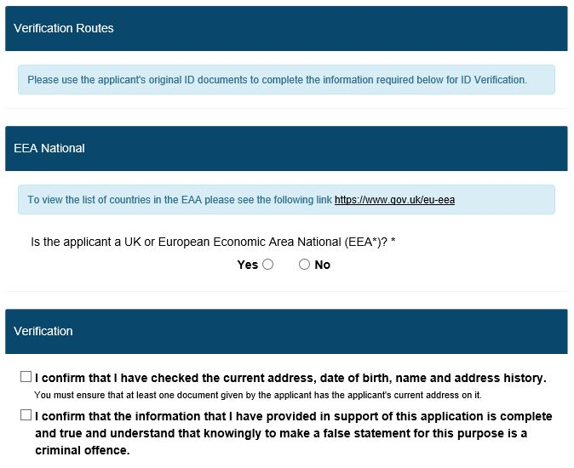

4.8 In the first instance the ID Verifier will be prompted to select ID to meet Route One from the appropriate groups. At the top of the page, you will see a banner, showing which route you are currently on and what ID combination is required for that particular route. This will change as you move through the different routes:



4.9 To proceed through Route 1 the question that produces a list of ID options is about whether the individual is a UK or EEA national.

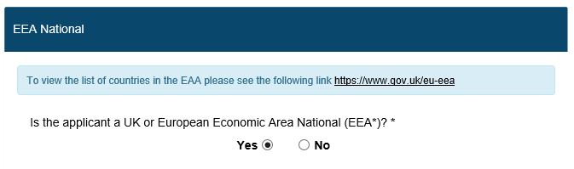

4.10 Answering yes shows information about which document is in which group, and by clicking the tool tip  next to certain fields, it will provide additional information e.g. how old a particular document can be in order to be considered valid for ID verification purposes.

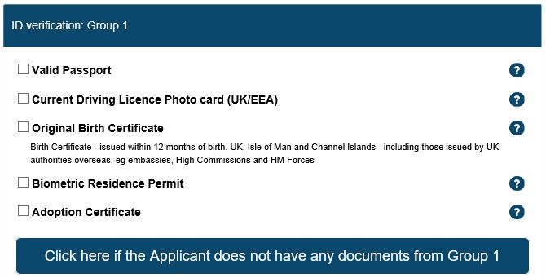

4.11 Note that for some types of ID e.g. passport, driver’s licence and birth certificates, the field will expand prompting the verifier to provide additional information e.g. date of issue, as shown below. Please note that when prompted to select a date a calendar will appear.

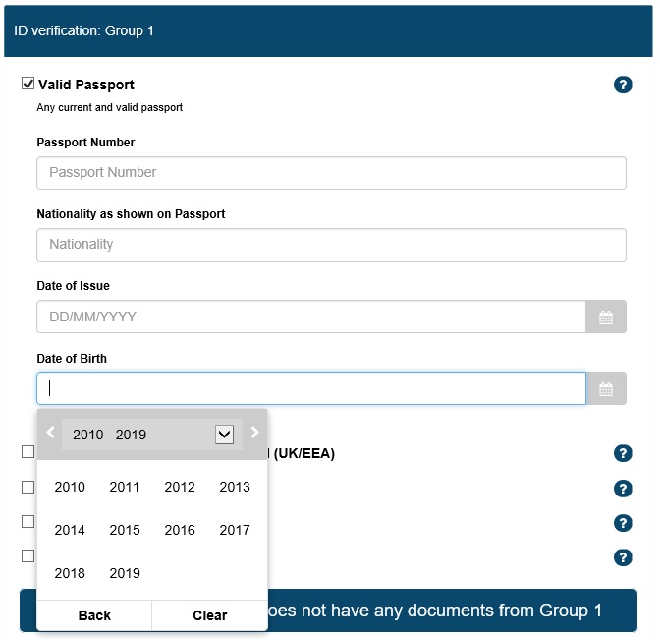

**5 System Validation**

5.1 The system will validate certain information from ID documents. E.g. it will check that the driving licence number is valid, including checks against names, gender and date of birth. This is similar to the passport and date of birth validation which ensures the same date of birth has been used throughout. The system validates that the correct number and type of documents (Group 1 and Group 2a and b) are entered. However, these system checks must be supplemented by checks undertaken by the ID Verifier who is responsible for ensuring that all original documents are manually checked to ensure their validity.

5.2 The system cannot recognise some data entry which may be made in error such as words or letters being entered in data fields where no entry is required? e.g. ‘NONE’, ‘N/A’, ‘X’ etc. or multiple entries being incorrectly made in the same field. It is the responsibility of the ID Verifier to ensure that no such data is entered.

5.3 Once sufficient ID has been provided, a note will appear at the top of the documentation list confirming this and the system will grey out other options, preventing you from selecting additional ID as shown below.

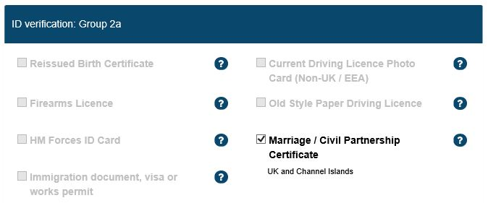

5.4 If the applicant cannot provide sufficient ID to meet Route One, the ID Verifier should select the button “Click here if the applicant does not have any documents from Group 1”.



Upon selecting this, this will then display the relevant ID groups for Route Two.

5.5 Route Two additionally requires the ID Verifier to complete an external ID verification check, by clicking the “Verify Identity” button. You must contact your HR and Payroll Support Team who will undertake the external ID verification check. The HR and Payroll Support Team will inform the ID Verifier of the result. If the external ID verification check is not undertaken by the HR and Payroll Support team the application will not be countersigned or submitted to the DBS. This will cause the application to be delayed.

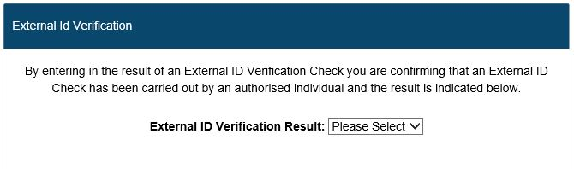

***MC900432658[1] TOP TIP – We strongly advise that you check that the applicant is able to provide sufficient ID for Route One before undertaking an external ID check.***

5.6 The ID verifier is informed of a pass or fail result. If they get a pass, they will be able to proceed down route 2. In the event that they get a fail, or the applicant cannot provide enough ID for Route Two, the applicant will need to move onto Route Three, please see below at 5.10.

5.7 Should the ID Verifier wish to return to a previous route, they can do so by selecting the route under the current ID selection. Please note that moving to a different route will remove data entered for the previous route and that if the result of Route 2 was a fail, you will not be able to go back to this route.

5.8 Once the requirements for a particular route have been met, the ID Verifier needs to confirm that they have checked the current address of the applicant and tick the declaration to confirm that the information provided in support of the application is complete and true before being able to submit the application.

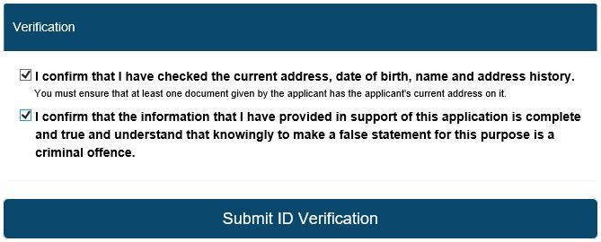

5.9 Once the ID verification has been completed, the ID Verifier should click on “Submit ID verification”. This will send the completed form to countersignatories for secure submission via e-bulk to the DBS. A message will appear onscreen to confirm this has been successful.



5.10 If the applicant has not met the requirements of Route 1 and 2 and failed the

external ID validation, the HR and Payroll Support team are required to speak to the applicant before Route 3 can be used. Following this conversation, which HR and Payroll Support will inform you of the outcome, you can choose switch to Route 3.

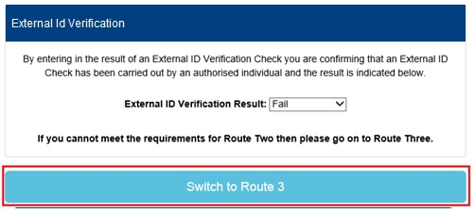

5.11 You are required to confirm the documents the applicant has produced for your inspection and tick the declarations and click submit ID verification.



5.12 The application will then be transmitted by the HR and Payroll Support team to the DBS by the Ebulk system. HR and Payroll Support will be alerted to the completed application therefore you don’t need to let them know that the application is ready to be transmitted.

5.13 Individuals with the Business Unit Admin role will be able to view the status of the DBS check, please see section 6 of the BU Admin guidance for the ‘Next steps’ in the process.

**5.14 Non-UK EU Applicants – foreign language assistants**

Non-UK EU applicants, for example foreign language assistants, should provide a current passport as part of their identification documents. If they are travelling with an EU national ID card and do not have a passport with them or a UK driving licence, biometric residence permit or UK birth certificate, they will not be able to progress down Route One. If they have not long lived in the UK then it is probable they will fail the external ID validation part of Route Two. It is unlikely they will be able to progress down Route Three as this requires a UK birth certificate. In these circumstances the applicant will be required to complete a paper form and attend a police station for finger printing. Please contact the HR and Payroll Support team for further guidance.

|  |  |
| --- | --- |
| **Employee identity checking form** |  |

Last updated April 2019 OFFICIAL

APPENDIX A

|  |  |  |  |  |  |  |  |  |  |  |  |  |  |  |  |  |  |  |  |  |  |  |  |  |  |  |  |  |  |  |  |  |  |  |  |  |  |  |  |  |  |  |  |  |  |  |  |  |  |  |
| --- | --- | --- | --- | --- | --- | --- | --- | --- | --- | --- | --- | --- | --- | --- | --- | --- | --- | --- | --- | --- | --- | --- | --- | --- | --- | --- | --- | --- | --- | --- | --- | --- | --- | --- | --- | --- | --- | --- | --- | --- | --- | --- | --- | --- | --- | --- | --- | --- | --- | --- |
|  |  | | | | | | | | | | | | | | | | | | | | | | | | | | | | | | | | | | | | | | | | | | | | | | | | |  |
|  | Managers are required to complete section A for **ALL** applicants and section B for applicants requiring a DBS disclosure check. | | | | | | | | | | | | | | | | | | | | | | | | | | | | | | | | | | | | | | | | | | | | | | | | |  |
|  |  | | | | | | | | | | | | | | | | | | | | | | | | | | | | | | | | | | | | | | | | | | | | | | | | |  |
|  |  | | | | | | | | | | | | | | | | | | | | | | | | | | | | | | | | | | | | | | | | | | | | | | | | |  |
|  |  | | | | | | | | | | | | | | | | | | | | | | | | | | | | | | | | | | | | | | | | | | | | | | | | |  |
|  | **Applicant details** | | | | | | | | | | | | | | | | | | | | | | | | | | | | | | | | | | | | | | | | | | | | | | | | |  |
|  | Full name of applicant | | | | | | | | | | | | |  | | | | | | | | | | | | | | | | | | | | | | | | | | | | | | | | | |  | |  |
|  |  | | | | | | | | | | | | | | |  | | | | | | | | | | | | | | | | | | | | | | | | | | | | | | | |  | |  |
|  | Post applied for | | | | | | | | | | | | |  | | | | | | | | | | | | | | | | | | | | | | | | | | | | | | | | | |  | |  |
|  |  | | | | | | | | | | | | | | |  | | | | | | | | | | | | | | | | | | | | | | | | | | | | | | | |  | |  |
|  | Position no. | | | | | | | | | | | | |  | | | | | | | | | | | | | |  | | | | | | | | | | | | | | | | | | | | | |  |
|  |  | | | | | | | | | | | | | | |  | | | | | | | | | | | |  | | | | | | | | | | | | | | | | | | | | | |  |
|  | Date of interview | | | | | | | | | | | | |  | | | | | | | | | | | | | |  | | | | | | | | | | | | | | | | | | | | | |  |
|  |  | | | | | | | | | | | | | | | | | | | | | | | | | | | | | | | | | | | | | | | | | | | | | | | | |  |
|  |  | | | | | | | | | | | | | | | | | | | | | | | | | | | | | | | | | | | | | | | | | | | | | | | | |  |
|  |  | | | | | | | | | | | | | | | | | | | | | | | | | | | | | | | | | | | | | | | | | | | | | | | | |  |
|  | **Section A – Right to work in the United Kingdom** | | | | | | | | | | | | | | | | | | | | | | | | | | | | | | | | | | | | | | | | | | | | | | | | |  |
|  | All documents submitted by the applicant to demonstrate their eligibility to work in the United Kingdom must be photocopied, signed and dated by the recruiting manager. All documents to be forwarded to the HR&OD Recruitment team for retention on personal files. | | | | | | | | | | | | | | | | | | | | | | | | | | | | | | | | | | | | | | | | | | | | | | | | |  |
|  |  | | | | | | | | | | | | | | | | | | | | | | | | | | | | | | | | | | | | | | | | | | | | | | | | |  |
|  |  | | | | | | | | | | | | | | | | | | | | | | | | | | | | | | | | | | | | | | | | | | | | | | | | |  |
|  |  | | | | | | | | | | | | | | | | | | | | | | | | | | | | | | | | | | | | | | | | | | | | | | | | |  |
|  | **Passport details** | | | | | | | | | | | | | | | | | | | | | | | | | | | | | | | | | | | | | | | | | | | | | | | | |  |
|  | Passport no. | | | |  | | | | | | | | | | | | | | | | | | | | | |  | | | | Issue date | | | | | | | | |  | | | | | | | |  | |  |
|  |  | | | | | | | | | | | | | | |  | | | | | | | | | | | | | | | | | | | | | | | | | | | | | | | |  | |  |
|  | Nationality | | | |  | | | | | | | | | | | | | | | | | | | | | |  | | | | Date of birth | | | | | | | | |  | | | | | | | |  | |  |
|  | If the applicant cannot or does not produce a valid passport, please request identification from list A or B (see https://intranet.dorsetcouncil.gov.uk/task/right-to-work-in-the-uk). Attach signed and dated photocopies to this form and record the documents produced below: | | | | | | | | | | | | | | | | | | | | | | | | | | | | | | | | | | | | | | | | | | | | | | | | |  |
|  | Document seen (1) | | | | | | | |  | | | | | | | | | | | | | | | | | | | | | | | | | | | | | | | | | | | | | | |  | |  |
|  |  | | | | | | | | | | | | | | |  | | | | | | | | | | | | | | | | | | | | | | | | | | | | | | | |  | |  |
|  | Document seen (2) | | | | | | | |  | | | | | | | | | | | | | | | | | | | | | | | | | | | | | | | | | | | | | | |  | |  |
|  |  | | | | | | | | | | | | | | | | | | | | | | | | | | | | | | | | | | | | | | | | | | | | | | | | |  |
|  |  | | | | | | | | | | | | | | | | | | | | | | | | | | | | | | | | | | | | | | | | | | | | | | | | |  |
|  |  | | | | | | | | | | | | | | | | | | | | | | | | | | | | | | | | | | | | | | | | | | | | | | | | |  |
|  | **Section B – DBS disclosure check** | | | | | | | | | | | | | | | | | | | | | | | | | | | | | | | | | | | | | | | | | | | | | | | | |  |
|  | Please only complete this section if the post the applicant has applied for requires a DBS disclosure check. Please note that if you have already completed passport details, this will also be used to verify checks for DBS disclosure applications. To apply for a criminal records check evidence of identity to meet either route 1 or 2 is required. **Route 1** **-** One document from group 1, plus two documents from either group 1, 2a or 2b one of which must verify current address. **Route 2 -** If the applicant cannot produce any document from group 1, check one document from group 2a, two further documents from group 2a or 2b one of which must verify their current address. Identity checks via route 2 will require external identity validation. In all cases please record the information directly from the original document. Please note that if the person’s identity documents are not in the applicant’s current name, official evidence of the name change (marriage certificate or deed poll evidence, etc.) should be seen and recorded. If using route 2 please attach copies of all documents seen. | | | | | | | | | | | | | | | | | | | | | | | | | | | | | | | | | | | | | | | | | | | | | | | | |  |
|  |  | | | | | | | | | | | | | | | | | | | | | | | | | | | | | | | | | | | | | | | | | | | | | | | | |  |
|  |  | | | | | | | | | | | | | | | | | | | | | | | | | | | | | | | | | | | | | | | | | | | | | | | | |  |
|  |  | | | | | | | | | | | | | | | | | | | | | | | | | | | | | | | | | | | | | | | | | | | | | | | | |  |
|  | **Driving licence details** | | | | | | | | | | | | | | | | | | | | | | | | | | | | | | | | | | | | | | | | | | | | | | | | |  |
|  | Driving licence no. | | | | | | |  | | | | | | | | | | | | | | | | | | |  | | | | Valid from | | | | | | | | |  | | | | | | | |  | |  |
|  |  | | | | | | | | | | | | | | |  | | | | | | | | | | | | | | | | | | | | | | | | | | | | | | | |  | |  |
|  | Country of issue | | | | | | |  | | | | | | | | | | | | | | | | | | |  | | | | Date of birth | | | | | | | | |  | | | | | | | |  | |  |
|  |  | | | | | | | | | | | | | | |  | | | | | | | | | | | | | | | | | | | | | | | | | | | | | | | |  | |  |
|  | Is it a photographic driving licence? | | | | | | | | | | | | | | | | | | | | | | | | | | | | | | | | | | | | | | | | | | Yes |  |  | No |  |  | |  |
|  |  | | | | | | | | | | | | | | | | | | | | | | | | | | | | | | | | | | | | | | | | | |  | | | | |  | |  |
|  |  | | | | | | | | | | | | | | | | | | | | | | | | | | | | | | | | | | | | | | | | | |  | | | | |  | |  |
|  |  | | | | | | | | | | | | | | |  | | | | | | | | | | | | | | | | | | | | | | | | | | | | | | | |  | |  |
|  | Address on the driving licence: | | | | |  | | | | | | | | | | | | | | | | | | | | | | | | | | | | | | | | | | | | | | | | | |  | |  |
|  |  | | | | | | | | | | | | | | | | | | | | | | | | | | | | | | | | | | | | | | | | | | | | | | |  | |  |
|  | Other comments | | | | |  | | | | | | | | | | | | | | | | | | | | | | | | | | | | | | | | | | | | | | | | | |  | |  |
|  |  | | | | | | | | | | | | | | | | | | | | | | | | | | | | | | | | | | | | | | | | | | | | | | | | |  |
|  |  | | | | | | | | | | | | | | | | | | | | | | | | | | | | | | | | | | | | | | | | | | | | | | | | |  |
|  |  | | | | | | | | | | | | | | | | | | | | | | | | | | | | | | | | | | | | | | | | | | | | | | | | |  |
|  | **One proof of address** | | | | | | | | | | | | | | | | | | | | | | | | | | | | | | | | | | | | | | | | | | | | | | | | |  |
|  | e.g. recent utility bill (UK), credit card statement (UK or EEA only), bank or mortgage statement (UK or EEA only) **Note mobile telephone bills or documents printed from the internet are not acceptable** | | | | | | | | | | | | | | | | | | | | | | | | | | | | | | | | | | | | | | | | | | | | | | | | |  |
|  |  | | | | | | | | | | | | | | |  | | | | | | | | | | | | | | | | | | | | | | | | | | | | | | | | |  |  |
|  | Type of document seen | | | | | | | | | |  | | | | | | | | | | | | | | | | | | | | |  | | Document date | | | | | | |  | | | | | | | |  |  |
|  |  | | | | | | | | | | | | | | | | | | | | | | | | | | | | | | | | | | | | | | | | | | | | | | | | |  |
|  | Recorded address: | | | | | | | | | |  | | | | | | | | | | | | | | | | | | | | | | | | | | | | | |  | | | | | | | |  |  |
|  | (including postcode) | | | | | | | | | |  | | | | | | | | | | | | | | | | | | | | | | | | | | | | | |  | | | | | | | |  |  |
|  |  | | | | | | | | | | | | | | | | | | | | | | | | | | | | | | | | | | | | | | | | | | | | | | | | |  |
|  |  | | | | | | | | | | | | | | | | | | | | | | | | | | | | | | | | | | | | | | | | | | | | | | | | |  |
|  |  | | | | | | | | | | | | | | | | | | | | | | | | | | | | | | | | | | | | | | | | | | | | | | | | |  |
|  | **Birth/adoption certificate details** | | | | | | | | | | | | | | | | | | | | | | | | | | | | | | | | | | | | | | | | | | | | | | | | |  |
|  |  | | | | | | | | | | | | | | | | | | | | | | | | | | | | | | | | | | | | | | | | | | | | | | | | |  |
|  | Place of birth | | | | | | | | | | |  | | | | | | | | | | | | | | | | | | | | |  | | | Date of birth | | | | | |  | | | | | |  | |  |
|  |  | | | | | | | | | | | | | | | | | | | | | | | | | | | | | | | | | | | | | | | | | | | | | | | | |  |
|  | Country of issue | | | | | | | | | | |  | | | | | | | | | | | | | | | | | | | | |  | | | Date of issue | | | | | |  | | | | | |  | |  |
|  |  | | | | | | | | | | | | | | | | | | | | | | | | | | | | | | | | | | | | | | | | | | | | | | | | |  |
|  |  | | | | | | | | | | | | | | | | | | | | | | | | | | | | | | | | | | | | | | | | | | | | | | | | |  |
|  |  | | | | | | | | | | | | | | | | | | | | | | | | | | | | | | | | | | | | | | | | | | | | | | | | |  |
|  |  | | | | | | | | | | | | | | | | | | | | | | | | | | | | | | | | | | | | | | | | | | | | | | | | |  |
|  | **Evidence of name change (If identity documents are not in the applicant’s current name)** | | | | | | | | | | | | | | | | | | | | | | | | | | | | | | | | | | | | | | | | | | | | | | | | |  |
|  | Marriage certificate | | | | | |  | | | |  | | Deed Poll | | | | |  |  | Other | | |  | |  | | | | | | | | | | | | | | | | | | | | | | | | |  |
|  |  | | | | | | | | | | | | | | |  | | | | | | | | | | | | | | | | | | | | | | | | | | | | | | | |  | |  |
|  |  | | If other, please specify: | | | | | | | | | | | | | |  | | | | | | | | | | | | | | | | | | | | | | | | | | | | | | |  | |  |
|  |  | | | | | | | | | | | | | | |  | | | | | | | | | | | | | | | | | | | | | | | | | | | | | | | |  | |  |
|  | Previous full name | | | | | | | | |  | | | | | | | | | | | | | | | | | | | | | | | | | | | | | | | | | | | | | |  | |  |
|  |  | | | | | | | | | | | | | | |  | | | | | | | | | | | | | | | | | | | | | | | | | | | | | | | |  | |  |
|  | New full name | | | | | | | | |  | | | | | | | | | | | | | | | | | | | | | | | | | | | | | | | | | | | | | |  | |  |
|  |  | | | | | | | | | | | | | | |  | | | | | | | | | | | | | | | | | | | | | | | | | | | | | | | |  | |  |
|  | Date of name change | | | | | | | | |  | | | | | | | | | | | | | | | | | |  | | | | | | | | | | | | | | | | | | | | | |  |
|  |  | | | | | | | | | | | | | | | | | | | | | | | | | | | | | | | | | | | | | | | | | | | | | | | | |  |
|  |  | | | | | | | | | | | | | | | | | | | | | | | | | | | | | | | | | | | | | | | | | | | | | | | | |  |
|  |  | | | | | | | | | | | | | | | | | | | | | | | | | | | | | | | | | | | | | | | | | | | | | | | | |  |
|  | **Please place a tick against all original documents seen and checked**  **Group 1 – Primary trusted identity credentials** | | | | | | | | | | | | | | | | | | | | | | | | | | | | | | | | | | | | | | | | | | | | | | | | |  |
|  |  | | | | | | | | | | | | | | | | | | | | | | | | | | | | | | | | | | | | | | | | | | | | | | | | |  |
|  |  | | | | | | | | | | | | | | | | | | | | | | | | | | | | | | | | | | | | | | | | | | | | | | | | |  |
|  |  | | | | | | | | | | | | | | | | | | | | | | | | | | | | | | | | | | | | | | | | | | | | | | | | |  |
|  |  | Current valid passport | | | | | | | | | | | | | | | | | | | | | |  | | Biometric residence permit (UK) | | | | | | | | | | | | | | | | | | | | | | | |  |
|  |  | | | | | | | | | | | | | | | | | | | | | | | | | | | | | | | | | | | | | | | | | | | | | | | | |  |
|  |  | Current photocard driving licence - (UK/Isle of Man/Channel Islands and EU (full or provisional) | | | | | | | | | | | | | | | | | | | | | |  | | Birth certificate (UK and Channel Islands) – issued within 12 months of date of birth; full or short form acceptable including those issued by UK authorities overseas, such as Embassies, High Commissions and HM Forces | | | | | | | | | | | | | | | | | | | | | | | |  |
|  |  |  | | | | | | | | | | | | | | | | | | | | | |  | |  | | | | | | | | | | | | | | | | | | | | | | | |  |
|  |  | Adoption certificate (UK and Channel Islands) | | | | | | | | | | | | | | | | | | | | | |  | |  | | | | | | | | | | | | | | | | | | | | | | | |  |
|  |  | | | | | | | | | | | | | | | | | | | | | | | | | | | | | | | | | | | | | | | | | | | | | | | | |  |
|  | **Group 2a – Trusted government/state issued documents** | | | | | | | | | | | | | | | | | | | | | | | | | | | | | | | | | | | | | | | | | | | | | | | | |  |
|  |  | | | | | | | | | | | | | | | | | | | | | | | | | | | | | | | | | | | | | | | | | | | | | | | | |  |
|  |  | Birth certificate (UK, Isle of man and Channel Islands) – issued after time of birth | | | | | | | | | | | | | | | | | | | | | |  | | Marriage/civil partnership certificate (UK/Channel Islands) | | | | | | | | | | | | | | | | | | | | | | | |  |
|  |  | | | | | | | | | | | | | | | | | | | | | | | | | | | | | | | | | | | | | | | | | | | | | | | | |  |
|  |  | Current paper driving licence (full or provisional) (If issued before 1998) - UK/Isle of Man/Channel Islands and EEA | | | | | | | | | | | | | | | | | | | | | |  | | Current photocard driving licence (full or provisional) All countries outside of EEA (excluding Isle of Man and Channel Islands) | | | | | | | | | | | | | | | | | | | | | | | |  |
|  |  | | | | | | | | | | | | | | | | | | | | | | | | | | | | | | | | | | | | | | | | | | | | | | | | |  |
|  |  | Firearms Licence (UK, Channel Islands & Isle of Man) | | | | | | | | | | | | | | | | | | | | | |  | | HM Forces ID card (UK) | | | | | | | | | | | | | | | | | | | | | | | |  |
| c  c  c | | | | | | | | | | | | | | | | | | | | | | | | | | | | | | | | | | | | | | | | | | | | | | | | | |  |
|  |  | Immigration document/work permit/visa issued by a country outside the EEA. Valid only for roles where applicant is living & working outside of the UK. Visa/permit must relate to the non EEA country in which the role is based.  c  c | | | | | | | | | | | | | | | | | | | | | | | | | | | | | | | | | | | | | | | | | | | | | | | |  |
|  |  | | | | | | | | | | | | | | | | | | | | | | | | | | | | | | | | | | | | | | | | | | | | | | | | |  |
|  | **Group 2b – Financial/social history documents** | | | | | | | | | | | | | | | | | | | | | | | | | | | | | | | | | | | | | | | | | | | | | | | | |  |
|  |  | | | | | | | | | | | | | | | | | | | | | | | | | | | | | | | | | | | | | | | | | | | | | | | | |  |
|  |  | Mortgage statement (UK or EEA ) ** | | | | | | | | | | | | | | | | | | | | | |  | | Benefit statement (UK) e.g. child benefit, pension * | | | | | | | | | | | | | | | | | | | | | | | |  |
|  |  | | | | | | | | | | | | | | | | | | | | | | | | | | | | | | | | | | | | | | | | | | | | | | | | |  |
|  |  | Credit card statement (UK or EEA ) * | | | | | | | | | | | | | | | | | | | | | |  | | Financial statement **-e.g. pension endowment (UK) | | | | | | | | | | | | | | | | | | | | | | | |  |
|  |  | | | | | | | | | | | | | | | | | | | | | | | | | | | | | | | | | | | | | | | | | | | | | | | | |  |
|  |  | P45/P60 statement ** (UK and Channel Islands) | | | | | | | | | | | | | | | | | | | | | |  | | Council tax statement ** (UK and Channel Islands) | | | | | | | | | | | | | | | | | | | | | | | |  |
|  |  | | | | | | | | | | | | | | | | | | | | | | | | | | | | | | | | | | | | | | | | | | | | | | | | |  |
|  |  | Bank/building society account opening confirmation letter (UK) Issued in the last 3 months | | | | | | | | | | | | | | | | | | | | | |  | | Utility bill (UK) * - not mobile telephone | | | | | | | | | | | | | | | | | | | | | | | |  |
|  |  | | | | | | | | | | | | | | | | | | | | | | | | | | | | | | | | | | | | | | | | | | | | | | | | |  |
|  |  | Benefit statement * - e.g. child allowance, pension | | | | | | | | | | | | | | | | | | | | | |  | | EEA national ID card – Must still be valid | | | | | | | | | | | | | | | | | | | | | | | |  |
|  |  | | | | | | | | | | | | | | | | | | | | | | | | | | | | | | | | | | | | | | | | | | | | | | | | |  |
|  |  | Bank/building society statement (UK, Channel Islands or EEA) If outside EEA, branch must be in the country where the applicant lives & works* | | | | | | | | | | | | | | | | | | | | | |  | | Cards carrying the PASS accreditation logo (UK, Isle of Man and Channel Islands) Must still be valid | | | | | | | | | | | | | | | | | | | | | | | |  |
|  |  | | | | | | | | | | | | | | | | | | | | | | | | | | | | | | | | | | | | | | | | | | | | | | | | |  |
|  |  | Letter from headteacher or college principal (UK 16 to 19 year olds in full time education) (only in exceptional circumstances when no other documents can be used) Must still be valid. | | | | | | | | | | | | | | | | | | | | | |  | | Letter of sponsorship from future employment provider (non UK) Non EEA only – if residing outside of the UK at time of application. Must still be valid. | | | | | | | | | | | | | | | | | | | | | | | |  |
|  |  |  | | | | | | | | | | | | | | | | | | | | | |  | |  | | | | | | | | | | | | | | | | | | | | | | | |  |
|  |  | | | | | | | | | | | | | | | | | | | | | | | | | | | | | | | | | | | | | | | | | | | | | | | | |  |
|  |  | A document from central/local government/government agency/local authority giving entitlement (UK and Channel Islands)*- e.g. from the Department for Work and Pensions, the Employment Service, HMRC. | | | | | | | | | | | | | | | | | | | | | | | | | | | | | | | | | | | | | | | | | | | | | | | |  |
|  |  |  | | | | | | | | | | | | | | | | | | | | | | | | | | | | | | | | | | | | | | | | | | | | | | | |  |
|  | **Please note - If a document in the list of valid identity documents is denoted with;**  * - it should be less than three months old ** - it should be issued within the past 12 months not denoted – it can be more than 12 months old | | | | | | | | | | | | | | | | | | | | | | | | | | | | | | | | | | | | | | | | | | | | | | | | |  |
|  |  | | | | | | | | | | | | | | | | | | | | | | | | | | | | | | | | | | | | | | | | | | | | | | | | |  |
|  |  | | | | | | | | | | | | | | | | | | | | | | | | | | | | | | | | | | | | | | | | | | | | | | | | |  |
|  |  | | | | | | | | | | | | | | | | | | | | | | | | | | | | | | | | | | | | | | | | | | | | | | | | |  |
|  |  | | | | | | | | | | | | | | | | | | | | | | | | | | | | | | | | | | | | | | | | | | | | | | | | |  |
|  | **Endorsement by ID verifier** | | | | | | | | | | | | | | | | | | | | | | | | | | | | | | | | | | | | | | | | | | | | | | | | |  |
|  | I certify that I have personally seen the originals of the documents detailed above, and that I am satisfied of their authenticity. I understand where section B is completed that this form will be used as evidence of identity for criminal records checking purposes. | | | | | | | | | | | | | | | | | | | | | | | | | | | | | | | | | | | | | | | | | | | | | | | | |  |
|  | Name (in BLOCK CAPITALS) | | | | | | | | | | | | | |  | | | | | | | | | | | | | | | | | | | | | | | | | | | | | | |  | | | |  |
|  |  | | | | | | | | | | | | | | |  | | | | | | | | | | | | |  | | | | | | | | | | | | | | | | | | | | |  |
|  | Signature | | |  | | | | | | | | | | | | | | | | | | | | | | | | |  | Date | | | | | | | |  | | | | | | | |  | | | |  |
|  |  | | | | | | | | | | | | | | |  | | | | | | | | | | | | |  | | | | | | | | | | | | | | | | | | | | |  |
|  | Please tick here if copy documents are attached | | | | | | | | | | | | | | | | | | | |  |  | | | | | | | | | | | | | | | | | | | | | | | | | | | |  |
|  | | | | | | | | | | | | | | | | | | | | | | | | | | | | | | | | | | | | | | | | | | | | | | | | | |  |
|  | **Note:** No written offer of employment will be made unless this form is fully and accurately completed. Inadequately completed forms will be referred back to the panel chairperson, which may cause delays in the appointment process. | | | | | | | | | | | | | | | | | | | | | | | | | | | | | | | | | | | | | | | | | | | | | | | | |  |
|  |  | | | | | | | | | | | | | | | | | | | | | | | | | | | | | | | | | | | | | | | | | | | | | | | | |  |
| **External Identity Validation Check - Applicant Consent** | | | | | | | | | | | | | | | | | | | | | | | | | | | | | | | | | | | | | | | | | | | | | | | | | | |
|  | | | | | | | | | | | | | | | | | | | | | | | | | | | | | | | | | | | | | | | | | | | | | | | | | | |
| I consent to Dorset Council undertaking a search with Experian for the purposes of verifying my identity. To do so Experian may check the details I supply against my particulars on any database (public or otherwise) to which they have access. Experian may also use my details in the future to assist other companies for verification purposes. I understand that a record of the search will be retained. | | | | | | | | | | | | | | | | | | | | | | | | | | | | | | | | | | | | | | | | | | | | | | | | | | |
|  | | | | | | | | | | | | | | | | | | | | | | | | | | | | | | | | | | | | | | | | | | | | | | | | | | |
| Signed | | | | | | | | |  | | | | | | | | | | | | | | | | | | | | | | | | | |  | | | | | | | | | | | | | | | |
|  | | | | | | | | | | | | | | | | | | | | | | | | | | | | | | | | | | | | | | | | | | | | | | | | | | |
| Name (please print) | | | | | | | | |  | | | | | | | | | | | | | | | | | | | | | | | | | |  | | Date | |  | | | | | | | | | | | |