**Dorset Council**

**Employment Check**

**System User Guide - Business Unit Administrator**

**(Updated April 2019)**

# Your role and other types of users

There are a number of roles available in the Employment Check system which allow Dorset Council as an employer to complete the DBS check process.

**Business Unit Admin (BUA)**

* creates and amends applications for DBS checks
* completes applications on behalf of an individual (if required)
* run reports
* view current status of the application

**Applicant**

* will be sent access details after the BUA has created the application in the system (unless BUA is completing on their behalf)

**ID Verifier (IDV)**

* validates the ID documents provided by the applicant
* completes online checks for assigned applications
* can only view applications assigned to them

**Countersignatory - HR only role**

* authorises eBulk submission of the form to the DBS

**Super Admin - HR only role**

* full access to the system, including set up

Before you are granted access to the system you are required to complete the DBS training on the Dorset council website [www.dorsetcouncil.gov.uk/dbs-training](http://www.dorsetcouncil.gov.uk/dbs-training)

You are required to complete the relevant modules and assessments for your role in the DBS process:

|  |  |  |  |  |
| --- | --- | --- | --- | --- |
|  | Your role: | Senior manager | Business Unit Administrator | ID Verifier |
| Modules required | DBS policy and procedures | 🗸 | 🗸\*  certificate required | 🗸\*  certificate required |
| Adding an applicant |  | 🗸  certificate required |  |
| Completing the application |  | 🗸 |  |
| ID verification |  |  | 🗸  certificate required |

🗸\* pre-requisite for completing the other required modules – you need to complete these modules first

You are required to submit copies of your certificates of completion and the DBS Employment Check system user acceptance statement to the relevant HR and Payroll Support team via the email address below:

For schools and external customers staff: [hrdbsteam@dorsetcouncil.gov.uk](mailto:hrdbsteam@dorsetcouncil.gov.uk)

For Dorset Council and Tricuro staff: [hrandpayrollsupport@dorsetcouncil.gov.uk](mailto:hrandpayrollsupport@dorsetcouncil.gov.uk)

Your HR and Payroll Support team will provide details of your user name and password via email address to enable you to log into the system.

# Accessing the system

Once you have your log in information you can access the home page of Dorset Council’s criminal record checking facility using the web address:

**<https://dorsetcc.employmentcheck.org.uk/>**

The system performs best in Google Chrome.

# Logging onto the system

3.1 To log on to the employment check system, click “Login” on the Home Page menu, and enter the username and password provided.

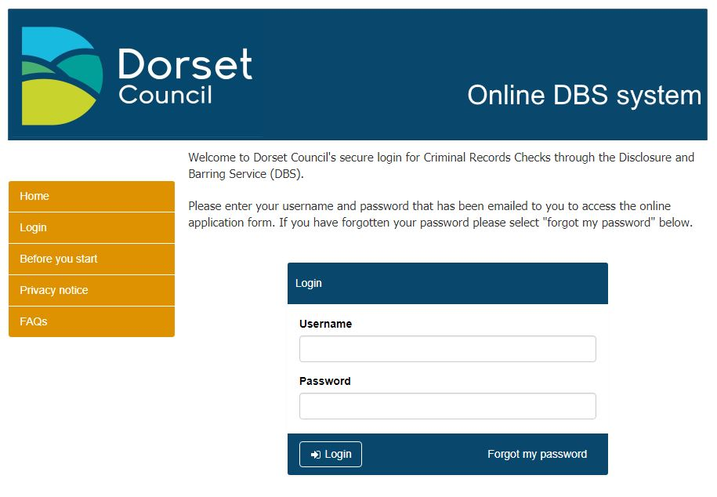

* + 1. Dorset Council has specified terms and conditions of use by BU Admins and ID Verifiers, you will be required to agree to these in order to access your account.

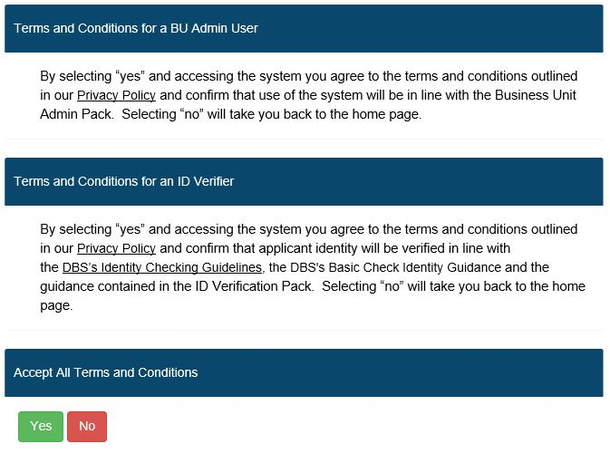

### Forgotten passwords

* + 1. If you have forgotten your password, you should click the “Forgot my password” link on the Login screen. You will then be prompted to enter your username, and click on “Request a reset”. You will then receive an email with a secure link enabling you to access the system in order to change your password.
    2. If a password is entered incorrectly three times, your access will be revoked, and you will need to use the “Forgot my password” option to generate an email to your account with a secure link to access the system to change your password.

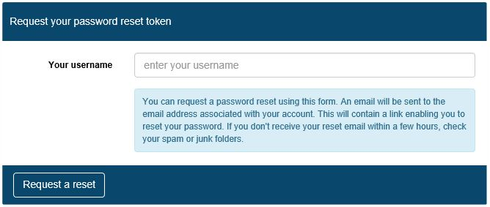

* + 1. BU Admins and HR and Payroll Support users can also reset applicant passwords manually, by selecting the “Manage Applications” option, searching the individuals name and clicking on the pencil icon.

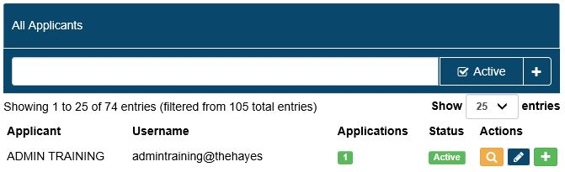

* + 1. They should then amend the details as required and click on “Save”. Please

note that if an applicant has locked themselves out of their account, the

administrator would also need to uncheck the “Access revoked” box at this stage.

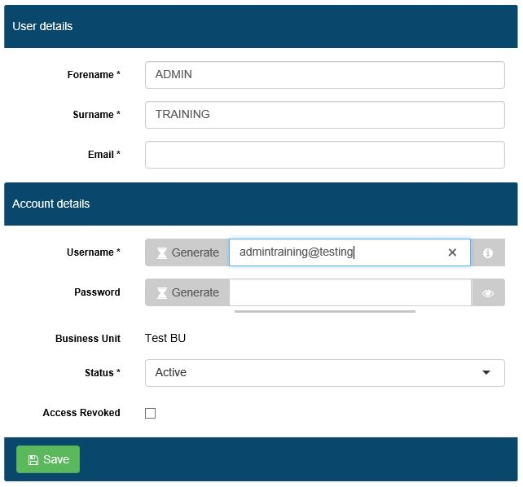

### Account activation/deactivation

* + 1. User accounts are automatically deactivated after six months of inactivity. Once an ID Verifier account becomes inactive it can only be reactivated by a BU Admin or HR and Payroll Support user. BU Admin level accounts can be reactivated by an HR and Payroll Support user. For applicants who have been deactivated, the system will automatically reactivate them when a new check is created.
    2. User accounts may also be manually activated/deactivated by system administrators, as summarised below:

|  |  |  |
| --- | --- | --- |
| **User type** | **User types who can activate / deactivate these accounts** | **How to activate / deactivate accounts** |
| Applicant | BU Admin (for ID Verifiers for the Business Unit to which the BU Admin is attached) | Search for the applicant under the “Manage Applications” section and click the  icon. If you scroll to the bottom, you can then archive the application using the “Application status” dropdown on the edit screen. |
| ID Verifier | BU Admin (for ID Verifiers for the Business Unit to which the BU Admin is attached) | Search for the ID verifier under the “Manager ID Verifiers” section and click on the  icon to edit the account. You can tick/untick the “Access Revoked” box in order to activate/deactivate the account and then click “Save ID Verifier”. |

### Editing your account details

* + 1. All users can edit their own password and contact email address using the “My Account” menu option.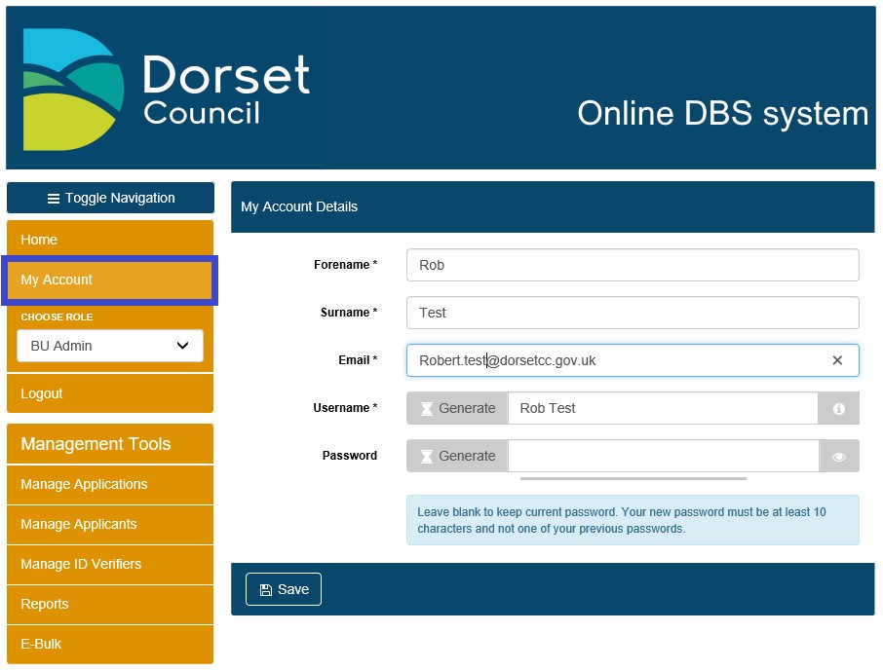
    2. Passwords must be at least ten characters long and contain characters from three of the following four categories:

1. English uppercase characters (A through Z)

2. English lowercase characters (a through z)

3. Numeric 10 digits (0 through 9)

Selecting “Show Password” will display the password entered

### Logging out of the system

* + 1. To log out of the system, simply click on “Logout” on the left hand menu.

### Guidance on symbols used

* + 1. The following symbols are used throughout the system to denote the various statuses that applications go through:

|  |  |  |
| --- | --- | --- |
| **Symbol** | **Status** | **Description of Status** |
| [https://ekhuft.employmentcheck.org.uk/images/status/waiting.png](https://ekhuft.employmentcheck.org.uk/admin/secure/?status=2) | Waiting for Applicant to Fill in Details | Once an applicant account has been created the application status changes to “Waiting for Applicant to Fill in Details”. It remains in this status until the applicant submits their form or the application is manually moved by a BU Admin, Admin+ or Admincs user. |
| [https://ekhuft.employmentcheck.org.uk/images/status/awaiting_id_verification.png](https://ekhuft.employmentcheck.org.uk/admin/secure/?status=12) | Awaiting ID Verification | When the applicant finishes their section of the form an email gets sent to the assigned ID Verifier asking them to check the ID for that applicant. Until this is completed (or the record is manually moved by a BU Admin, Admin+ or Admincs user) the application sits in Awaiting ID Verification status. |
| [https://ekhuft.employmentcheck.org.uk/images/status/completed.png](https://ekhuft.employmentcheck.org.uk/admin/secure/?status=3) | Ready for eBulk Processing | This status is used for holding applications ready for countersigning, until the counter signatory sends them via secure eBulk to the DBS. |
| [https://www.employmentcheck.org.uk/images/status/submitted.png](https://www.employmentcheck.org.uk/admin/secure/?status=4) | Application Submitted via eBulk | Submitted applications move into this status until a receipt confirming that the DBS have the application has been obtained at which point the status changes to Received by DBS. |
| [https://ekhuft.employmentcheck.org.uk/images/status/received_by_crb.png](https://ekhuft.employmentcheck.org.uk/admin/secure/?status=5) | Received by DBS | This status confirms that the DBS have successfully received an application. The DBS check sits in this status until the results are returned from DBS. Within this status you can track the progress of checks against the various stages of the DBS process. |
| [https://ekhuft.employmentcheck.org.uk/images/status/result_received.png](https://ekhuft.employmentcheck.org.uk/admin/secure/?status=11) | Result Received from DBS | Disclosure results are received electronically and display in this status. A paper copy of the disclosure certificate is also sent to the individual applicant. If the disclosure is clear an email is automatically generated to the manager to notify them that the disclosure has been returned.  Any disclosure with additional information will be flagged with a “**P**” and a note to say, “Please wait to view applicant certificate”. |
| [https://ekhuft.employmentcheck.org.uk/images/status/archive.png](https://ekhuft.employmentcheck.org.uk/admin/secure/?status=13) | Application Archived | Once a recruitment decision has been made or a check cancelled, the application can be archived. Once done, the system will automatically purge any confidential information after 6 months in line with DBS requirements. |
| [https://ekhuft.employmentcheck.org.uk/images/status/holding.png](https://ekhuft.employmentcheck.org.uk/admin/secure/?status=19) | Holding | This status is used to pause applications for example in cases where an applicant is on long term leave and the check should be requested upon their return. Applications in this status will no longer receive any automated reminder emails. Applications can be moved here via the edit screen and eBulk menus by BU Admin, Admin+ and Admincs users. |
| [https://ekhuft.employmentcheck.org.uk/images/status/in_progress.png](https://ekhuft.employmentcheck.org.uk/admin/secure/?status=8) | In Process with DBS | This status is for hardcopy application forms where applicants cannot get access to a PC. Applications may be placed here until the hardcopy results are returned, to ensure these records are included in reporting. |
| [https://ekhuft.employmentcheck.org.uk/images/status/error.png](https://ekhuft.employmentcheck.org.uk/admin/secure/?status=20) | Error | This status displays applications that have been rejected by the DBS. The error code describes the reason for rejection. Applications in this status generally require action from an Admincs user before the check can be resubmitted to the DBS. |

* + 1. Additionally, the following symbols are used throughout the system to indicate common functions:

|  |  |
| --- | --- |
| **Symbol** | **Description** |
|  | Add/Expand |
|  | Edit |
|  | History log |
|  | Tool tip |
|  | Preview |

|  |  |
| --- | --- |
| **Symbol** | **Description** |
|  | Clone |
|  | History |
|  | Assign |
|  | Logs |
|  | View |

# Disclosure applications

4.1 BU Admin users can set up disclosure applications on the system for applicants from the Business Unit to which the BU Admin is assigned. Only HR and Payroll Support colleagues are able to countersign and transmit eBulk applications.

4.1.1 Logging onto the system will bring up the administration panel, as shown below. Please note that the menu options visible will reflect the permissions associated with the type of administrative user account as detailed in section 1 above.

4.1.2 You can change between your assigned roles using the drop down to ‘choose role’, where you have more than one role.

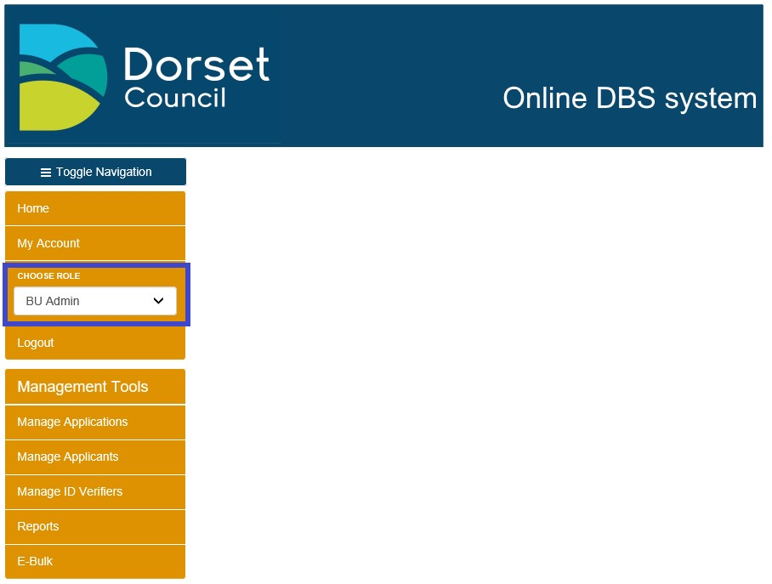

**4.2 Adding an applicant**

4.2.1 To start a new DBS disclosure application for someone who hasn’t been DBS checked by your Business Unit before, hover over “Manage Applications” on the left hand menu, then click “Create New Application” and then select “DBS Check”.

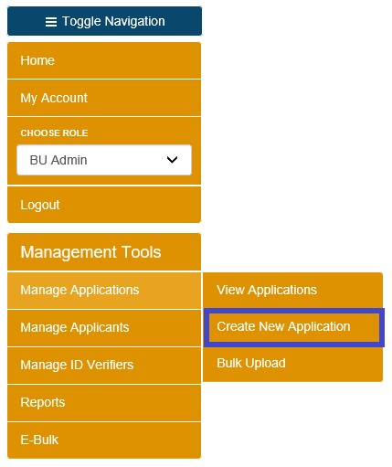

4.2.2 At this point you will be provided with the choice of creating a DBS check or a DBS basic check. Please see the guidance on SharePoint and Learning Online to determine which type of check is required before making this decision.

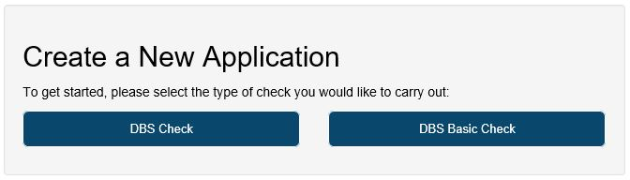

4.2.3 The screens for DBS check or DBS basic check are similar. Clicking on ‘**DBS check**’ will bring up a form as illustrated below at section 4.2.6.

4.2.4 To create a new application for someone who has been DBS checked by your Business Unit before, search for the applicant using the “Manage Applicants” tab on the left hand menu which will bring up a list of all applicants and search for the correct person by typing their name in the box.

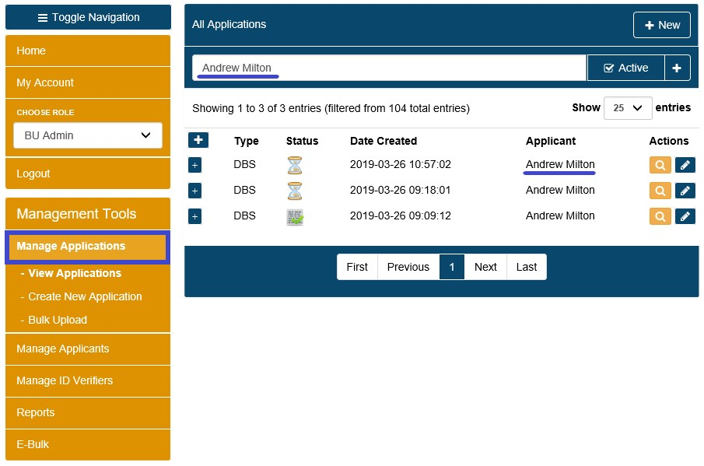

4.2.5 Click on their name in the list which will bring up the following screen and click the 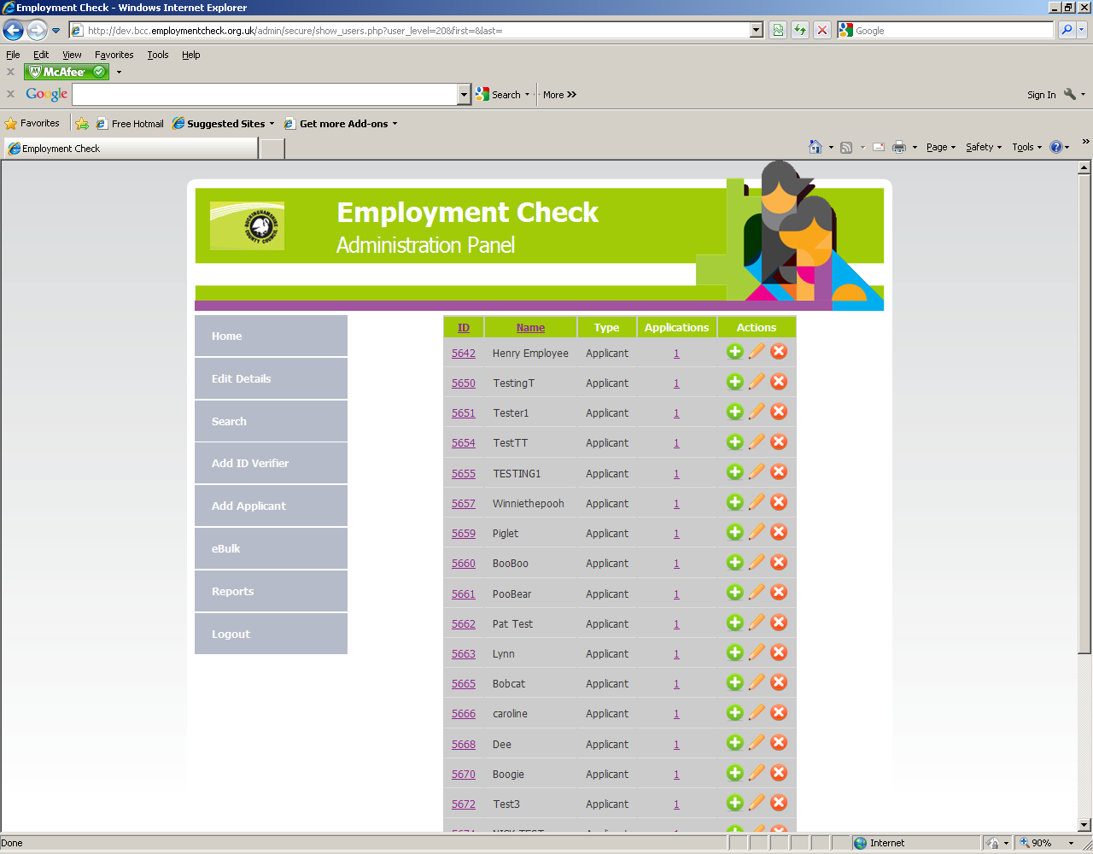 icon to add a new record for that applicant.

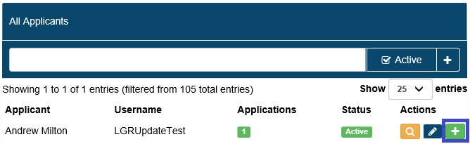

* + 1. This will bring up a form as illustrated below. You need to complete all of the mandatory fields (denoted with an \*) in order for the application to be created.

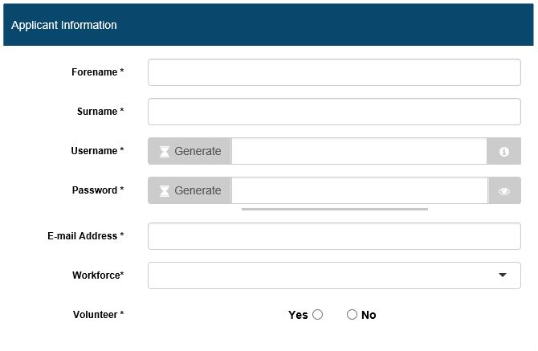

See note 2

See note 1

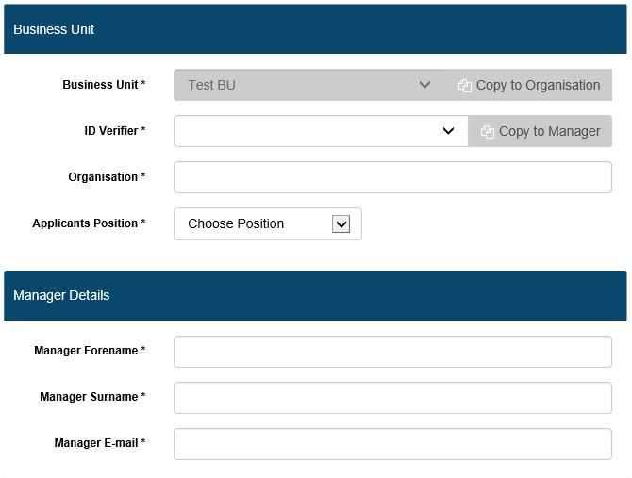

See note 3

See note 4

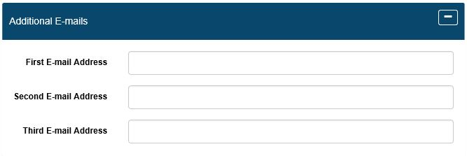

See note 5

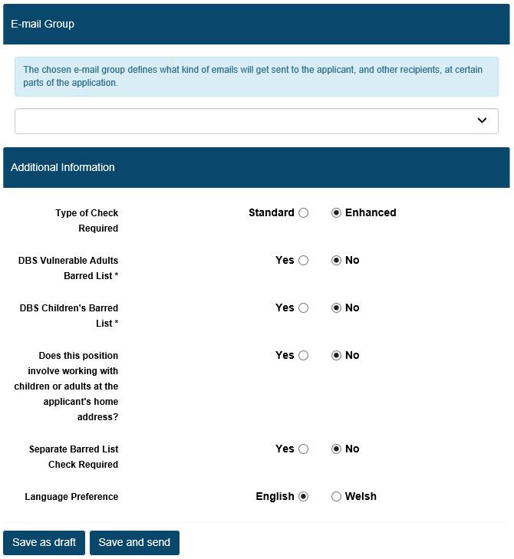

See note 7

See note 6

Note 1 - the format for creating an applicant’s user name should be the

applicants email address. If no email address is available then enter their

forename and surname followed by @BusinessUnit. If the applicant has been set up previously at a different business unit with their email address as their username, then you will have to use their email address followed by a number, e.g. [a.test@dorsetcc.gov.uk2](mailto:a.test@dorsetcc.gov.uk2), or you can use the generate username button.

When creating the password BU Administrators are advised to use the

generate function to generate a suitable password. Where an application is

to be completed on site immediately, please remember to click the ‘toggle password visibility’ icon  and make a note of the password generated.

If the individual is completing the required information themselves, their username and password will be sent to them at the email address provided.

Note 2 - the ‘workforce’ is a mandatory pre-populated drop down menu with the following options, Child Workforce, Adult Workforce, Child and Adult Workforce, Other Workforce. This entry will be added to that made in the ‘position’ field, described below, to make up the final position data submitted. This ensures the application is eligible for subscription to the DBS Update Service.

Note 3 - the “position” is selected from a drop-down menu. If you need a new position created, please speak to your HR & Payroll Support team, the email addresses are included at section 1.

Note 4 - the “Manager details” section details the individual who should be notified of the disclosure result. If this is the same person as the ID Verifier, you can check the box entitled “Copy to Manager”.

For “Organisation” (as it should appear on the disclosure certificate) please enter ‘Dorset Council’ for all DC applicants including foster carers, please enter ‘Tricuro’ for Tricuro applicants, for all other applicants it should be the same as the Business Unit, and you can click the box “Copy to Organisation” icon.

Please note that for checks set up by BU Admin users, the Business Unit will be fixed to the Business Unit to which the BU Admin is assigned. The list of ID Verifiers will also be limited to those assigned to the same Business Unit as the BU Admin. Additional ID Verifiers can be set up by the HR and Payroll Support team, please contact them if your Business Unit requires additional ID Verifiers. The HR and Payroll Support team will ensure that the necessary training is undertaken and issue system logins.

Note 5 - up to 3 additional email addresses (to the manager’s) can be added to notify of the result of the check. You should add the relevant HR and Payroll Support team’s email address to your applications to ensure they are informed of the result, otherwise the recruitment process may be delayed.

Note 6 - the section “Email Type” refers to the automated emails that the applicant, ID Verifier and BU Administrator will receive. It is important to correctly select the correct email type i.e. “New” for a new applicant, “Recheck” for applicants being rechecked, “Volunteer” for volunteers and “Basic” for basic checks.

Note 7 - the ‘working at applicant’s home’ option is linked to the type of application. For standard applications this will default to ‘No’, if the applicant is working from their own home (not a service user’s home) you must check ‘Yes’.

* + 1. Once all fields have been completed, click on “Save and Send”. A screen will appear to confirm that the applicant has been successfully set up. This process will also trigger an automated e-mail to the applicant in question, providing their log-in details.
    2. There is also the option “Save as Draft” should you wish to come back to the application and send this at a later date.

4.2.9 Hardcopy application forms

Where circumstances are such that it is not possible for applicants to complete their application form on-line then a hard copy application form may

be accepted. This should be kept to a minimum. Applicants should be asked

to complete a Hard copy Application Approval Form and submit this with their

application form. This gives permission for the BU Administrator to input the

hard copy details directly into the system. A copy is included at Appendix A.

### Completing the application form

* 1. Once an application has been set-up, the applicant will automatically

receive an automated email (where the email address has been provided) containing their login details and a link to the employment check website to enable them to complete their online application.

5.2 Logging in takes the applicant directly to the online application form as shown below. A Frequently Asked Questions (FAQ) guidance page is also available via the menu on the left hand side of the window.

* 1. If the BUA is completing the information on behalf of the individual after

meeting the requirements of the hardcopy application form (see section 4.2.9) they should use the username and password generated at 4.2.6 above and log in themselves.

5.4 To enter the required information, the applicant should click on ‘my applications’ which will bring up a list of DBS applications for themselves, and click on ‘complete’ next to the relevant application.

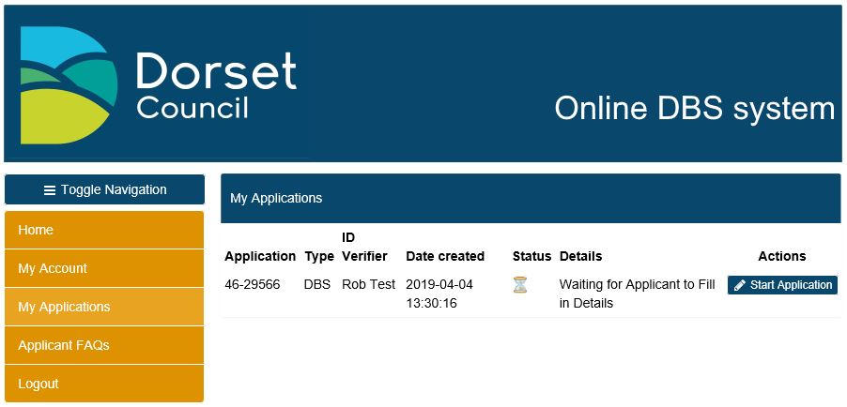

5.5 This brings up all the fields that are required to be completed.

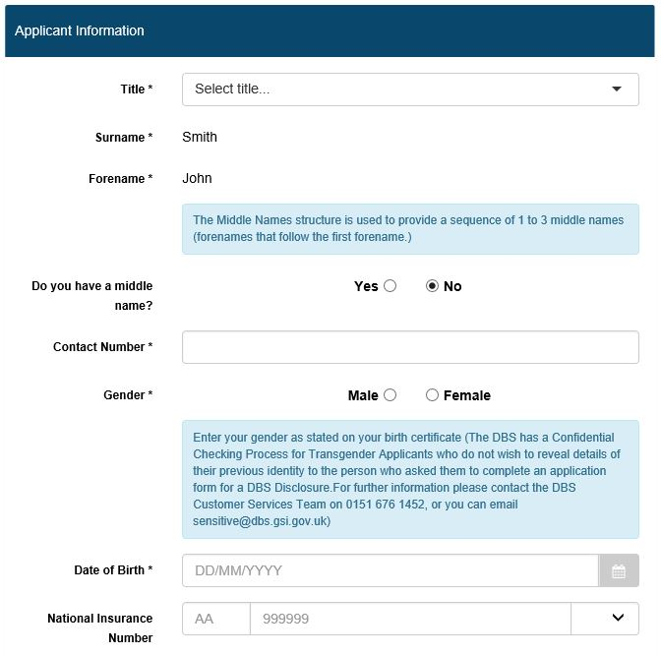

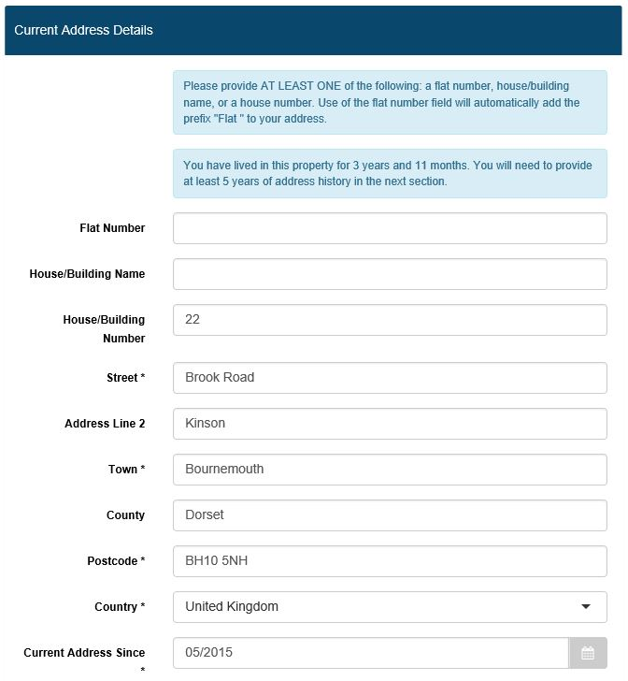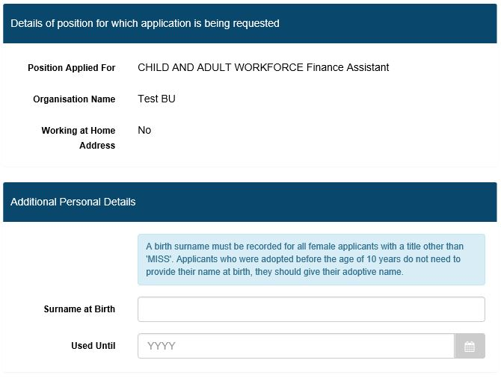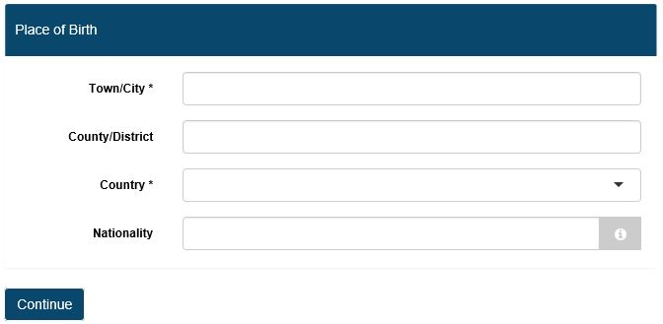

* 1. The name of the applicant as well as their employment details will already be

entered. If these details are incorrect, the applicant should contact an administrator, using the link in the “Details of position for which disclosure is being requested” section.

* 1. The applicant should then proceed with completing the fields on the

application. Mandatory fields are denoted with an asterisk. Holding your mouse over the tool tip (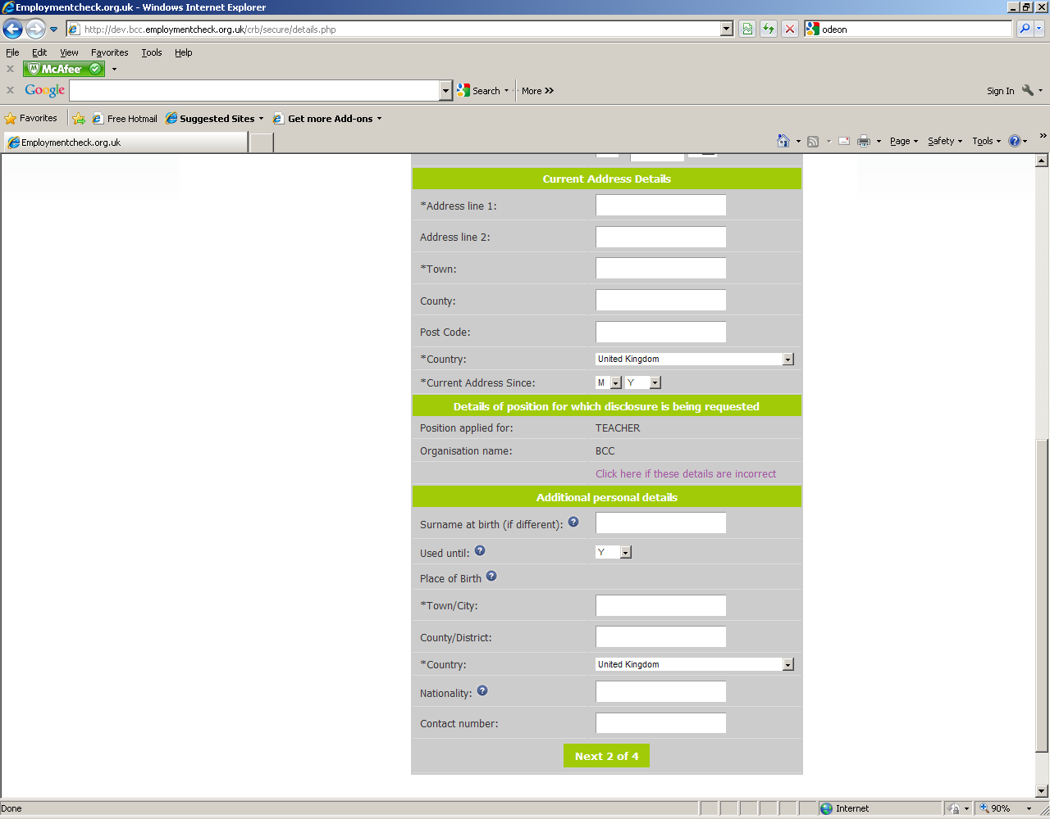) icon will provide additional detail as to the information required.

* 1. All of the key fields on the online application form are validated to prevent

invalid data entry. Some common errors include selecting Mrs as a title and not entering a previous surname or not including the town/city of birth. The system will not allow the candidate to progress on to the next stage of the application form if they have not completed a compulsory field on the form. Below are a few examples of error message pop-ups to alert the applicant of an error.

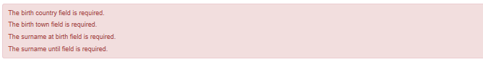

* 1. For ease of completion, the application form is split over four pages. Each

completed page is saved. Applicants can navigate through these pages using the application tracker menu on the left hand side and see at a glance what still needs to be completed.

* 1. If an applicant has not submitted the required five-year continuous address

history they will not be able to proceed through the application until they have added this. Overlaps are permitted, however the system will pick up any gaps in address history, as illustrated below, you add further address information using the ‘add address’ button in the middle of the error message:

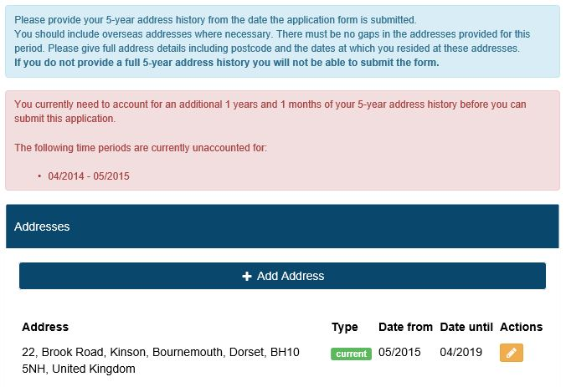

* + 1. Once five years continuous address history has been provided the applicant has the option to add additional addresses used in this period (e.g. student addresses) or to progress onto the next stage of the application.

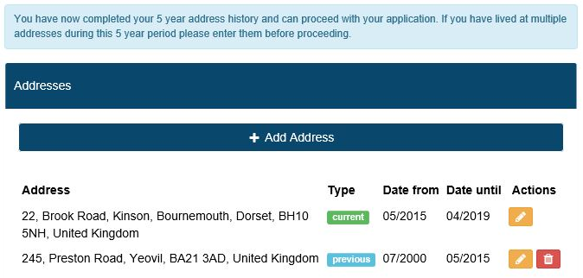

* 1. If the applicant has made a mistake they are able to edit and delete

addresses as well as navigate to previous page(s) of the application form.

* 1. After entering their address history, the applicant is then prompted to enter

details of any previous surnames or forenames as shown below:

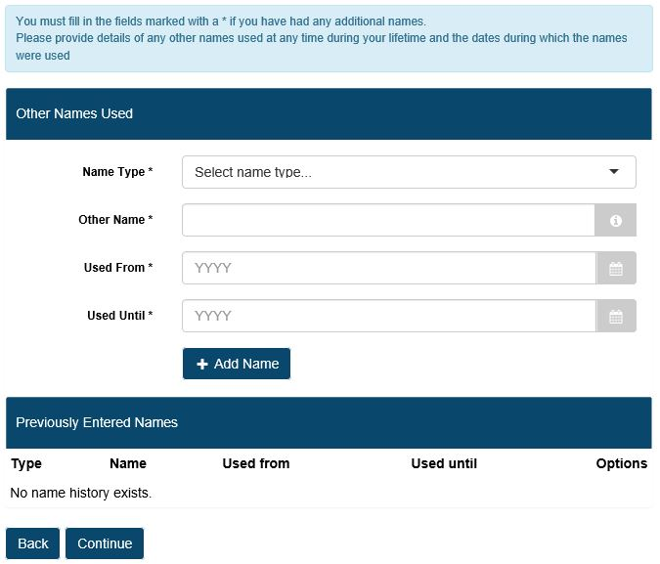

* 1. Once the applicant has entered their previous names this will preview below

the entry fields. If an applicant does not have any previous names they will be able to progress through to the last stage of the application.

* 1. Once this has been completed, the final page of the application form allows

the applicant to preview all of the information they have entered. If they notice there is an error on their form they can navigate back to the screen with the incorrect information and amend it.

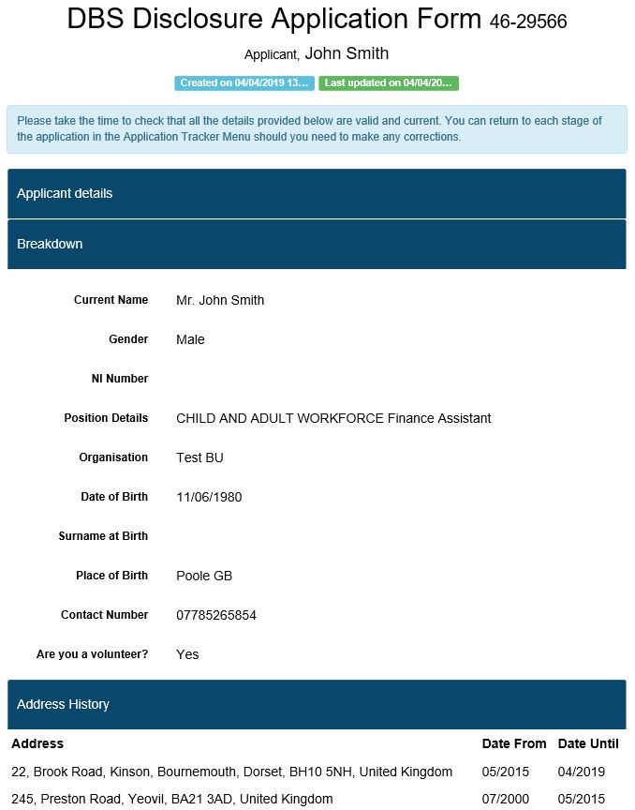

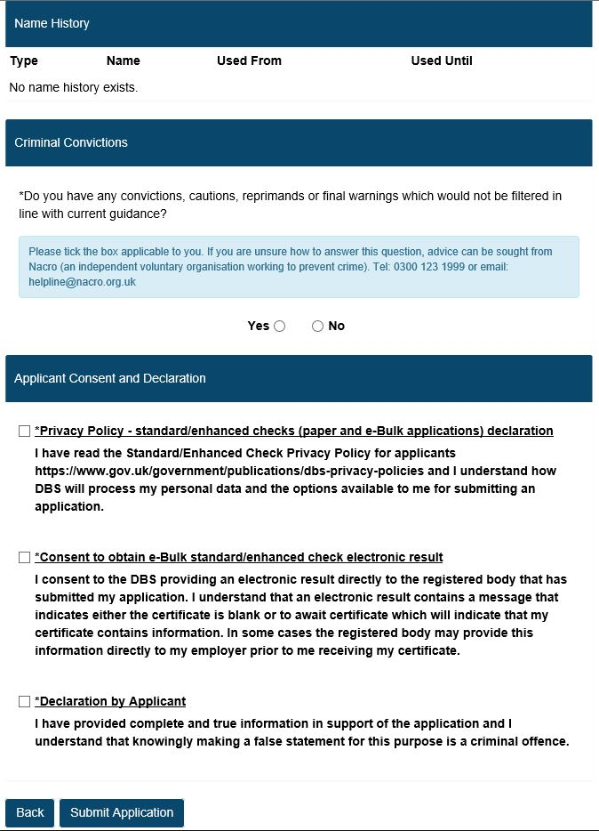

* 1. The applicant must then indicate whether they have had any convictions,

cautions or warnings which would not be filtered and confirm their acquiescence of the “Declaration by Applicant” otherwise they will not be able to submit the application.

* 1. Once submitted the applicant will receive an onscreen confirmation (see

below) and email.

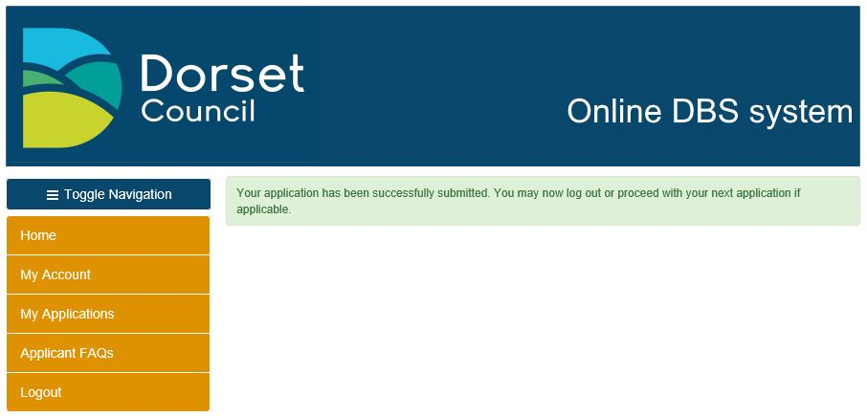

* 1. If the applicant fails to complete and submit their form an automated reminder

email will be sent to them after 5 days, with a notification also sent to

the ID Verifier.

5.18 If the BU Administrator assists the applicant in completing the on-line

application, please print out a copy of the completed form for the applicant.

5.19 Once an application has been submitted, please do not go back into the

application and make any amendments. Once the application has been sent

to the DBS there is no requirement to update address histories or make any

other amendments. Please contact the HR & Payroll Support team if you have any queries.

5.20 If the completion of an application may be legitimately delayed (or where an off-system process is required) the HR and Payroll Support team can change the status of an application to ‘holding’, if this is required please contact the team, this will pause the application process and the automated reminder emails.

1. **Next steps**

6.1 Once the applicant has completed their application, the ID verifier is required

to validate the ID documentation and confirm the ID documents submitted by the applicant. Please see the ID Verifier learning online module and guidance to understand the requirements of this role.

6.2 Once the application has been verified the application will be transmitted by

the HR and Payroll Support team to the DBS by the Ebulk system. HR and

Payroll Support will be alerted to the completed application therefore you don’t need to let them know that the application is ready to be transmitted.

6.3 Once checks have been completed, a disclosure number is issued by the

DBS. Disclosures for online applications are received electronically and can

be accessed by viewing the information in the [result_received](https://ekhuft.employmentcheck.org.uk/admin/secure/?status=11) “Result Received from DBS” category from the e-bulk menu. To view the details click on the actions icon  on the right hand side of the screen.

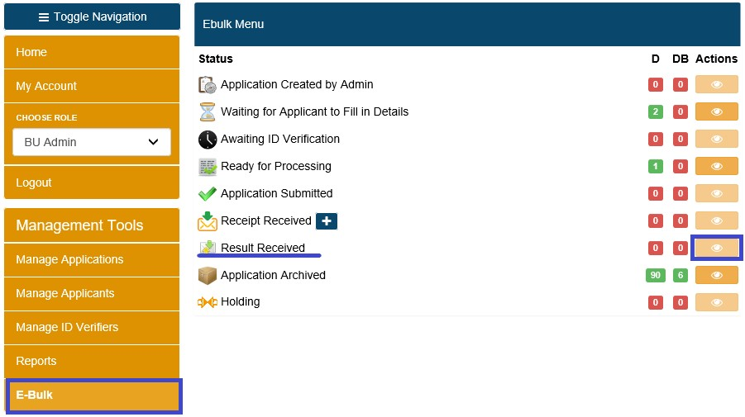

6.4 Any clear online disclosure will be denoted with a [result_received](https://ekhuft.employmentcheck.org.uk/admin/secure/?status=11) symbol, and a

confirmation that “Certificate contains no information”. A system-generated email is also automatically sent to the nominated manager(s) informing them that the DBS check has been completed for their employee, providing the disclosure number for that check. A hard copy certificate is posted to the applicant.

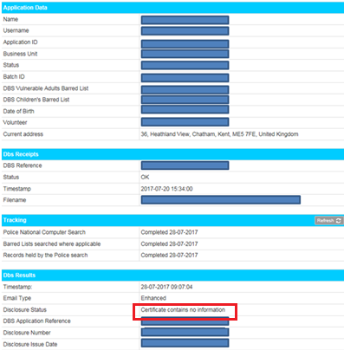

* 1. Any online disclosure with additional information will be returned with a “[result_received](https://ekhuft.employmentcheck.org.uk/admin/secure/?status=11)**P**”

and a note to say “Please wait to view applicant certificate”. In addition, a

‘Notification of Result with Content’ email will be sent to the nominated manager(s) (set on the add application screen) informing them that they have received a result which will require them see the applicants certificate.

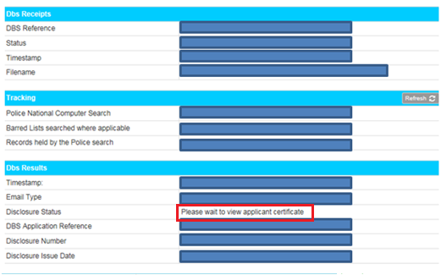

.

* 1. For all disclosures with additional information, the DBS records can be moved

to the ‘holding’ status whilst a decision is made regarding the continuity of the applicant’s employment.

* 1. Once an employee has been cleared to continue working, the DBS

record will be archived by HR and Payroll Support users and the manager notified of the disclosure number and issue date. Personal data is purged in line with DBS requirements 6 months after being moved to archive status.

**Hard Copy Application Approval Form**

APPENDIX A

**TO BE COMPLETED AND RETURNED WITH DBS APPLICATION FORM**

I confirm that I give permission for a System Administrator approved to use

the Dorset Council (DC) – Criminal Record Checking System to

input and submit the information on my DBS application form via

**https://www.dorsetcc.employmentcheck.org.uk** on my behalf.

I confirm the information that I have provided is complete and true and understand that knowingly to make a false statement for this purpose may be a criminal

offence.

In line with DBS requirements a record of this consent form will be securely

retained for a period of 12 months. Once the retention period has elapsed,

Dorset Council will ensure that this information is immediately and

suitably destroyed by secure means.

Applicant Name:\_\_\_\_\_\_\_\_\_\_\_\_\_\_\_\_\_\_\_\_\_\_\_\_\_\_\_\_\_

Position applied for:\_\_\_\_\_\_\_\_\_\_\_\_\_\_\_\_\_\_\_\_\_\_\_\_\_\_\_\_\_

Applicant Signature:\_\_\_\_\_\_\_\_\_\_\_\_\_\_\_\_\_\_\_\_\_\_\_\_\_\_ Date:\_\_\_\_/\_\_\_\_/\_\_\_\_