Open Market Review

Superfast Dorset Programme –Ultrafast Broadband

REQUEST FOR INFORMATION

1. INTRODUCTION

Dorset County Council through the Superfast Dorset Programme strives to provide the best broadband connectivity possible across its programme Area. The Superfast Dorset Programme is made up of all the local authorities within Dorset, Poole and Bournemouth. The overarching aspiration of the Superfast Dorset programme is to deliver digital Infrastructure to support our economic growth priorities with ultrafast broadband to meet business needs by 2018.

2. GEOGRAPHICAL SCOPE

As described above, our area encompasses the premises that are defined within the accompanying spreadsheet which details the premises and their associated post codes. The premise data has been sourced from AddressBase Premium, from Ordnance Survey, from January 2016. A map of this area is shown at the foot of this document and is also available in a GIS format upon request.

3. PROGRESS TO DATE

Our initial Local Broadband Plan was approved in January 2012 covering an Intervention Area of some 87,000+ premises that were assessed as being outside the scope for normal commercial NGA investment through an open market review process. The phase 1 contract signed in July 2013 has delivered 90% superfast broadband coverage to the Programme Area and is in line with the UK Government’s targets, we are seeking to substantially contribute to the Government objective of at least 95% superfast coverage nationally by the end of 2017 though our phase 2 contract signed in May 2015.

We have been allocated £2m additional public funding from the Department for Culture, Media and Sport (DCMS) Broadband Delivery UK Programme to help towards this challenge and we have secured funding to match this value from the Dorset Local Economic Partnership and details of these and any restrictions on their usage will be explained in our forthcoming tender documentation. It is therefore Dorset County Council’s intention to procure Next Generation Access solutions – those capable of achieving a minimum of 30 Mbps download speed - for the remaining area in scope for NGA deployment.

4. PURPOSE OF THIS OMR

As part of this new procurement process, we are now commencing an Open Market Review (“OMR”) to establish existing and planned (next 3 years) commercial coverage of broadband services across the Superfast Dorset programme’s area by all existing and any prospective, NGA broadband infrastructure providers.

This OMR is intended as a precursor to a formal public consultation document. The UK applies a best practice process that promotes the use of both an Open Market Review (“OMR”) and a Public Consultation, the latter being conducted in a manner consistent with the requirements of the Broadband Guidelines. We consider that early market engagement at this stage is an essential and extremely important part of our early market research The results of the OMR will assist us with understanding the broadband infrastructure (Next Generation Access (NGA)) already in place and where there are plans for investment in such infrastructure in the coming three years and a significant step in the design of the intervention area to be targeted by the new contract.

Once we have defined these Intervention Areas from the OMR, we will be conducting a minimum one month State aid Public Consultation on our proposed Intervention Areas. We propose to launch our ITT in the financial year 2016/17.

5. YOUR RESPONSE REQUIRED

We are sending this OMR to all recognised broadband infrastructure and internet providers in our area. In addition, we are publishing this OMR document on our website here:
https://www.dorsetforyou.com/broadband/state-aid

We require responses by 26 May 2016 to the questions set out in the Annex, which includes a full response template spread sheet of all 386,617 premises in our geographic area and we request you provide coverage at premise level. Within the full response spread sheet please complete columns D to F with your current provision and please complete columns G to J with your future coverage plans. If you require spatial coordinates for the premises locations to support your response please request this by emailing superfast@dorsetcc.gov.uk

When responding, we would be grateful if you could confirm your organisation's name and address, as well as the name, position and contact details of the person responding on behalf of the organisation.

6. ACCCESS TO DATA

The OMR Response Template is provided on the basis that a signed Partners Standard Form Contractor Licence, which can be found at the end of this document, will be returned to superfast@dorsetccc.gov.uk

The data you provide in your response will be treated as commercially confidential to Dorset County Council, although it may be necessary to share some/all of your response data with our professional advisors and/or DCMS/BDUK, Ofcom, BIS State Aid Branch and the European Commission in the course of seeking State Aid. It should also be noted that it is a State Aid requirement to utilise this information to produce State Aid maps to define white, grey and black areas for basic and NGA broadband. These maps will be published as part of the Public Consultation process and will be utilised to define the intervention area. However, please note that these published maps will be anonymous and assimilate data from all relevant operators and will not be directly attributable to a single source.

If you have any questions about any of the above, please contact Pete Bartlett from the Superfast Dorset Programme Team on:
P.bartlett@dorsetcc.gov.uk

ANNEX
1. Please provide details and supporting evidence of any current or planned investment in broadband infrastructure (basic broadband and NGA broadband) in Dorset County Council’s area. In the case of planned investment, we are particularly interested in plans for the coming three years (to April 2019). Beyond completion of the attached spreadsheet template (or instead of the spreadsheet if you are not able to provide the information in the required template form), any information provided in response to this request should include but not be limited to:

  - Premises detail for basic broadband and NGA broadband showing the existing coverage and separately maps detailing the planned investment in the basic broadband and NGA infrastructure networks for at least the next three years;

  - Exact detail of premises passed or covered, including information on the number of premises passed (in the case of a fixed network) or covered and able to receive services (in the case of a wireless/satellite network);

  - Details of the technology and where these claim to be NGA, demonstrate how they meet the minimum standards as set-out in the BDUK Technology Guidelines.

  - Description of the services/ products currently offered and separately those to be offered within the next 3 years;

  - Installation and rental tariffs for those services/products clearly identifying whether they are inclusive or exclusive of VAT;

  - Upload and download speeds typically experienced by end users;

  - Appropriate indicators of quality of the service e.g. contention ratio or bandwidth allocation per end user;

  - Evidence to substantiate actual or planned coverage claims including business cases and evidence of available funding to enable plans to be fulfilled.

  - Details and timing of roll-out for future investment; and

  - Confirmation from an authorised signatory that all information provided is of suitable accuracy.

Please supplement with supporting evidence as you consider appropriate e.g. public
websites.

Thank you,
The Superfast Dorset Programme, Dorset County Council
Map of Geographic area
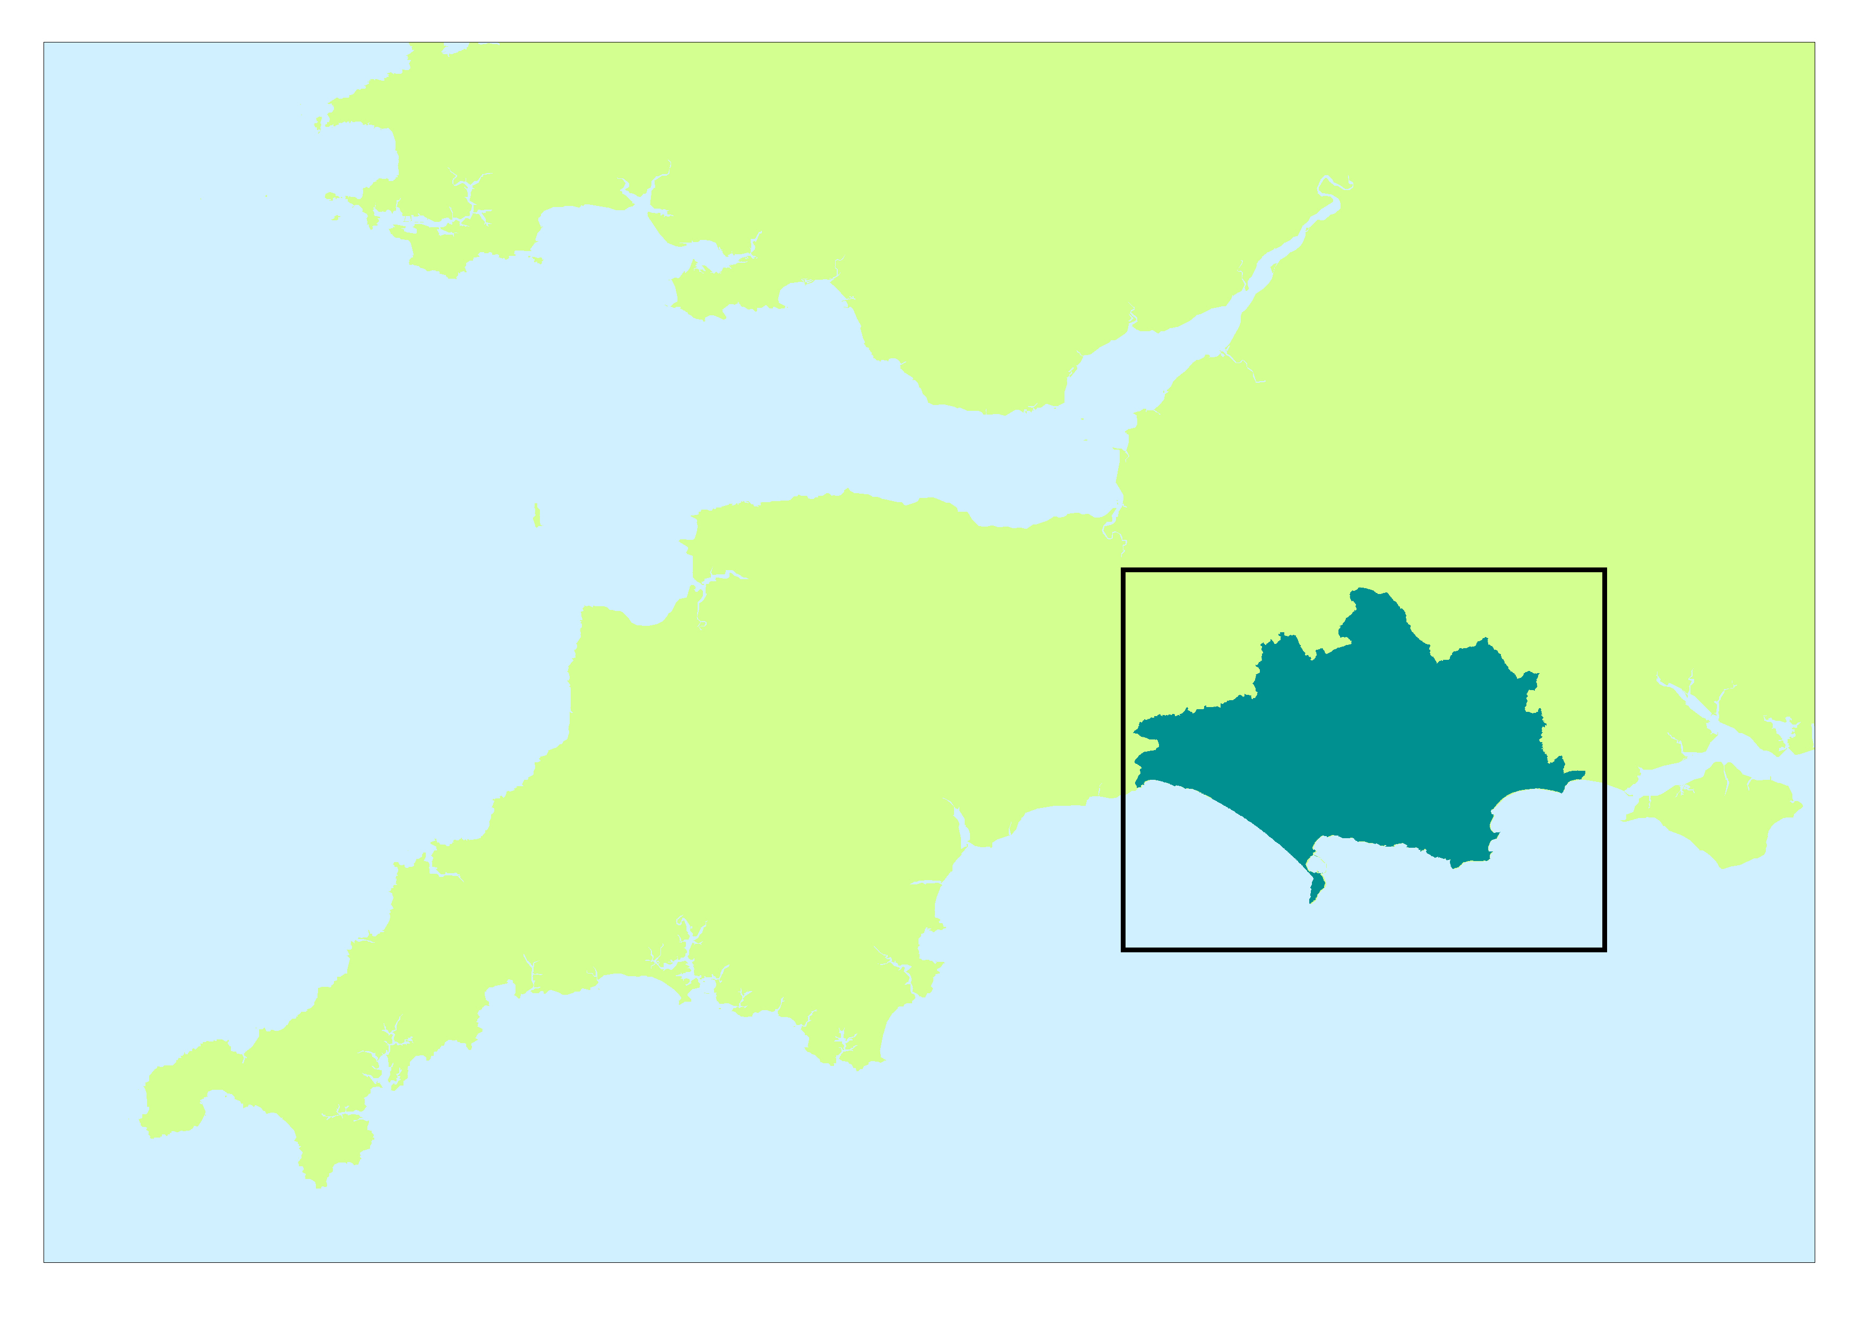

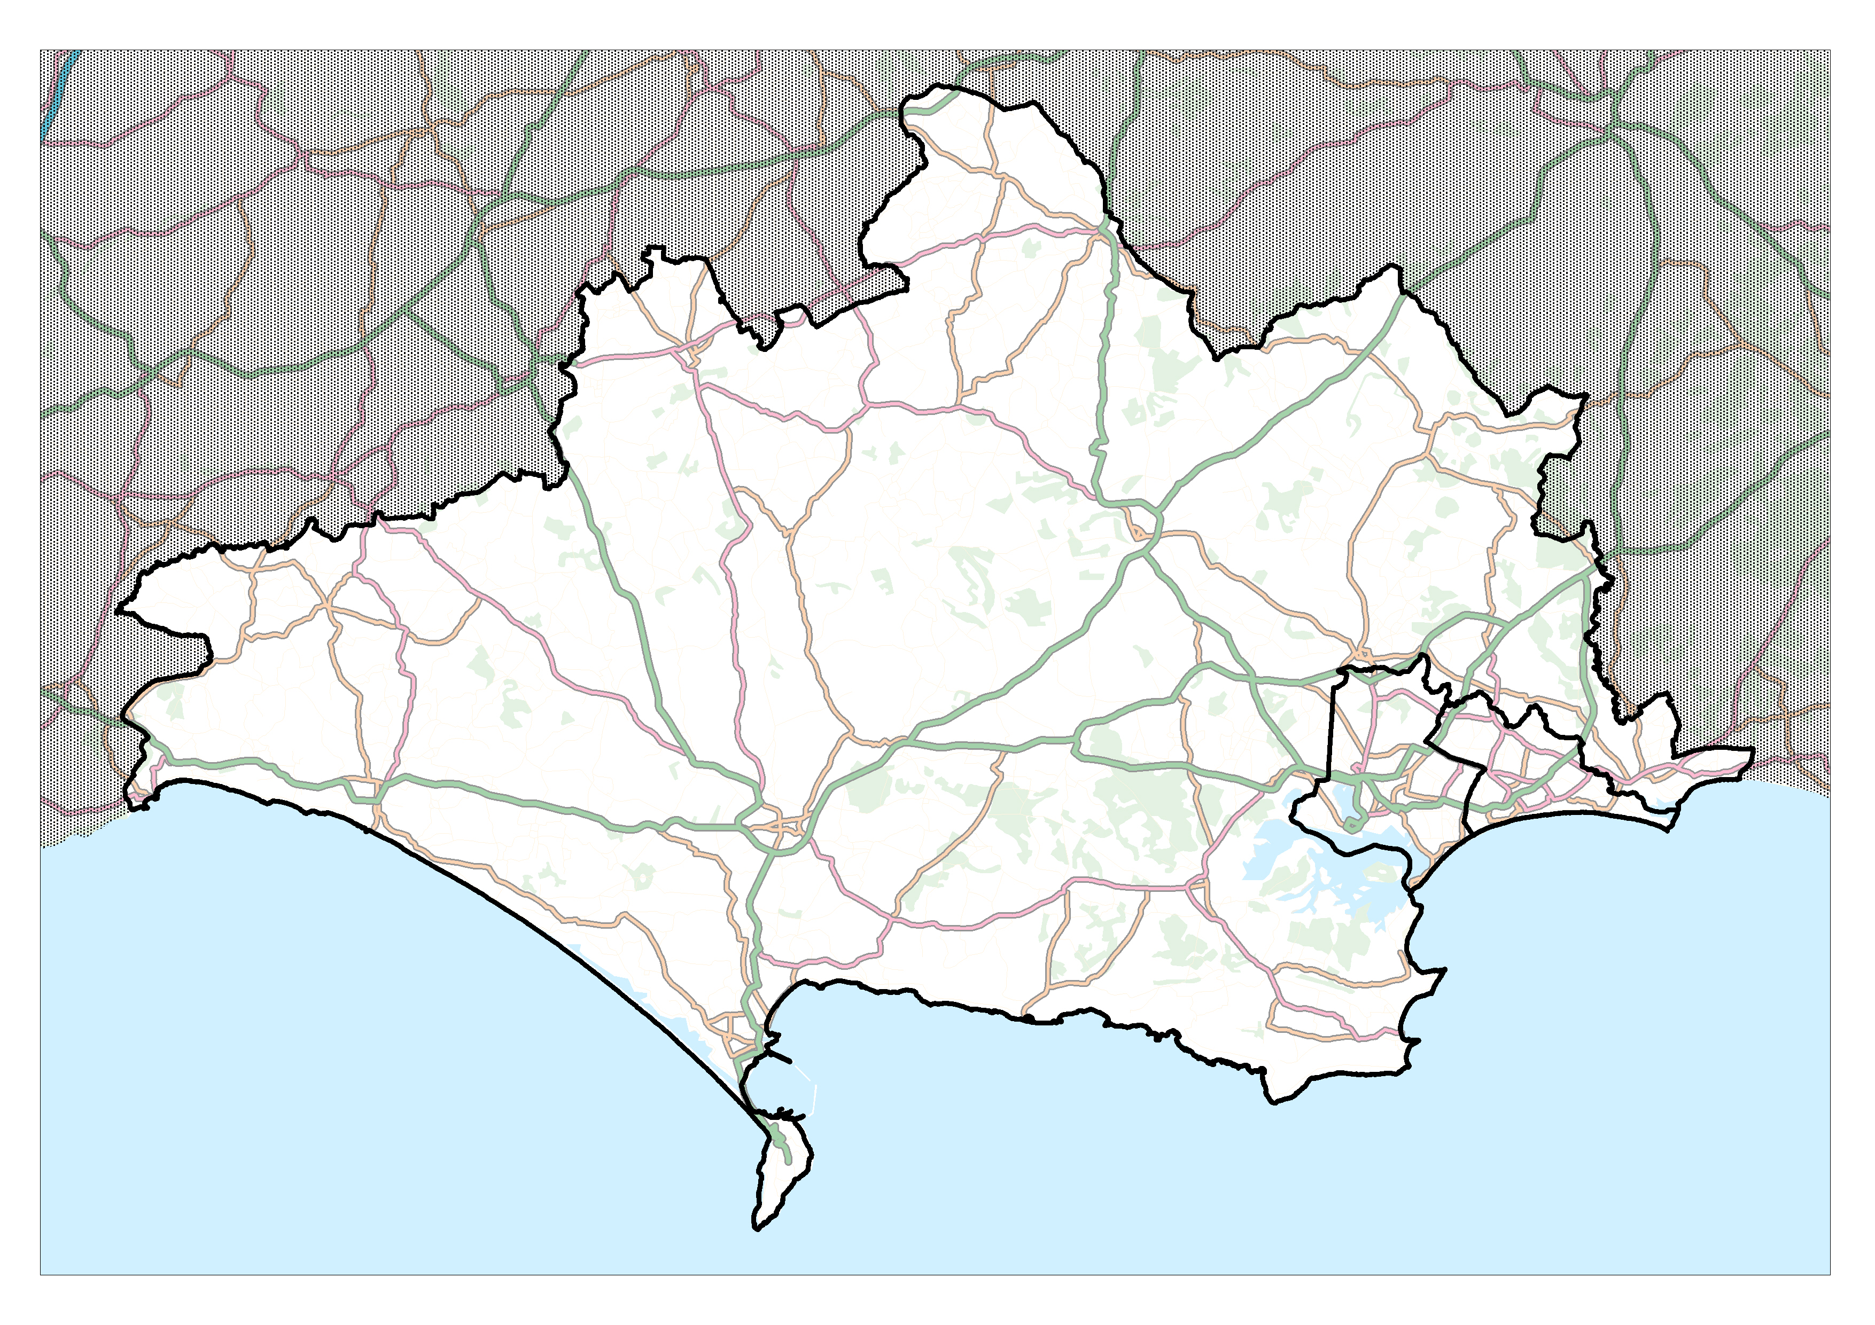

PSMA Standard Form Contractor Licence

Available via our website
https://www.dorsetforyou.com/broadband/state-aid

Full response template spread sheet

Available via our website
https://www.dorsetforyou.com/broadband/state-aid

The OMR response template is provided by Dorset County Council for the sole use of responding to this Open Market Review. Dorset County Council requires a signed PSMA Standard Form Contractor Licence returning, which can be found at the end of this document
Community Guidelines for the application of State aid rules in relation to rapid deployment of broadband networks http://eur-lex.europa.eu/LexUriServ/LexUriServ.do?uri=OJ:C:2013:025:0001:0026:EN:PDF
https://www.gov.uk/government/publications/state-aid-advice

