Pan Dorset Malnutrition Programme
‘MUST’ /Nutritional Screening electronic form
https://app.dorsetcouncil.gov.uk/MUST
Guidance notes for Administration and Reporting

Contents
Data Amendments 3
Create / Edit User Screen 4
Searching for users 4
To search to see if someone is already a user of the system. 5
Search Results 5
Editing a User’s Records 6
How to Create a User 6
Create user screen 6
Running Reports 8
Form Detail Reports 9
Emails Sent Report 10
User Report 11
NHS Load Report 12
Email Setup Report 12
Surgery Areas Report 12

Info

All users of the “MUST” electonic system can:
- Set up new system users
- Delete or edit electronic forms if they have been completed incorrectly
- Run reports

Issues with the Electronic System
For ICT issues e.g. The system is down, not working correctly or to reporting any general ICT issues that pertain solely to the electronic form. Please contact Dorset Council ICT support desk on 01305 224062

For SystmOne hyperlink issues: contact Dorset HealthCare’s IT helpdesk

For Locality issues regarding the following :
- Changes in GP practices within your locality
- Changes to the email addresses of those who receive the automated e mails i.e Health and Social Care Co-Ordinators.
Please contact Sue Hawkins e mail sue.hawkins6@nhs.net .

General inputting information:
Please refer to the ‘Pan Dorset Malnutrition Programme Guidance notes for Home and Community Pathway: First Option’ https://www.dorsetforyou.gov.uk/media/224452/Malnutrition-Programme-electronic-form-guidance/pdf/Malnutrition_Programme_1st_Option_Guidance_Notes.pdf

Data Amendments
  - Create users; run reports; edit a client; amend or delete a form.

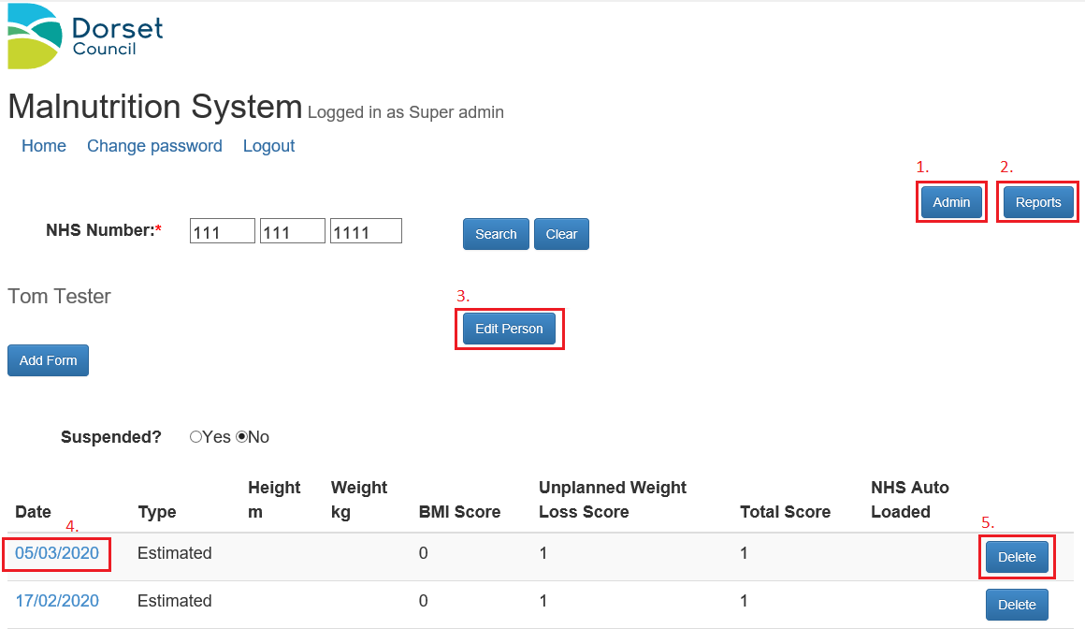

Buttons 3, 4 and 5 will only appear after you have entered a client’s NHS number

- Admin – This button will take you to the area where you can create new or edit users of the system (See further guidance).
- Reports – This button will take you to an area where you can run reports ( See further guidance)
- Edit Person – This button will allow you to edit the following client details: NHS Number: Client’s first name or surname. This will change their core client record and all forms will remain attached.
- Date Hyperlinks e.g. 17/02/2020– This will take you to an existing form. You can amend the information within the form, but you must click the “Update” button to save these changes, rather than the back button. This is useful if there is an error on the form, but the rest of the form is ok so does not require deleting entirely.
- Delete – This button deletes individual forms from a client’s record when they have been entered in error.

Create / Edit User Screen
  - Create or edit a user of the electronic system or search to see if a person is already set up as a user of the system.

Searching for users

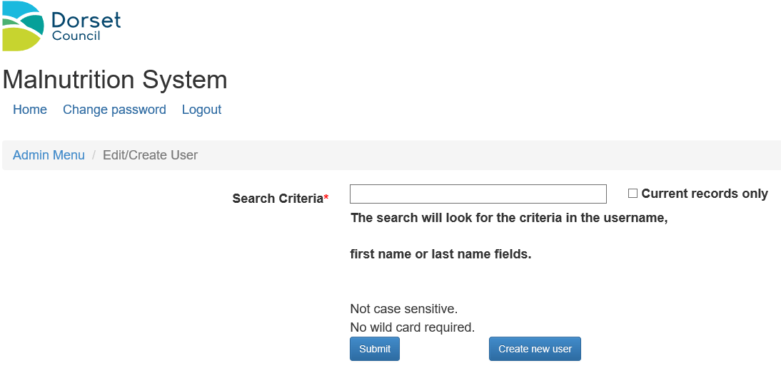
- Search criteria – here you can enter part of a name when looking for a specific person (as with most searches you want to enter as little in as possible to ensure you get the correct results, but enough to get a manageable list of results). The search will look for records where the search criteria are contained in the username, first name or last name field.
- Current records only – if this button is ticked, only users with an open status will be shown.
- Submit – this button will trigger the search based on the fields above.
- Create new user – this button enables you to create a new user. (See further guidance).

To search to see if someone is already a user of the system.

- Enter part or all of the users name ( first or surname) – in this example we entered the surname Brown
- Click Submit

Search Results
If your search does not bring back any results the following will be displayed under the search area
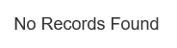

Otherwise, a list of records will be displayed as follows
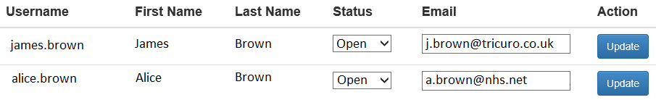

If we searched
The search would return Barry and Glen as ‘len’ appears in Allen and Glen.
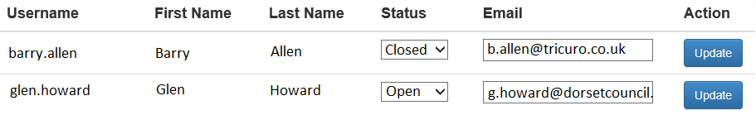

But if we had also ticked “Current records only”, it would have only returned Glen.

It is best to leave Current records only unticked when searching for a user, though it may be useful to tick it if you want to see a quick list of current users.

Editing a User’s Records

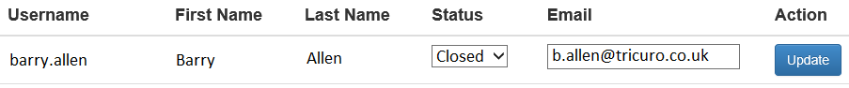

Once you have found the relevant record you can edit the following
- Status – You can reopen a closed account by changing the dropdown to Open or end an account by changing the status to Closed.
- Email – If the user’s email has changed you can amend it. Please note, this cannot be used to amend the automated generic emails that Health and Social Care Co-ordinators receive.

Once the amendments have been made, press the Update button to save the changes.

Please note you cannot:
- Amend more than one record at a time
- Amend a name or username - if you need to amend a name e.g. surname has changed then you need to set the current record status to closed and create a new user.

How to Create a User

Create user screen

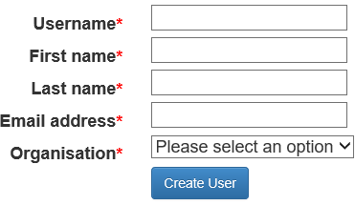

Example
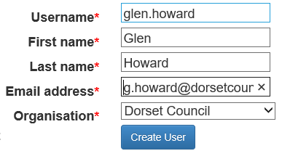

Complete as per example screen.

- User Name –
firstname.lastname eg john.smith
Please do not use capital letters in the username
- Complete the First and Last Name
- Type in the e mail address – double check this is absolutely correct as this is the address that the new user’s first password will be sent.
- Choose from the drop down list your organisation
- Click the Create User Button
- You will then see a success message screen

- If the username already exists you will get this message after you click the submit button.

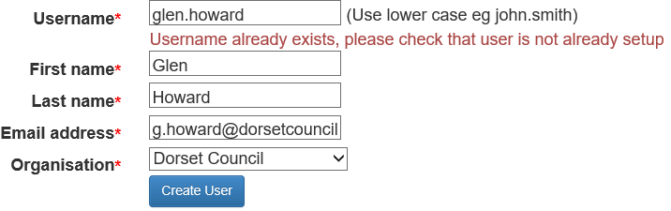

If so, double check that your user does not have a login by using the search criteria. If they definitely do not, then add a middle initial or number e.g. john.a.smith or john.smith1

The security/login module for the “MUST” application is a generic module also used by other systems, so it is possible that a name will already exist elsewhere so cannot be used.

Running Reports
To run reports you need to:
- Log in
- Choose the ‘Reports’ button at the top right of the screen:
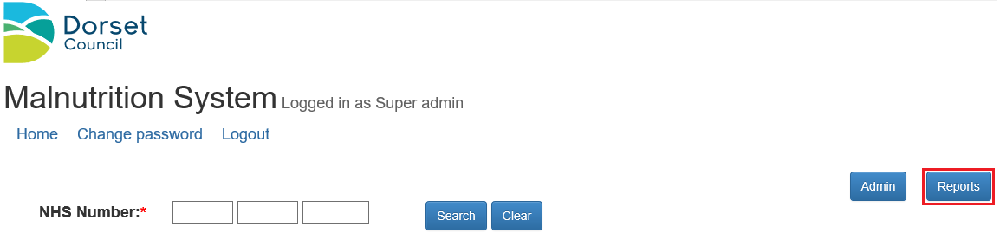

This will bring you to this screen which has six options:

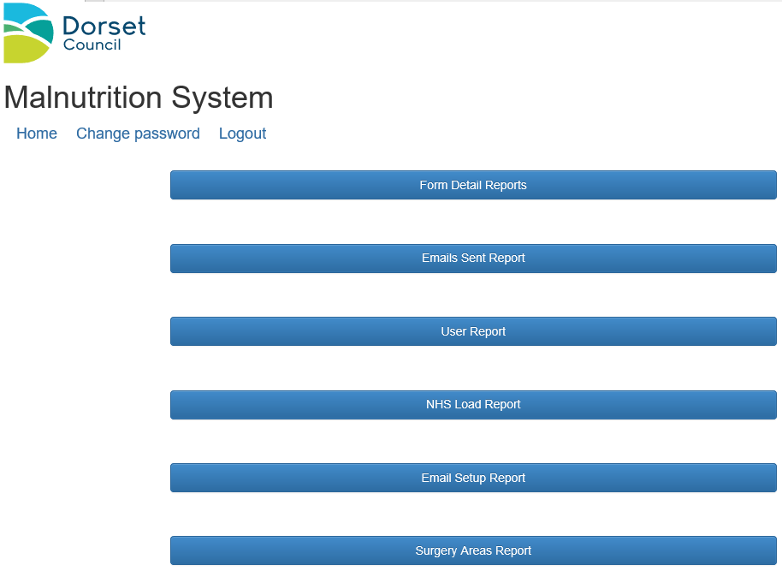

Form Detail Reports
The first option ‘Form Detail Reports’ will take you to a page from where you can run detailed reports for:
- A chosen locality
- The type of form - Home and Community Pathway
- Any set of dates
- Report Type – use full detail unless you need an anonomised report.
- If you want this to be anonymised i.e. names and NHS numbers removed, select ‘Public Health – anonymous’ from the ‘Report Type’ option:
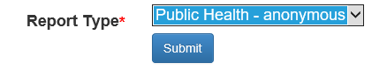
For example:
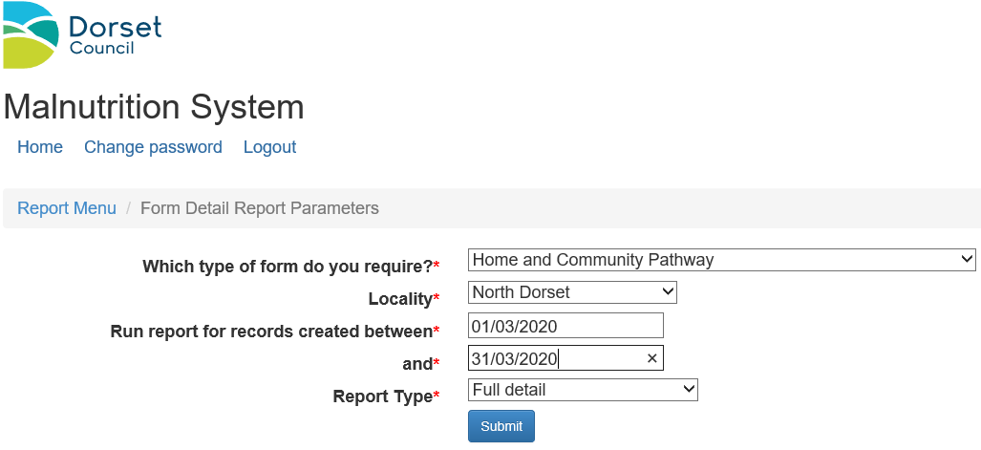

When you choose ‘Submit’ it will download an Excel report that you can “save to computer” or “open”. It will give you details of locality, names (if not anonymised), NHS number, GP, scales used, height, weight, BMI, weight loss comments, total ‘MUST’/Nutritional screening figure, job title, name of screener and date of screening.
With basic Excel knowledge this can be manipulated/ filtered to prioritise chosen information.

Emails Sent Report
The second option will allow you to run reports on the automated e mails that are generated by the system.
Input the dates you want and press submit. The appropriate Excel Report will be produced.
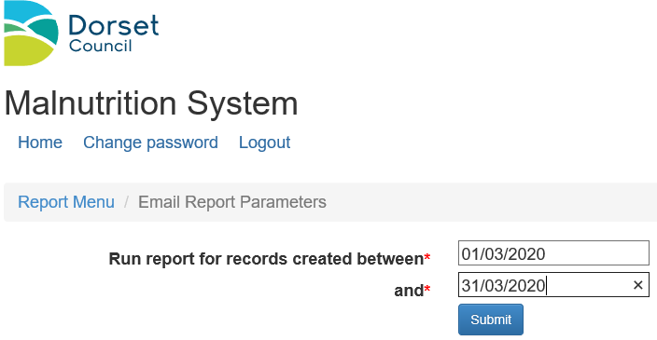
The Excel report informs you of
- Who received the automated email
- Who completed the screening
- When they submitted the form to generate the email
- The client’s NHS number

User Report
The third option ‘User Report’ is for seeing lists of System Users within specific organisations.
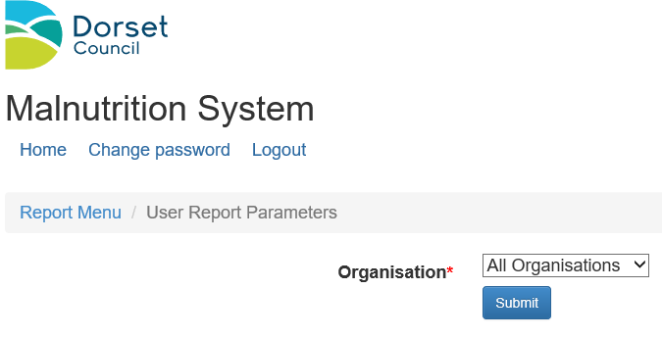
Here you choose the organisation from the drop down menu ‘Organisation’:
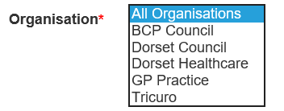
When you choose Submit, this will generate an excel report, alphabeticised by first name. It also shows:
- Surname
- User name
- Email address
- Organisation
N.B You cannot alter information simply by updating it on the Excel report. Please see the chapter ‘Systems User’ in order to do this.

NHS Load Report
The ‘NHS Load Report’ is for monitoring the NHS downloads from SystmOne to the Malnutrition system

Email Setup Report
The fifth option ‘Email Setup Report’ generates an Excel report detailing the names and email address of those who receive the automated emails generated by the system. This lists the :
- Locality
- Email type:
- Name of person receiving it and their email address
- N.B You cannot alter information simply by updating it on the Excel report. Please contact Sue Hawkins e mail sue.hawkins6@nhs.net if any e mail addresses need to be amended.

Surgery Areas Report
The sixth option ‘Surgery Areas Report’ generates an Excel report that details the surgeries by locality.
If you are aware of changes in your locality (e.g. surgeries merging) then you can use this report to see if the database is up to date.
N.B You cannot alter information simply by updating it on the Excel report. Please contact Sue Hawkins on e mail sue.hawkins6@nhs.net if any GP surgeries need to be amended or linked.

