Parking Services
Annual Report
2020/2021

www.dorsetcouncil.gov.uk/parking

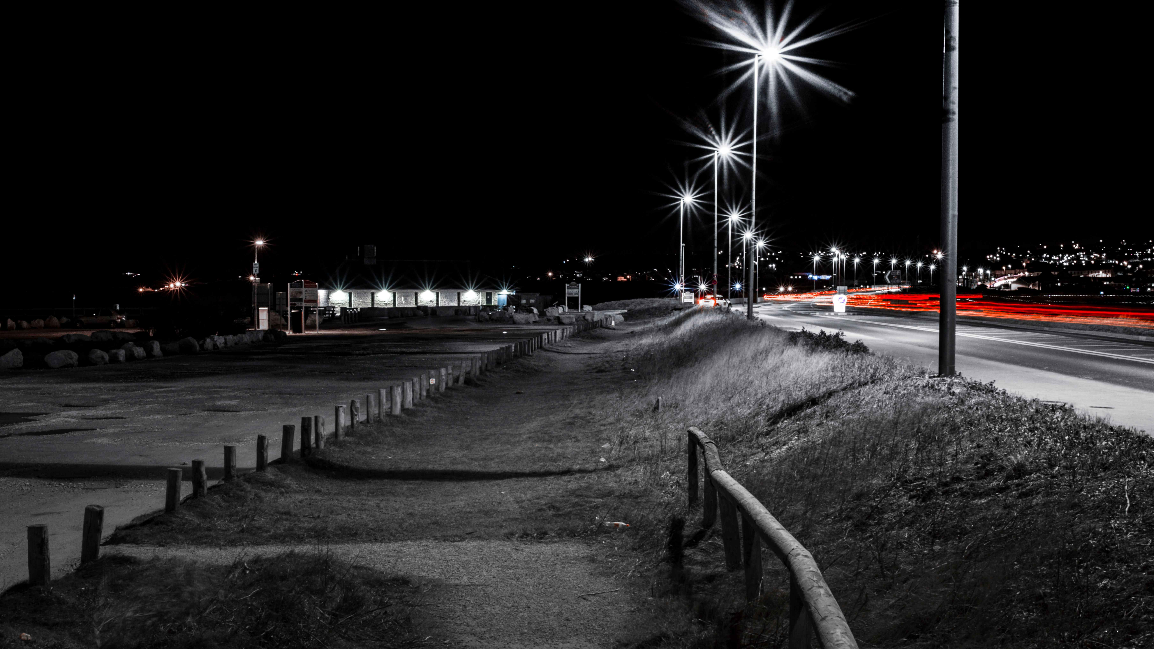

Forward
Councillor Ray Bryan
Portfolio Holder for Highways, Travel and Environment
Welcome to the Parking Services annual report for Dorset Council for 2020/2021.
The parking services function is worked by two teams, the office team and the civil enforcement team. Both teams have a broad and diverse knowledge on all aspects of parking, including the rules and regulations for parking and highways. The teams display high level customer service and are expert in dealing with difficult conversations.
This year saw the continued the work of bringing together the former council processes and procedures through the restructuring of the Office Team. This led to the appointment of an Office Team Leader and Deputy Team Leader.
We have focused our attention on aligning former charging strategies for the purpose of enabling fair and consistent charging. This included the introduction of Sunday charging (in locations that did not already have it), standardising charging hours across the Dorset Council area to 8am – 6pm and matching the ‘all-day’ rate at Lyme Regis and West Bay to Weymouth.

Introduction
The purpose of this report is to provide financial, statistical and performance data
relating to Parking in Dorset Council, and covers the period from 1 April 2020 to 31 March 2021. Reports for previous years can be found on Dorset Council’s website at https://www.dorsetcouncil.gov.uk/parking

Enforcement

The table below shows the number of PCNs issued from 2019/2020 to 2020/2021, categorised by the type of contravention and level of PCN.

PCN statistic | 2019/2020 |  | 2020/2021
 | On-street | Off-street | On-street | Off-street
Higher Level PCNs issued | 10710 | 1385 | 10190 | 997
Lower Level PCNs issued | 5408 | 13675 | 5057 | 7797
Total PCNs issued | 16118 | 15060 | 15247 | 8774
PCNs paid at discount rate | 10993 | 8430 | 10024 | 4807
PCNs paid at non-discount rate | 1861 | 1706 | 1674 | 889
Total PCNs paid | 12854 | 10136 | 11698 | 5696
Total PCNs unpaid | 3264 | 4924 | 3549 | 3078
PCNs registered as Debts | 2960 | 2395 | 2658 | 886
Appeals/Representations received | 3857 | 5085 | 3229 | 2548
PCNs cancelled through the use of discretion or due to evidence being supplied | 994 | 2746 | 893 | 1454
PCNs cancelled for statutory reasons | 96 | 42 | 75 | 30
Total PCNs cancelled | 1090 | 2788 | 968 | 1484
PCNs going to Adjudication | 27 | 13 | 21 | 6
PCNs written off (untraceable keepers) | 298 | 291 | 270 | 238
Vehicles clamped or removed | 0 | 0 | 0 | 0

Financial Data

Income and expenditure statement 2019/2020

 | 2019/2020 (£) | 2020/2021 (£)
Expenditure
Internal Charges (Expenditure) | 137,955 | 166,924
Pay Related Costs | 1,367,766 | 1,489,114
Premises Related Costs | 1,520,851 | 1,527,441
Transport Related Costs | 28,945 | 57,861
Supplies and Services | 904,104 | 602,098
Third Party (Contracted Out) Payments | 38,607 | 6,264
Total Expenditure | 3,998,228 | 3,849,703
Income
Parking Waivers & Permits | -895,808 | -676,693
Pay & Display Charges | -5,841,896 | -5,821,210
Mobile Phone Charges | -1,197,472 | -1,447,804
Penalty Charge Notices | -968,786 | -692,197
Other income | -916,950 | -303,903
Total Income | -9,820,910 | -8,941,809
Financial adjustments | -77,094 | -84,161
Deficit/Surplus | -5,899,776 | -5,176,265

Car parks that are 24 hour are not included in this change

