Public Review

24 June 2021 to 25 July 2021

UK GIGABIT PROGRAMME

REQUEST FOR
INFORMATION

Index

1. Introduction 3
Why Dorset Council and BDUK are seeking your support 4
2. Purpose of this Public Review 4
Current context - Dorset 4
Role of Local Bodies 5
3. Proposed Areas - Eligible for Subsidy 5
Forthcoming procurement – Dorset Council 6
4. Participating / responding to this Public Review 7
Responses from suppliers 7
Suppliers - providing us with feedback on our procurement approach 8
5. Supplier Submission Requirements 8
We request the following information from suppliers 8
Data Submission Requirements 9
6. Next Steps 9
Annex A: Data Submission Format 10
Annex B: Supporting Evidence 11
Summary Extract from the Ofcom Voluntary Code of Practice 12
Annex C: Technology Definition 14
Annex D: Map to show intervention areas 16
Requesting a review of a subsidy award 17
Key eligibility requirements for public subsidy 17

Public Review Dorset

New procurement to extend coverage of gigabit-capable
broadband across Dorset

Duration: To commence on 24 June 2021 and close on 25 July 2021.

Introduction

The Government’s ambition is to deliver nationwide gigabit-capable broadband as soon as possible. We recognise that there is a need for government intervention in the parts of the country that are not commercially viable, this is why the Government has committed £5bn for the hardest to reach parts of the country, ensuring that all areas of the UK can benefit. This will be spent through a package of coordinated and mutually supportive interventions, collectively known as the UK Gigabit Programme.

Dorset Council and BDUK conducted an Open Market Review (OMR) for Dorset on 17 March to 14 April 2021. The identified geographical areas of Dorset which fall into this category of hard to reach, is subject to change following ongoing discussions with BDUK and responses received to this review.

The Public Review process aims to validate the outcome of the OMR to ensure that it correctly represents the information provided by suppliers in the course of the OMR and to ensure that the right areas are targeted for government investment. We invite stakeholders (including broadband infrastructure operators, internet service providers, the public, and businesses) to provide us with feedback about the proposed eligible areas for government investment (intervention) set out in this document.

Suppliers who missed contributing to the preceding OMR, had no definitive plans and/or evidence base on which to substantiate claims at that earlier stage, or have subsequently updated their plans now have a final opportunity to notify Dorset Council and BDUK before the procurement stage. The premises identified by Dorset Council and BDUK as eligible, as described in section 3, may be grouped into one or more appropriately sized Intervention Areas (IAs). The IAs will be issued to the market so that suppliers can bid for funding to support delivery to those areas.

Why Dorset Council and BDUK are seeking your support

Our goal is to ensure that premises in the identified geography that need government investment are accurately targeted. Each contributor to this public review will help to optimise the use of public subsidy in helping to provide faster and better connectivity across all parts of Dorset, please note this public review excludes Bournemouth, Christchurch and Poole.

Please respond if you have information to contribute to this data validation process. If you did not respond to the recent OMR, and have existing network coverage, or plan to build infrastructure within the next three years, please submit your plans so that public subsidy can be targeted more accurately and over-building commercial infrastructure can be avoided.

Provide your views about the accuracy of data and mapped areas (to inform the final Intervention Area), by reporting where premises have existing or planned gigabit-capable broadband coverage.

Purpose of this Public Review

This Public Review sets out a description of the proposed subsidy measure and defines the proposed eligible areas, to enable all interested stakeholders (including broadband infrastructure operators, internet service providers, the public, and businesses) to comment on those proposals.

Supplier data submitted during the OMR has been incorporated into the consultation area maps using a methodology that protects commercially sensitive supplier data.

All meaningful responses to the Public Review will be carefully considered and where necessary, utilised to determine eligible premises. The final eligible area maps and a summary report confirming details of the changes will be published on gov.uk website after the close of the review period. The finalised eligible premises and proposed Intervention Areas will then be submitted to BDUK’s National Competence Centre (NCC) for approval against the UK Subsidy Control Regime. The responses and output from the Public Review will therefore help us gain further confidence that the proposed interventions are in areas that are eligible for subsidy, i.e., areas which are not commercially viable and require government intervention to address market failure.

Current context - Dorset

Dorset Council initiated an Open Market Review (OMR) for Dorset in March 2021. The OMR indicated that planned commercial coverage for gigabit-capable broadband would reach approximately 187,172 premises within the next 3 years and would therefore leave the remaining 101,344 premises without access to gigabit-capable broadband.

As part of this public review, we will evaluate any further responses in order to validate the eligibility of the premises for government subsidy. Once concluded, this Public Review will confirm the premises to be included in procurements.

Public Review Process Flowchart:
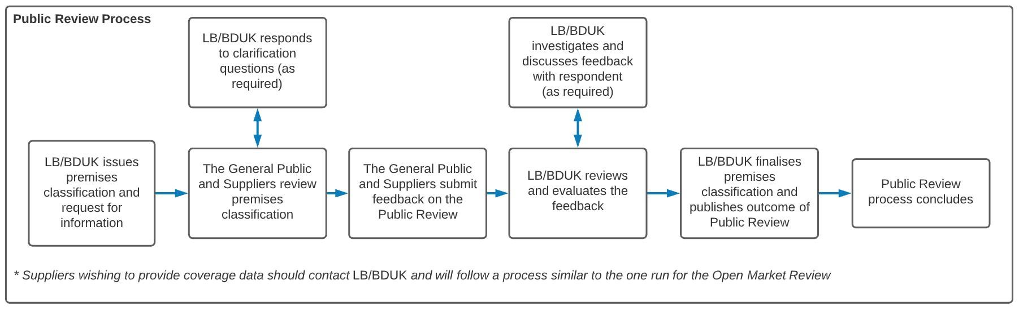

OMR to Procurement Process Flowchart:
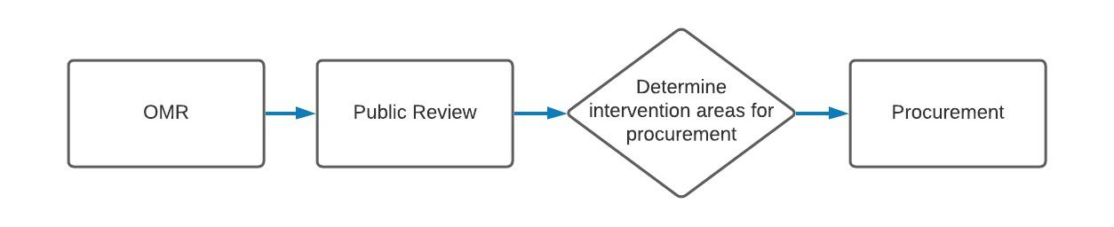

Role of Local Bodies

Dorset Council will work alongside BDUK and other relevant local bodies, to answer questions, evaluate supplier responses, assess data accuracy, manage the build phase and engage with the local community. Dorset Council and BDUK will confirm the eligible premises to be included in the Intervention Area at the end of the Public Review.

This Public Review is being carried out independently of any activities that local bodies may be undertaking, for example, under the National Broadband Scheme 2016 known as the Superfast Programme.

Proposed Areas - Eligible for Subsidy

For ease of reference, and for presentational purposes only, postcodes have been used to summarise the premise classifications and map the proposed eligible areas (NB we will only subsidise builds to premises which have been designated as White). The proposed intervention areas are those which have been identified by the Open Market Review as premises which are not currently commercially viable and where no infrastructure exists or is planned to be built within the next three years. For this purpose, the postcodes have been classified as follows:

- A postcode is White if any ‘White’ premises (i.e. premises with no Gigabit infrastructure) are present;
- A postcode is Under Review if any ‘Conditional White’ premises are present (i.e. where premises may be included in build plans, but BDUK are not confident that these plans will be completed);
- A postcode is Black if all premises in the postcode are classified ‘Black (i.e. premises with two or more Gigabit infrastructures from different suppliers planned or available) ;
- A postcode is Grey if all premises are ‘Grey’ (i.e. premises planned or served by a single Gigabit infrastructure provider) or a mixture of ‘Grey’ and ‘Black’.

The outcome of the OMR is summarised in terms of ‘White’, ‘Grey’, ‘Black’ and ‘Under Review’/‘Conditional White’ postcodes and premises below.

Postcode Classification | Number of Postcodes | Number of Gigabit Black Premises | Number of Gigabit Grey Premises | Number of Gigabit Under Review Premises | Number of Gigabit White Premises
White | 7,259 | 89 | 4,814 | 0 | 103,740
Under Review | 4,355 | 24 | 2,941 | 68,264 | 0
Grey | 1,020 | 226 | 9,076 | 0 | 0
Black | 41 | 397 | 0 | 0 | 0
Total | 13,072 | 737 | 16,966 | 68,125 | 101,344

Procurement and Commercial Approach

BDUK has undertaken extensive early market engagement in relation to procurement for interventions. This engagement has included consultation on the programme design, different potential target areas, technical specification (including wholesale access), procurement types and contractual terms. Feedback from broadband suppliers and other stakeholders has been taken into account in all of these areas.

Procurements will be carried out in accordance with the Public Contracts Regulations 2015 (PCR2015). BDUK procurement approaches are designed to address the scale of the individual procurements. The procurements will be conducted in a transparent and non-discriminatory manner.

Forthcoming procurement – Dorset Council

BDUK will allocate a specific budget drawn from public funding, based on the final number of premises requiring subsidy for this area, at the procurement stage. The budget will be specified within the Invitation To Tender (ITT) documentation, following the Public Review with any restrictions on the use of public subsidy explained in the tender documentation. BDUK intends to procure gigabit-capable solutions – those capable of achieving a minimum of 1Gbps download speed - for the identified premises in scope for gigabit-capable deployment shown in the Premises Data Postcode list.

Once the review is closed and BDUK, in conjunction with Dorset Council, has finalised the Intervention Areas, an Invitation To Tender (ITT) will be issued within 6 months via a procurement portal, for suppliers to bid for the opportunity to deliver extended gigabit-capable broadband coverage.

Participating / responding to this Public Review

Dorset Council and BDUK request information and supporting evidence from suppliers - in relation to the presence of gigabit-capable broadband infrastructure within the project area. We wish to hear from all relevant stakeholders - including the public, businesses, internet service providers and broadband infrastructure operators - particularly in relation to the proposed mapped eligible areas - Annex D and a list of post codes can be downloaded off the web page or you can email us at connectingdorset@dorsetcouncil.gov.uk for a copy.

Please only respond to this Public Review if you have a meaningful contribution to make.

Please tell us about your:
- Existing broadband infrastructure
- Plans for developing / improving broadband infrastructure over the next 3 years.

Members of the public and other respondents should complete the Digital Dorset broadband survey. LINK tbc

Responses from suppliers
For supplier submissions, Dorset Council and BDUK would be grateful if you would contact us to register your intention to submit a response and could confirm in your submission the following:
- Your organisation’s name (if applicable)
- Your organisations, or residential address (if applicable)
- Your name
- Position
- Contact telephone number
- Email Address

In addition to providing contact details in the format above and when making a data response - See section 5 - Submission Requirements Suppliers below.

Suppliers - providing us with feedback on our procurement approach
Suppliers should provide us with feedback as soon as possible about the changes in coverage. However, feedback on the procurement approaches can be supplied via the supplier engagement and under the Planning for Gigabit consultation process. You may for example separately want to tell us about your capacity to make a bid.

Supplier Submission Requirements

We request the following information from suppliers

Please provide information at premise (UPRN) level on, and supporting evidence for, any current or planned (within the next 3 years) investment in broadband infrastructure in the Dorset geographic area, where this may not be already reflected within the proposed gigabit-capable broadband maps attached in Annex D.

Making a Data Response

To submit a data response, please follow these steps:

- If you have not already done so, please email connectingdorset@dorsetcouncil.gov.uk for a copy of the Public Sector Geospatial Agreement (PSGA) End User Licence Agreement

- Once we have a signed license, Dorset Council will send you the data via email

- You may seek clarification on making a data response, at any time from 24 June 2021 to 21 July 2021 Please send these questions to us at connectingdorset@dorsetcouncil.gov.uk.

- When you are ready to submit data to us, please email the data and supporting evidence to connectingdorset@dorsetcouncil.gov.uk.

Please note that the data you provide in your response will be treated as commercially confidential, albeit that it may be necessary to share some/all of your response data with our professional advisors and local bodies, Ofcom and BEIS Subsidy Control Branch. We will use this information to define the intervention areas following the Public Review.

Please ensure that you engage with us as soon as possible to confirm whether you would require to put in place a non-disclosure agreement (NDA) enabling us to share data between each other as part of this NDA process.

It should also be noted that it is a requirement to use this information to produce maps to define ‘White’, ‘Grey’, ‘Black’ and ‘‘Under Review’ areas for gigabit-capable broadband. However, the published maps will show the aggregated ‘White’, ‘Grey’, ‘Black’ and ‘Under Review’ broadband areas, not the data provided on a per-operator basis. The final maps and UPRNs that will be used for procurement purposes will be published shortly after the conclusion of this Public Review and once approved by the National Competence Centre.

If you have any questions about any of the above, please contact connectingdorset@dorsetcouncil.gov.uk.

Data Submission Requirements

Responses to this Public Review must include the following:

- A data submission that should cover your current and planned premise coverage as per Annex A:

  - The required data fields are provided.
  - The premises list will also be made available.

- Your written supporting evidence through the word template provided on request.

- Dorset Council and BDUK would also like to hear from operators their views as to the types of wholesale access products they would like to see offered on any newly created subsidised network infrastructure. This information may inform the intervention design. Please note that we are not obliged to include these products in the invitation to tender.

Note also the Technical Definition guidance at Annex C.

Next Steps

Please submit responses to this Public Review by the closing date of 25 July 2021. BDUK plans to publish the final maps showing finalised Intervention Areas shortly after the close of the review period.

This will be followed by the launch of the Invitation To Tender to suppliers, enabling them to bid for the opportunity to fulfil a new contract to deliver the extended coverage.

Annex A: Data Submission Format

Field | Type
String_UPRN | String | Fields sent out
UPRN | Integer
Single_Line_Address | String
Postcode | String
Local_Authority_District | String
Longitude | Float
Latitude | Float
Current Technology | String | Fields asked for back
Current Max Download Speed | Float
Current Max Upload Speed | Float
Future Technology | String
Future Max Download Speed | Float
Future Max Upload Speed | Float
Date of Future Rollout | Float

Annex B: Supporting Evidence

Please provide details and additional supporting evidence of any current or planned investment in broadband infrastructure (Next Generation Access broadband, ultrafast and gigabit-capable) in the identified geography. In the case of planned investment, we are particularly interested in plans for the forthcoming three years. In addition to the completion of the attached word file template, any information provided in response to this request should include but not be limited to:

- An appropriate demonstration/explanation as to how your broadband infrastructure or suppliers’ service(s) meets with minimum standards where these claim to be Next Generation Access, ultrafast or gigabit.

- For information only, capability definition is consistent with the definitions set out in Ofcom Connected Nations Reports, e.g.,

  - decent (10 Mbps and above),
  - superfast (30 Mbps and above),
  - ultrafast (300 Mbps and above) and
  - gigabit-capable broadband, which can offer speeds of 1 Gbps and above.

Note: where a supplier’s service offer is limited to passive services only (e.g. dark fibre, duct access, mast access), this would not generally be considered to be an Next Generation Access, ultrafast or gigabit-capable broadband network, unless the supplier provides a description of how an active services provider is technically and commercially able to support Next Generation Access, ultrafast or gigabit-capable services over the infrastructure.

- Nevertheless, if a passive infrastructure supplier is offering access to infrastructure in the identified geography, it is encouraged to provide further details of its location in order that bidders for any future procurement process might consider its use in designing their solutions.

- Within each broadband category (Next Generation Access, ultrafast or gigabit-capable) please indicate: (i) what level of take-up is expected in total; and (ii) what level of takeup can be sustained by the network design and dimensioning.

- For example, a fixed wireless supplier may only be expecting 10% take-up of premises covered by its superfast network, and only be able to support a total of 20% of all premises passed converting to customers without significant capacity upgrades to the network.

- Please indicate the “normally available” and “minimum” speeds for the customers of each service e.g.

Service | Download “normally available” | Download “minimum” | Upload “normally available”
100Mbps | 100Mbps | 80Mbps | 20Mbps
300Mbps | 300Mbps | 240Mbps | 60Mbps
1Gbps | 980Mbps | 800Mbps | 200Mbps

Please refer to the full text of the Ofcom’s Voluntary Code of Practice for Better Broadband Speeds (March 2019), however, these definitions can be summarised as follows:

Summary Extract from the Ofcom Voluntary Code of Practice

“Normally available” speed is defined as the speed a customer could expect to receive during peak times – measured as 8-10pm for residential services and 12-2pm for business services and reflecting when customers are most likely to use the service.

“Minimum speed” is defined as the minimum guaranteed speed a customer should expect from the service, which would trigger the customers right to exit the contract if speeds fall below this minimum level and are unable to be resolved within a 30-day period.

- Appropriate indicators of quality of the service e.g., contention ratio and/or bandwidth allocation per end user, together with a technical explanation of how these will support the achievement of the normally available and minimum speeds for all users.

- A description of the technical architectures that demonstrate how the claimed data speeds and performance will be maintained end-to-end across the deployed infrastructure. This could include, for example, network connectivity diagrams, deployment/coverage maps, design/dimensioning rules for network elements, backhaul capacity information, types and quantities of equipment, technical specifications, network performance measurements etc.

- Description of all services/products offered over the infrastructure including any wholesale provision to any retail service providers currently offered and any planned extension to these services within the next 3 years. Please indicate which retail service providers are using these services and what services are being taken?

- Installation and rental tariffs for those services/products clearly identifying whether they are inclusive or exclusive of VAT.

- For future coverage and plans the broadband infrastructure provider will need to provide evidence to demonstrate credible and plausible character of the planned investment and as a minimum should include a business plan, a detailed calendar deployment plan, proof of adequate financing, proposed technical architecture (see above).

- Confirmation from an authorised signatory that all information provided is of suitable accuracy.

Please feel free to supplement the supporting evidence word template with other supporting evidence documentation as you consider appropriate e.g. public websites, published reports, etc.

Annex C: Technology Definition

The UK will review the criteria for gigabit-capable networks within three months of the launch of the Dynamic Purchasing System, based upon the consultation with industry, and the UK regulator, around the criteria below. In the meantime BDUK will work with the following technical definition:

Infrastructure that can support gigabit-capable downstream services directly or via third party providers without restriction, as set out below:
- connections that are gigabit-capable (capable of delivering 1000Mbps or more download speeds) at the time of delivery of the connection without the need for future hardware upgrades or modification i.e., gigabit-capability to be available from day one and if the consumer takes a slower speed it must be soft upgradeable without undue delay;
- products with a clear and comprehensible explanation of the minimum and maximum advertised download and upload speeds;
- products with 100 Mbps download speed as a minimum;
- upload speeds in line with industry norms for corresponding download speeds (e.g. typically 20 Mbps and above for 100 Mbps download services, and proportional for higher download speed services);
- low data latency in line with recent industry norms and/or the requirements of realtime services (e.g. 10 ms and below);
- maintenance of other technical performance indicators (e.g. jitter, packet loss, contention ratio etc.) in line with recent industry norms industry norms and/or the requirements of real-time services (e.g. voice/video calling, telematics, telemedicine etc.);
- actual data speeds and performance during the busiest hours of the day (not more than 4 out of every 24), that do not degrade more than 50% below the higher of these criteria and providers’ service specifications (note: for performance where lower values are better, such as latency, jitter and packet loss, then a factor of 100% above would apply instead);
- actual data speeds and performance that do not degrade outside of the busiest hours below 95% of the higher of these criteria and providers’ service specifications;
- actual data speeds and performance that do not degrade as take-up of services approaches 100% of the addressable market (including any part arising from switchoff of legacy networks), to be demonstrated by firm commercial and technical (including capacity upgrade) plans.
- where service offerings and performance vary by locality e.g. as a result of subscribers’ distances from infrastructure, gigabit-capability to be maintained for all potential customers;

- order fulfilment and rectification within typical industry timescales, supported by demonstrably efficient wholesale service management processes;
- maintenance of customer service levels and network availability in line with industry norms, ideally supported by service level agreements;
- service provision that does not unfairly discriminate against particular types of services, providers, subscribers or third parties (e.g., via traffic shaping or quality of service measures); and
- for subsidised networks only; offering of wholesale access products on open and non-discriminatory terms in line with the principle of technological neutrality, to enable the interconnection to the subsidised network of any technology which other communications providers and/or retail providers may reasonably consider appropriate in accordance with the wholesale access requirements.

Annex D: Map to show intervention areas

The map below is an image of our current draft intervention map. The postcode level data has also been published alongside this document.

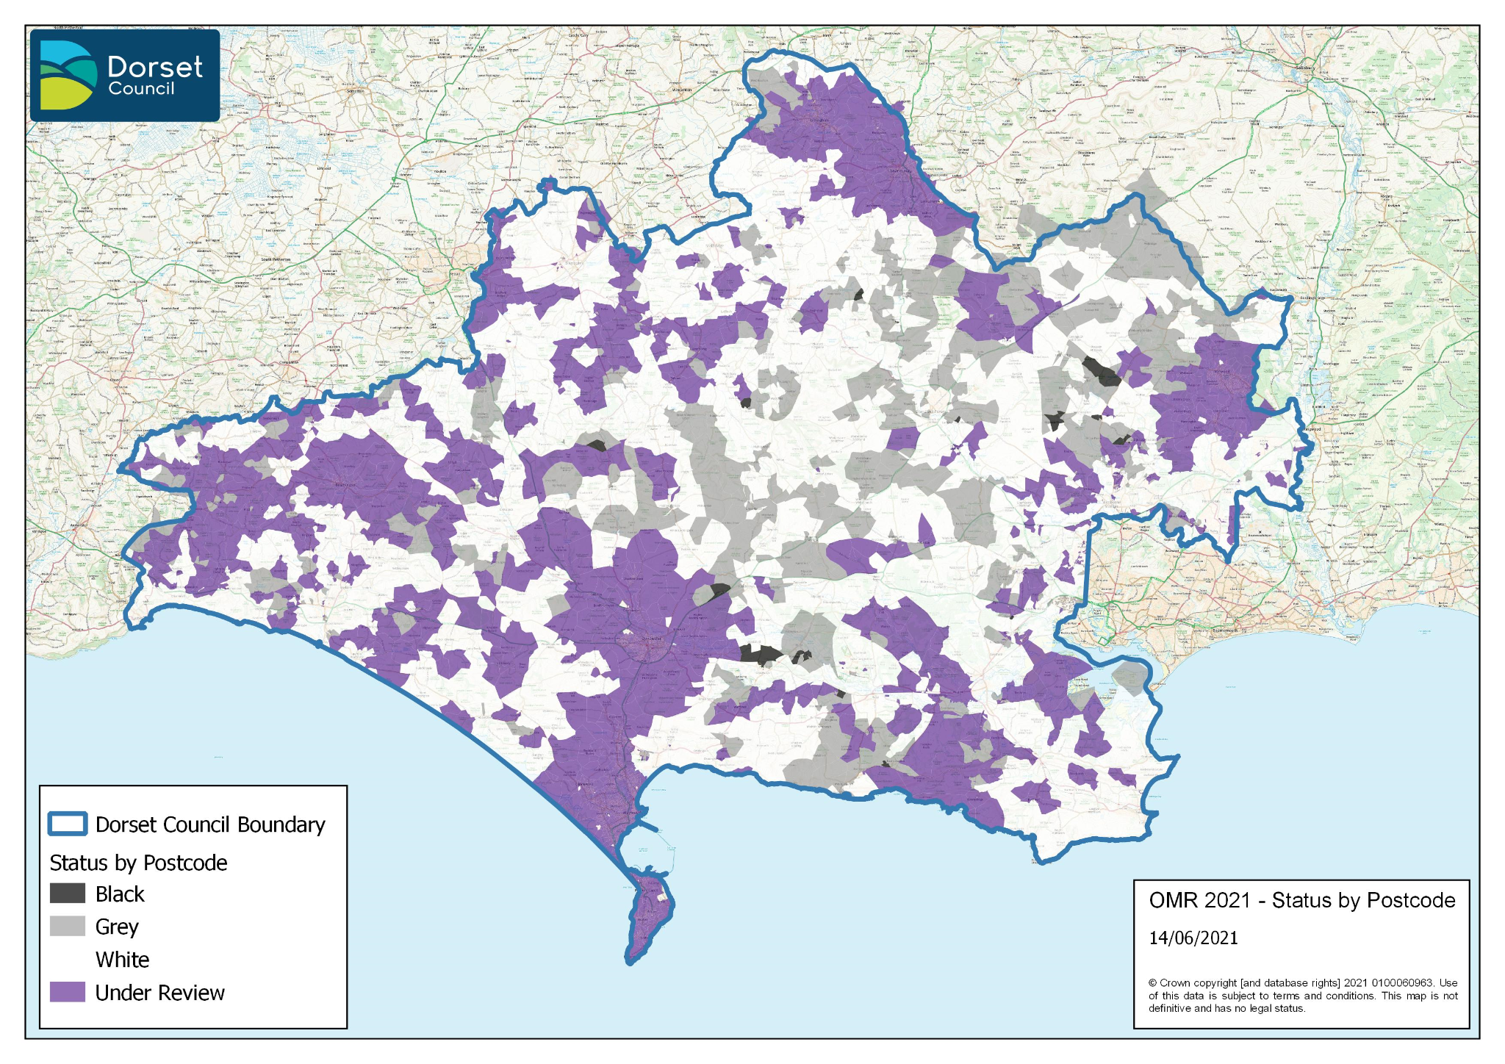

Annex E: Subsidy Control

Following the UK’s departure from the European Union on the 31st January 2020, the award of public subsidy needs to take account of World Trade Organisation rules and any international commitments made in free trade agreements. BDUK considers that this proposed subsidy falls under the subsidy control principles in Section 3 of the Trade and Cooperation Agreement (TCA) agreed between the European Union and UK Government on the 24th December 2020. The TCA places an obligation on both the UK and EU to have an effective system of subsidy control with independent oversight.

BDUK will ensure that it meets these subsidy principles in awarding public subsidy for gigabit capable broadband infrastructure, for example, by ensuring subsidy is designed to target failure in the market to achieve full UK coverage while minimising negative effects on competition. Public subsidy will be targeted to limit the risks of crowding out private investment, altering commercial investment incentives and ultimately distorting competition. Projects will continue to be procured under the Public Contracts Regulations (2020), to help meet our subsidy control requirements.

Suppliers have the opportunity during the OMR and Public Review stages, to share with BDUK, any firm and credible investment plans that may mean that public subsidy will not be warranted.

Requesting a review of a subsidy award

Under UK subsidy control requirements, anyone can request for a review about the award of subsidy. Requests must be submitted no later than one month from the date of the award of the subsidy for Dorset Council. The award of subsidy will follow the procurement and contract award and BDUK’s National Competency Centre will consider requests submitted within the one-month timescale, under the terms of the TCA.

This proposed award will be published by the Department of Business Energy Industrial Strategy (BEIS). The process for making such a request will be published here too.

Information about the UK’s Subsidy Control regime may be found on our government website:
https://www.gov.uk/government/news/government-sets-out-plans-for-new-approach-tosubsidy-control

Key eligibility requirements for public subsidy

For the purposes of the design of this intervention, BDUK has considered gigabit-capable broadband networks set out in Annex C. (Further guidance on the characteristics of qualifying technologies is available from BDUK).

BDUK also requires that public intervention should be able to ensure a ‘step change’ in broadband availability from that currently available as well as credible planned networks. This is demonstrated by:

- Generally, download speeds must be at least doubled and upload speeds substantially higher as a result of the intervention when compared with existing download and upload speeds
- Significant new investments in the broadband network are undertaken (i.e.
investments that must include civil works and installation of new passive elements)
- The new infrastructure brings significant new capabilities to the market in terms of broadband service availability, capacity and speeds and or competition.

The ‘step change’ in broadband availability shall be compared to that of existing as well as credible planned networks.

BDUK classify premises on the basis of their existing or planned broadband infrastructure:

- ‘White’ premises are those in which there is no qualifying broadband infrastructure and none is likely to be developed within 3 years;
- ‘Grey’ premises are those where only one qualifying broadband infrastructure is present or is to be deployed within the coming 3 years; and
- ‘Black’ premises are those where at least two qualifying broadband infrastructures of different operators exist or will be deployed in the coming 3 years.

In addition, the proposed intervention area includes a number of ‘under review’, or ‘conditional white’ areas. These are areas where suppliers have reported planned commercial broadband coverage, but where those plans have been judged through the OMR as potentially being at risk of not being completed. These areas will be subject to continued monitoring and verification of supplier plans within the three-year period by BDUK. BDUK may request commitment from the supplier that significant progress is made within three years. In the event that these commercial plans fall away these premises will be mapped as eligible and form part of the proposed intervention area and so eligible for intervention via this aid measure.

BDUK will target only those premises identified as ‘white’.

This principally applies to CPE but also backhaul/other network upgrades.
Minimum download speeds may include the usual framing and packet overheads of the technologies used, provided that they amount to no more than a few percent of the total traffic i.e. data speed is defined as (user data traffic + overheads) / time
Typically contention ratios of around 20:1 to 30:1 have been found to meet these criteria and should not be exceeded unless it can be otherwise demonstrated how these criteria would be met. For the avoidance of doubt, the performance criteria take precedence over contention ratio considerations.

